

Task Title: Compare Hotel Room Size

OALCF Cover Sheet – Practitioner Copy

Learner Name: __________________________________________
Date Started: ___________________________________________
Date Completed: _________________________________________

Goal Path: | Employment | Apprenticeship
Secondary School | Post Secondary | Independence
Successful Completion: Yes No

Task Description: The learner will use floor plans and dimensions to calculate and compare hotel room sizes.
Main Competency/Task Group/Level Indicator:
- Understand and Use Numbers/Use measures/C3.2
Materials Required:
- Pen/pencil and paper and/or digital device
- Calculator or digital device with calculator function

Learner Information
When travelling or booking hotel rooms it is important to know the size of the room so you can book the space that you need.

Work Sheet
Task 1: Calculate what the square foot difference is between the “Double-Double Suite” and the “King Suite” shown here. Both rooms are 14’ wide. The Double-Double Suite is 35’ long, and the King Suite is 29’ long.
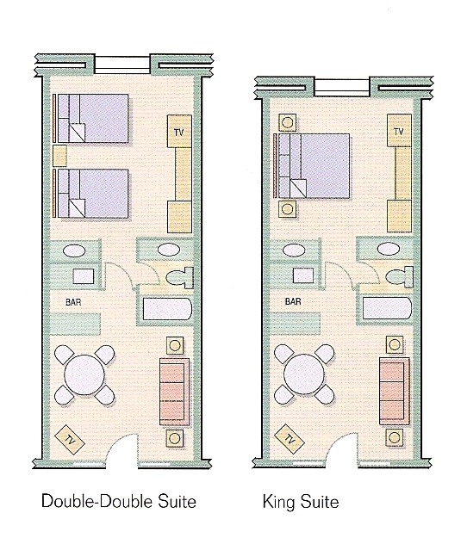

Answer:

______________________________________________________

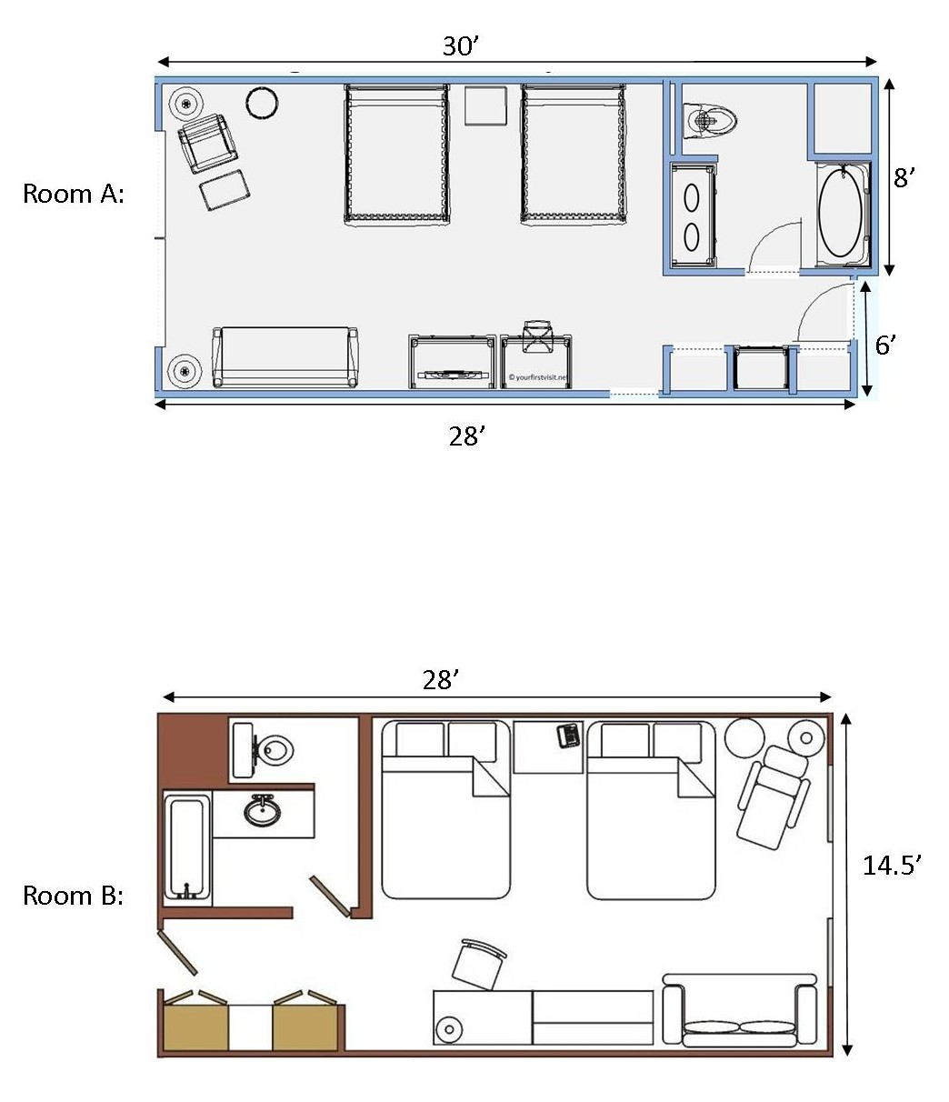
Task 2: Using the floor plans for Room A and Room B, determine which hotel room is larger, and by how many square feet.

Answer:

______________________________________________________

Answers
Task 1: Calculate what the square foot difference is between the “Double-Double Suite” and the “King Suite” shown here. Both rooms are 14’ wide. The Double-Double Suite is 35’ long, and the King Suite is 29’ long.
Answer:
DD Suite: 14’ x 35’ = 490 sq feet
KS Suite: 14’ x 29’ = 406 sq feet
490 – 406 = 84 sq feet

Task 2: Using the floor plans for Room A and Room B, determine which hotel room is larger, and by how many square feet.
Answer:
Room A: 30’ x 8’ = 240 sq ft
28’ x 6’ = 168 sq ft
240 + 168 = 408 sq feet
Room B: 28’ x 14.5’ = 406 sq feet

Room A is 2 square feet larger than Room B.

Performance Descriptors
Levels | Performance Descriptors | Needs Work | Completes task with support from practitioner | Completes task independently
C3.2 | calculates using numbers expressed as whole numbers, fractions, decimals, percentages and integers
 | understands and uses formulas for finding the perimeter, area and volume of simple, common shapes
 | chooses and performs required operation(s); may make inferences to identify required operation(s)
 | selects appropriate steps to solutions
 | uses strategies to check accuracy (e.g. estimating, using a calculator, repeating a calculation, using the reverse operation)

This task: Was successfully completed Needs to be tried again

Learner Comments:

Instructor (print): Learner (print):
__________________ _________________

Skill Building Activities

Links to Online Resources:

LearningHUB Math Courses: https://www.learninghub.ca/apps/pages/index.jsp?uREC_ID=1118749&type=d&pREC_ID=1380783
LearningHUB Course Catalogue: https://www.learninghub.ca/apps/pages/coursecatalogue

Khan Academy – Comparing Areas of Rectangles (short video):
https://www.khanacademy.org/math/cc-fourth-grade-math/area-perimeter/imp-area-and-perimeter/v/comparing-area
Khan Academy – Area Problem Questions: https://www.khanacademy.org/math/cc-fourth-grade-math/area-perimeter/imp-area-and-perimeter/e/area_of_squares_and_rectangles

WikiHow – Measuring a Room (with pictures): https://www.wikihow.com/Measure-a-Room

