

Task Title: Compare College Employment Rates

OALCF Cover Sheet – Practitioner Copy

Learner Name: __________________________________________
Date Started: ___________________________________________
Date Completed: _________________________________________

Goal Path: | Employment | Apprenticeship
Secondary School | Post Secondary | Independence
Successful Completion: Yes No

Task Description: The learner will compare graduate satisfaction and employment rates between colleges.
Main Competency/Task Group/Level Indicator:
- Find and Use Information/Interpret documents/A2.2
- Understand and Use Numbers/Manage data/C4.1
Materials Required:
- Pen/pencil and paper and/or digital device

Learner Information
Learners on the Post Secondary goal path have a lot to consider when choosing a college. One way to compare colleges is by looking at the Employment Rates of graduates.
Look at “Ontario Colleges Key Performance Indicators”.
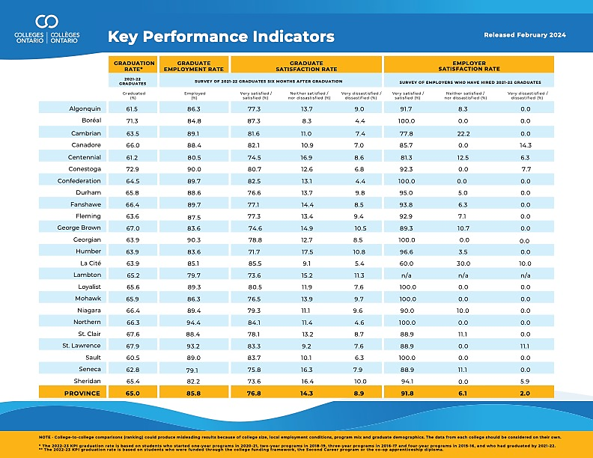
Work Sheet
Task 1: List the three colleges that have the highest graduate rates for 2021-2022 in order from highest to lowest.
Answer:

______________________________________________________
Task 2: List the three colleges with the highest graduate employment rates for 2021-2022 in order from highest to lowest.
Answer:

______________________________________________________
Task 3: Which colleges have an employer satisfaction rate of 100% (very satisfied/satisfied) in 2021-2022?
Answer:

______________________________________________________

Answers
Task 1: List the three colleges that have the highest graduate rates for 2021-2022 in order from highest to lowest.
Answer: Note – Learner may include percentages, but they are not required.
- Conestoga 72.9%
- Boreal 71.3%
- St. Lawrence 67.9%

Task 2: List the three colleges with the highest graduate employment rates for 2021-2022 in order from highest to lowest.
Answer: Note – Learner may include percentages, but they are not required.
- Northern 94.4%
- St. Lawrence 93.2%
- Georgian 90.3%

Task 3: Which colleges have an employer satisfaction rate of 100% (very satisfied/satisfied) in 2021-2022?
Answer:
- Boreal
- Confederation
- Georgian
- Loyalist
- Mohawk
- Northern
- Sault

Performance Descriptors
Levels | Performance Descriptors | Needs Work | Completes task with support from practitioner | Completes task independently
A2.2 | Extracts information from tables and forms
 | Uses layout to locate information
 | Makes connections between parts of documents
 | Makes low-level inferences
 | Begins to identify sources and evaluate information
C4.1 | Recognizes values in number and word format
 | Identifies and compares quantities of items
 | Understands numerical order
 | Uses strategies to check accuracy (e.g. estimating, using a calculator, repeating a calculation, using the reverse operation)
This task: Was successfully completed Needs to be tried again

Learner Comments:

Instructor (print): Learner (print):
__________________ _________________

