

Task Title: Compare Cell Phone Plans

OALCF Cover Sheet – Practitioner Copy

Learner Name: __________________________________________
Date Started: ___________________________________________
Date Completed: _________________________________________

Goal Path: | Employment | Apprenticeship
Secondary School | Post Secondary | Independence
Successful Completion: Yes No

Task Description: Compare cell phone plan options to determine the best deal.
Main Competency/Task Group/Level Indicator:
- Understand and Use Numbers/Manage money/C1.3
Materials Required:
- Pen/pencil and paper and/or digital device
- Calculator or digital device with calculator function

Learner Information
An administrative assistant or purchasing assistant may be asked to determine which cell phone plan is the best option for their employer. You will also want to compare cell phone plans before making a purchase for yourself.
Look at the provided plan information from Koodo, Fido and Public Mobile. All three companies offer a variety of low-cost plans when you bring your own phone.

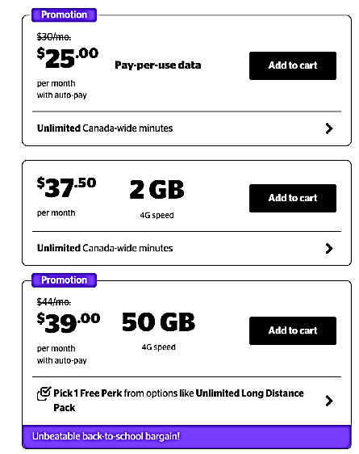
Koodo Fido
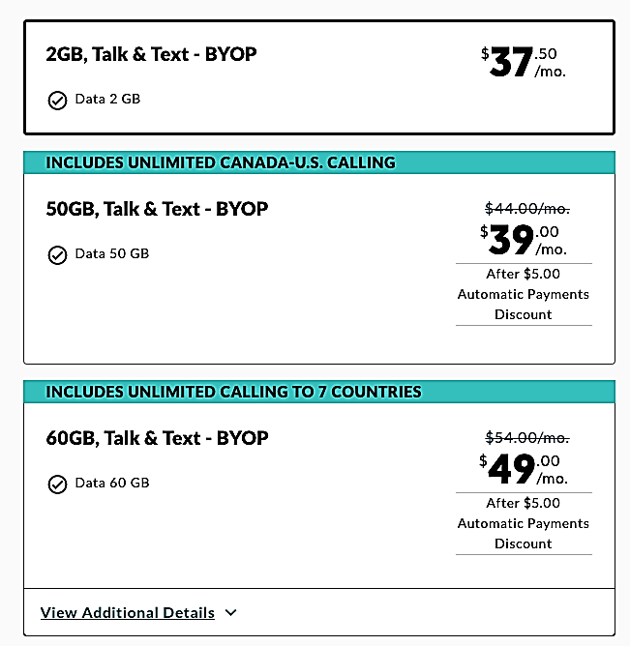

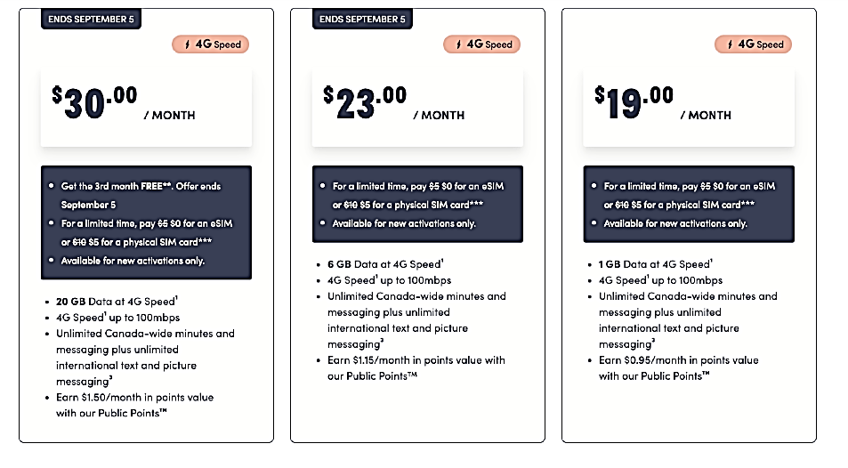
Public Mobile

Work Sheet
Task 1: You need at least 2GB of data and don’t want to spend more than $40.00 per month. Which phone plans meet these criteria?
Answer:

______________________________________________________
Task 2: The cheapest plan that Koodo offers is $25.00 per month. This does not include data. Calculate the monthly cost you would pay for this phone if you pay for data at a rate of $5.00/GB and you need 2GB each month. Add HST to the total.
Answer:

______________________________________________________
Task 3: Your supervisor has asked you to find the cheapest phone plan. They use 5GB of data per month. Assume that each cell phone plan charges $5.00 for each additional GB of data beyond what is included in the monthly package. Add HST to the total. You do not want to recommend a plan that has more than 5GB of data because it will not be used. Which cell phone plan would you recommend?
Answer:

______________________________________________________

Answers
Task 1: You need at least 2GB of data and don’t want to spend more than $40.00 per month. Which phone plans meet these criteria?
Answer:
Koodo - $37.50 for 2GB and $39.00 for 50GB
Fido - $37.50 for 2GB and $39.00 for 50GB
Public Mobile - $23.00 for 6GB or $30.00 for 20GB

Task 2: The cheapest plan that Koodo offers is $25.00 per month. This does not include data. Calculate the monthly cost you would pay for this phone if you pay for data at a rate of $5.00/GB and you need 2GB each month. Add HST to the total.
Answer:
$25.00 + $10.00 = $35.00
$35.00 x .13 (HST) = $4.55
Total: $35.00 + $4.55 = $39.55

Task 3: Your supervisor has asked you to find the cheapest phone plan. They use 5GB of data per month. Assume that each cell phone plan charges $5.00 for each additional GB of data beyond what is included in the monthly package. Add HST to the total. You do not want to recommend a plan that has more than 5GB of data because it will not be used. Which cell phone plan would you recommend?
Answer:

Koodo:
$37.50 for 2GB of data + $15.00 (3 x $5.00 for extra 3GB) = $52.50
$52.50 x 0.13 = $6.83
Total: $52.50 + $6.83 = $59.40 for 5GB of data

Fido
$37.50 for 2GB of data + $15.00 (3 x $5.00 for extra 3GB) = $52.50
$52.50 x 0.13 = $6.83
Total: $52.50 + $6.83 = $59.40 for 5GB of data
Public $19.00 for 1 GB of data + $20.00 ($4 x $5.00 for extra GB) = $39.00
$39.00 x 0.13 = $5.07
Total: $39.00 + $5.07 = $44.07 for 5GB of data

The cheapest plan for 5GB of data is Public Mobile’s $19.00 plan: Total is $44.07 for 5GB of data per month.

Performance Descriptors
Levels | Performance Descriptors | Needs Work | Completes task with support from practitioner | Completes task independently
C1.3 | calculates using numbers expressed as whole numbers, fractions, decimals, percentages and integers
 | manages unfamiliar elements (e.g. context, content) to complete the task
 | chooses and performs required operations; makes inferences to identify operations
 | selects appropriate steps to reach solutions from among options
 | identifies a variety of ways to complete the task
 | finds, integrates and analyzes numerical information
 | uses strategies to check accuracy

This task: Was successfully completed Needs to be tried again

Learner Comments:

Instructor (print): Learner (print):
__________________ _________________

