

Task Title: Browse Classified Listings

OALCF Cover Sheet – Practitioner Copy

Learner Name: __________________________________________
Date Started: ___________________________________________
Date Completed: _________________________________________

Goal Path: | Employment | Apprenticeship
Secondary School | Post Secondary | Independence
Successful Completion: Yes No

Task Description: The learner will browse through classified advertisements to search for a used couch.
Main Competency/Task Group/Level Indicator:
- Find and Use Information/Interpret documents/A2.2

Materials Required:
- Pen/pencil and paper and/or digital device

Learner Information
Online classified advertisements are a great place to find used furniture at a reasonable cost. Look at the five classified advertisements from Kijiji.

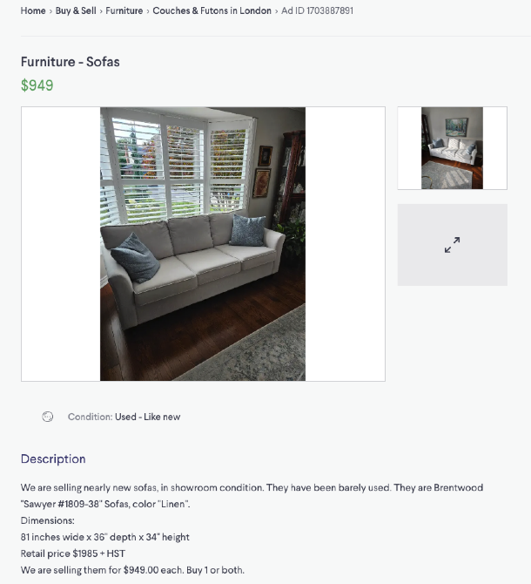

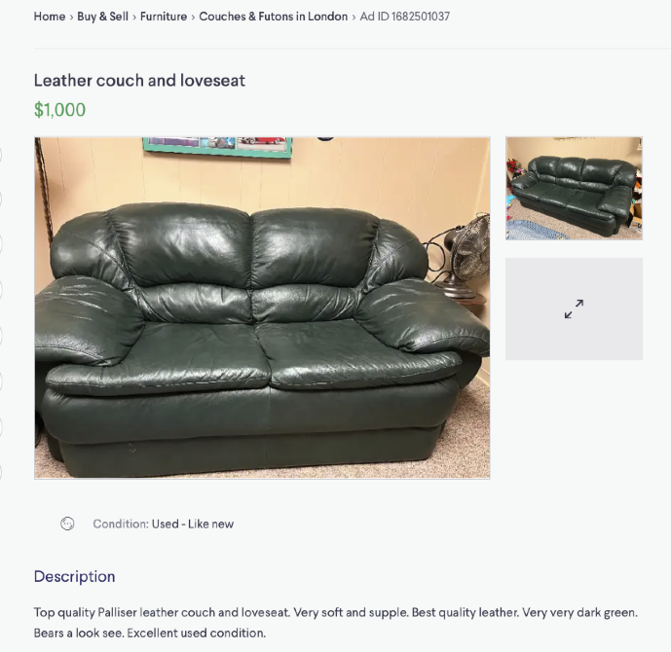

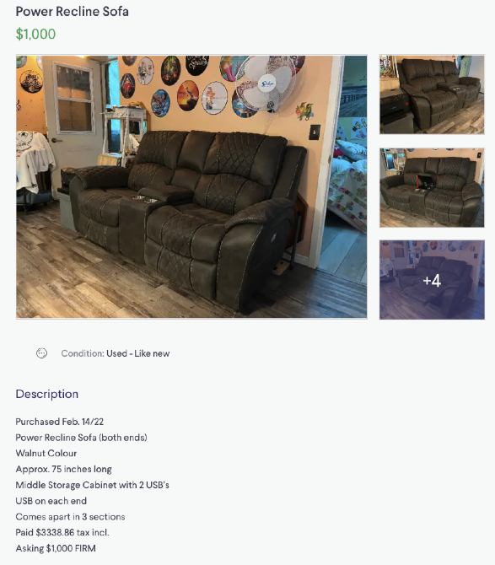

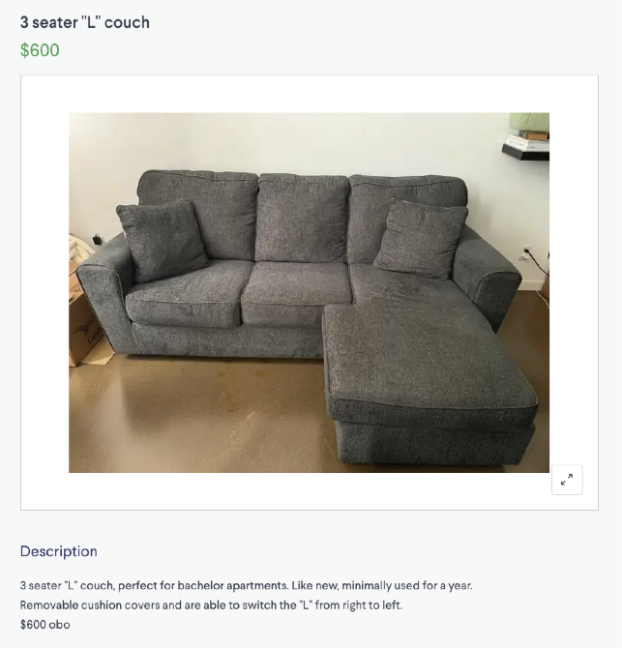

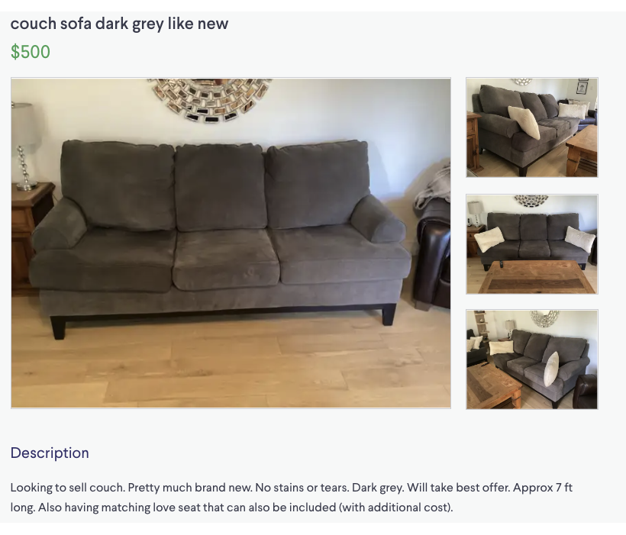

Work Sheet
Task 1: If your budget is $700, how many of the couches listed are in your price range?
Answer:

______________________________________________________
Task 2: You prefer a fabric couch. How many couches could you consider purchasing?
Answer:

______________________________________________________
Task 3: You want to purchase a couch that meets the following criteria:
- Seats 3 people
- Fabric can be removed for washing
- Comes apart so it can fit through your apartment doorway
Which of the couch advertisements give enough information so you can make your decision?
Answer:

______________________________________________________

Answers
Task 1: If your budget is $700, how many of the couches listed are in your price range?
Answer: two.
Task 2: You prefer a fabric couch. How many couches could you consider purchasing?
Answer: four. There may be some variation in this answer. Only one couch is specifically described as leather; the remaining couches appear to be fabric in the pictures, but the learner may interpret this differently.
Task 3: You want to purchase a couch that meets the following criteria:
- Seats 3 people
- Fabric can be removed for washing
- Comes apart so it can fit through your apartment doorway
Which of the couch advertisements give enough information so you can make your decision?
Answer: None of the ads give enough information to confirm whether or not they meet all three criteria.
Couch 1: Looks like it has three seats, do not know if fabric can be removed, do not know if it comes apart for moving.
Couch 2: does not look like it has three seats, do not know if fabric can be removed, do not know if it can come apart for moving.
Couch 3: does not look like it has three seats, do not know if fabric can be removed, does come apart for moving.
Couch 4: does have three seats, removable covers for washing, do not know if it comes apart for moving.
Couch 5: looks like it has three seats, do not know if fabric can be removed, do not know it if comes apart for washing.

Performance Descriptors
Levels | Performance Descriptors | Needs Work | Completes task with support from practitioner | Completes task independently
A2.2 | performs limited searches using one or two search criteria
 | extracts information from tables and forms
 | uses layout to locate information
 | makes connections between parts of documents
 | makes low-level inferences
 | begins to identify sources and evaluate information
This task: Was successfully completed Needs to be tried again

Learner Comments:

Instructor (print): Learner (print):
__________________ _________________

