

Task Title: Retail Price of a Coat

OALCF Cover Sheet – Practitioner Copy

Learner Name: __________________________________________
Date Started: ___________________________________________
Date Completed: _________________________________________

Goal Path: | Employment | Apprenticeship
Secondary School | Post Secondary | Independence
Successful Completion: Yes No

Task Description: The learner will calculate the retail price of a coat, less a discount.
Main Competency/Task Group/Level Indicator:
- Find and Use Information/Interpret documents/A2.1
- Understand and Use Numbers/Manage money/C1.1
Materials Required:
- Pen/pencil and paper and/or digital device

Learner Information
Online stores often have discounts and free shipping that can help you save money when making purchases. Scan the page from Joe Fresh.


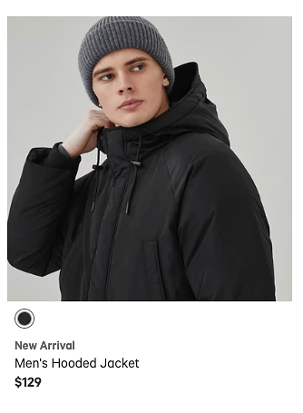

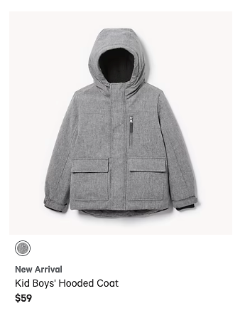
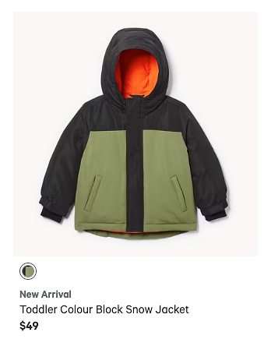
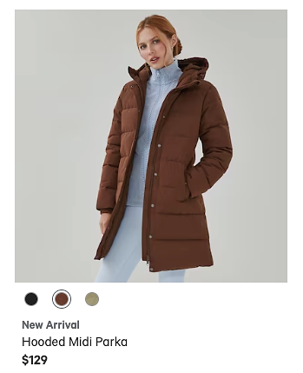


Free Shipping Orders $50+ (pre-tax)
November Offer (November 1-10):
$20 is deducted from all winter coats priced over $60

Work Sheet
Task 1: When is the sale offer valid?
Answer:

______________________________________________________
Task 2: List the coats in the flyer that are eligible for the offer.
Answer:

______________________________________________________
Task 3: How much money does someone need to spend to get free shipping?
Answer:

______________________________________________________
Task 4: Calculate the cost (before tax and shipping) of the Men’s Hooded Jacket if it is purchased November 8.
Answer:

______________________________________________________
Task 5: Calculate the cost of the Printed Quilted Oversized Jacket (before tax and shipping) if it is purchased November 2.
Answer:

______________________________________________________

Answers
Task 1: When is the sale offer valid?
Answer: Between November 1 and November 10

Task 2: List the coats in the flyer that are eligible for the November Offer.
Answer:
- Men’s Hooded Jacket
- Hooded Midi Parka
- Printed Quilted Oversized Jacket

Task 3: How much money does someone need to spend to get free shipping?
Answer: $50 (before tax)

Task 4: Calculate the cost (before tax and shipping) of the Men’s Hooded Jacket if it is purchased November 8.
Answer: $129.00 - $20.00 = $109.00

Task 5: Calculate the cost of the Printed Quilted Oversized Jacket (before tax and shipping) if it is purchased November 2.
Answer: $69.94 - $20.00 = $49.94

Performance Descriptors
Levels | Performance Descriptors | Needs Work | Completes task with support from practitioner | Completes task independently
A2.1 | scans to locate specific details
 | interprets brief text and common symbols
 | locates specific details in simple documents, such as labels and signs
C1.1 | adds, subtracts, multiplies and divides whole numbers and decimals
 | recognizes values in number and word format
 | identifies and performs required operation
 | follows apparent steps to reach solutions
 | interprets and represents costs using monetary symbols and decimals

C1.1 cont. | uses strategies to check accuracy (e.g. estimating, using a calculator, repeating a calculation, using the reverse operation)

This task: Was successfully completed Needs to be tried again
Learner Comments:

Instructor (print): Learner (print):
__________________ _________________

