

Task Title: Read A Product Brochure

OALCF Cover Sheet – Practitioner Copy

Learner Name: __________________________________________
Date Started: ___________________________________________
Date Completed: _________________________________________

Goal Path: | Employment | Apprenticeship
Secondary School | Post Secondary | Independence
Successful Completion: Yes No

Task Description: Read a brochure to learn about a product.
Main Competency/Task Group/Level Indicator:
- Find and Use Information/Read continuous text/A1.2

Materials Required:

- Pen/pencil and paper and/or digital device

Learner Information
Employees are often given new equipment to use on the job. In order to understand a new product, they must read brochures or inserts that explain the benefits of the equipment and how it works.
Scan the brochure from Amstore Innovations about a new product (Digital Key).
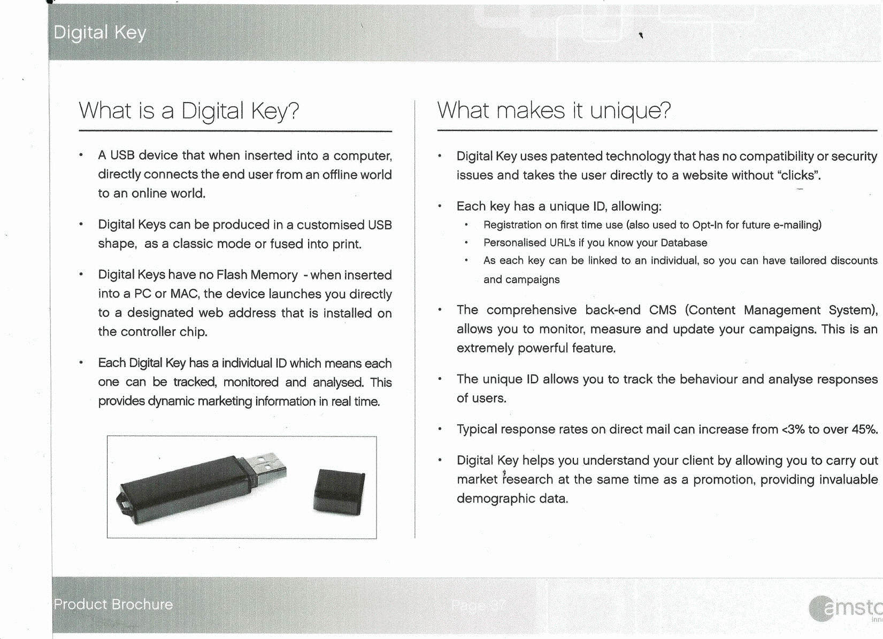

Work Sheet
Task 1: List 2 things that the Unique ID allows a Digital Key to do.
Answer:

______________________________________________________
Task 2: What does the unique ID allow you to track and analyse?
Answer:

______________________________________________________
Task 3: What happens when a Digital Key is inserted into a MAC or PC?
Answer:

______________________________________________________
Task 4: How does a Digital Key help you understand your client?
Answer:

______________________________________________________

Task 5: List the 3 things the individual ID can do for each Digital Key to provide dynamic marketing information.
Answer:

______________________________________________________

Answers
Task 1: List 2 things that the Unique ID allows a Digital Key to do.
Answer: Any two of the following:
- Registration on first time use
- Personalized URL’s if you know your Database
- As each key can be linked to an individual, so you can have tailored discounts and campaigns

Task 2: What does the unique ID allow you to track and analyse?
Answer: The unique ID allows you to track the behaviour and analyse responses of users.

Task 3: What happens when a Digital Key is inserted into a MAC or PC?
Answer: The device launches you directly to a designated web address that is installed on the controller chip.

Task 4: How does a Digital Key help you understand your client?
Answer: By allowing you to carry out market research at the same time as a promotion, providing invaluable demographic data.

Task 5: List the 3 things the individual ID can do for each Digital Key to provide dynamic marketing information.
Answer: Each one can be tracked, monitored and analysed

Performance Descriptors
Levels | Performance Descriptors | Needs Work | Completes task with support from practitioner | Completes task independently
A1.2 | scans text to locate information
 | locates multiple pieces of information in simple texts
 | makes low-level inferences
 | makes connections between sentences and between paragraphs in a single text
 | begins to identify sources and evaluate information

This task: Was successfully completed Needs to be tried again
Learner Comments:

Instructor (print): Learner (print):
__________________ _________________

