

Task Title: Purchasing Notebooks

OALCF Cover Sheet – Practitioner Copy

Learner Name: __________________________________________
Date Started: ___________________________________________
Date Completed: _________________________________________

Goal Path: | Employment | Apprenticeship
Secondary School | Post Secondary | Independence
Successful Completion: Yes No

Task Description: The learner will determine how many notebooks they can purchase for $20.
Main Competency/Task Group/Level Indicator:
- Understand and Use Numbers/Manage money/C1.1
Materials Required:
- Pen/pencil and paper and/or digital device
- Calculator or digital device with calculator function (optional)

Learner Information
A student wishes to buy as many notebooks as possible for $20.00. The local office supply store is having a “tax free” sale day.
Scan the “Notebooks” flyer.

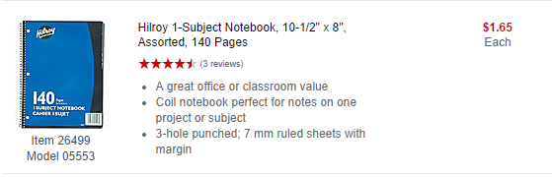
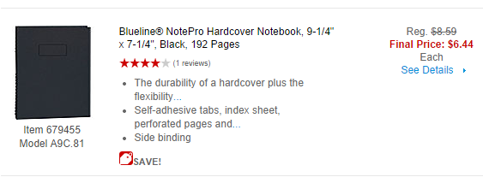
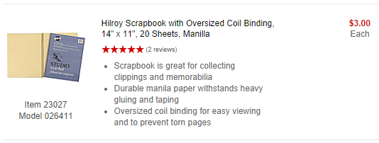
Notebooks

Work Sheet
Task 1: Calculate how many Hilroy 1-Subject Notebooks you can buy for $20.00.
Answer:

______________________________________________________
Task 2: Calculate how many Blueline NotePro Hardcover Notebooks you can buy for twenty dollars.
Answer:

______________________________________________________
Task 3: Calculate how many Hilroy Scrapbook Notebooks you can buy for $20.00.
Answer:

______________________________________________________

Answers
Task 1: Calculate how many Hilroy 1-Subject Notebooks you can buy for $20.00.
Answer:
$20 ÷ 1.65 = 12.12
You can buy 12 notebooks for $20.

Task 2: Calculate how many Blueline NotePro Hardcover Notebooks you can buy for twenty dollars.
Answer:
$20 ÷ 6.44 = 3.11
You can buy 3 notebooks for $20.

Task 3: Calculate how many Hilroy Scrapbook Notebooks you can buy for $20.00.
Answer:
$20 ÷ 3.00 = 6.67
You can buy 6 notebooks for $20.

Performance Descriptors
Levels | Performance Descriptors | Needs Work | Completes task with support from practitioner | Completes task independently
C1.1 | adds, subtracts, multiplies and divides whole numbers and decimals
 | recognizes values in number and word format
 | identifies and performs required operation
 | follows apparent steps to reach solutions
 | interprets and represents costs using monetary symbols and decimals
 | rounds to the nearest dollar
 | uses strategies to check accuracy (e.g. estimating, using a calculator, repeating a calculation, using the reverse operation)

This task: Was successfully completed Needs to be tried again

Learner Comments:

Instructor (print): Learner (print):
__________________ _________________

