

Task Title: Find the Coupon Expiry Date (Set One)

OALCF Cover Sheet – Practitioner Copy

Learner Name: __________________________________________
Date Started: ___________________________________________
Date Completed: _________________________________________

Goal Path: | Employment | Apprenticeship
Secondary School | Post Secondary | Independence
Successful Completion: Yes No

Task Description: The learner will locate coupon expiry dates in a variety of formats.
Main Competency/Task Group/Level Indicator:
- Find and Use Information/Interpret documents/A2.1
Materials Required:
- Pen/pencil and paper and/or digital device

Learner Information
Coupons can save shoppers money. Most coupons have an expiry date, and cannot be used after that date.
Scan the various coupons provided.

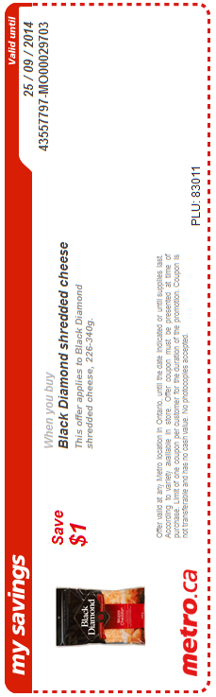
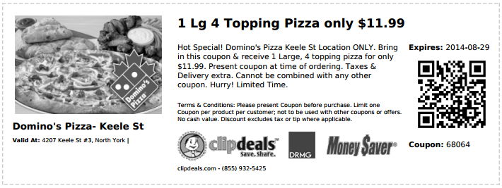

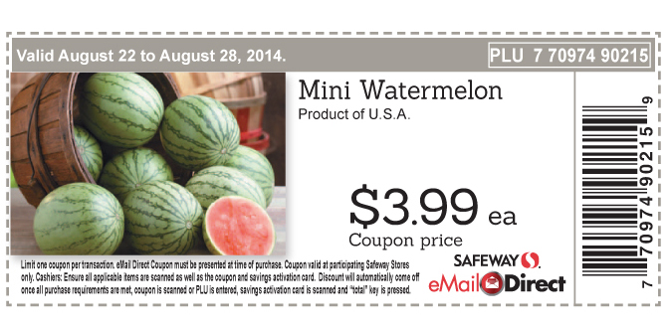



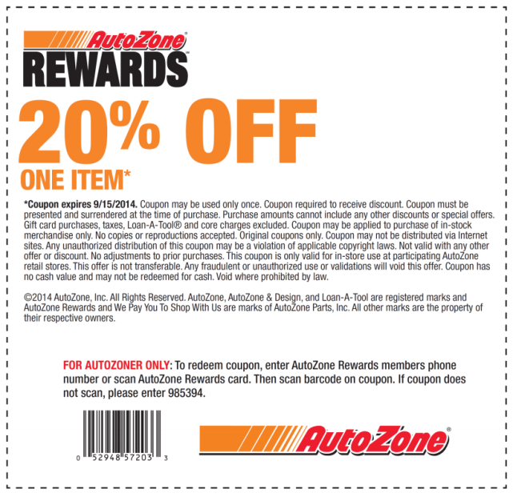

Work Sheet
Task 1: Until when was the Black Diamond cheese coupon valid?
Answer:

______________________________________________________
Task 2: When did the Domino’s Pizza coupon expire?
Answer:

______________________________________________________
Task 3: When did the Auto Zone coupon expire?
Answer:

______________________________________________________
Task 4: When was the Bulk Barn coupon valid?
Answer:

______________________________________________________
Task 5: When was the Safeway watermelon coupon valid?
Answer:

______________________________________________________

Answers
Task 1: Until when was the Black Diamond cheese coupon valid?
Answer: 25/09/2014 [September 25, 2014]

Task 2: When did the Domino’s Pizza coupon expire?
Answer: 29-08-2014 [August 29, 2014]

Task 3: When did the Auto Zone coupon expire?
Answer: 9/15/2014 [September 15, 2014]

Task 4: When was the Bulk Barn coupon valid?
Answer: Friday, February 22 - Thursday, March 7, 2013

Task 5: When was the Safeway watermelon coupon valid?
Answer: August 22 to August 28, 2014

Performance Descriptors
Levels | Performance Descriptors | Needs Work | Completes task with support from practitioner | Completes task independently
A2.1 | Scans to locate specific details
 | Interprets brief text and common symbols
 | Locates specific details in simple documents, such as labels and signs
 | Requires support to identify sources and to evaluate and integrate information

This task: Was successfully completed Needs to be tried again
Learner Comments:

Instructor (print): Learner (print):
__________________ _________________

