

Task Title: Find a Coupon Expiry Date (Set 2)

OALCF Cover Sheet – Practitioner Copy

Learner Name: __________________________________________
Date Started: ___________________________________________
Date Completed: _________________________________________

Goal Path: | Employment | Apprenticeship
Secondary School | Post Secondary | Independence
Successful Completion: Yes No

Task Description: The learner will locate coupon expiry dates in a variety of formats.
Main Competency/Task Group/Level Indicator:
- Find and Use Information/Interpret documents/A2.1
Materials Required:
- Pen/pencil and paper and/or digital device

Learner Information
Coupons can save shoppers money. Most coupons have an expiry date, and cannot be used after that date.
Look at the coupons.
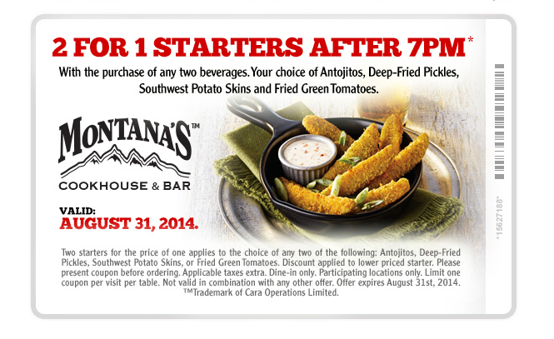

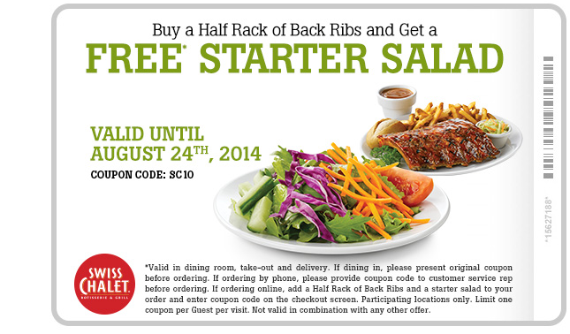

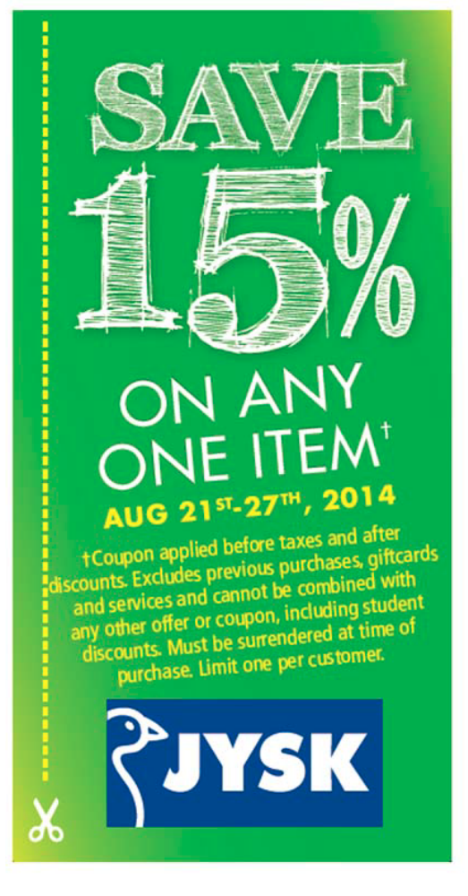
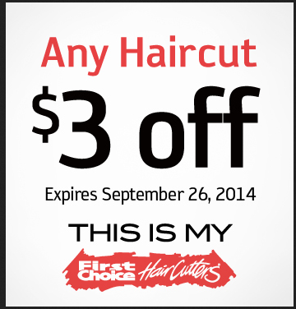

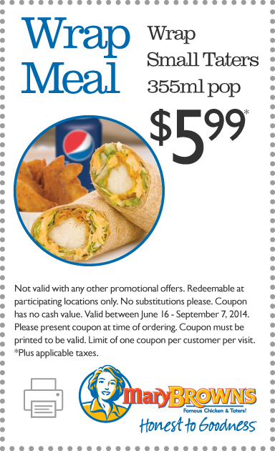

Work Sheet
Task 1: Until when was the Montana’s coupon valid?
Answer:

______________________________________________________
Task 2: Until when was the Swiss Chalet coupon valid?
Answer:

______________________________________________________
Task 3: When did the First Choice coupon expire?
Answer:

______________________________________________________
Task 4: When could you use the Jysk coupon?
Answer:

______________________________________________________
Task 5: When could you use the Mary Brown coupon?
Answer:

______________________________________________________

Answers
Task 1: Until when was the Montana’s coupon valid?
Answer: August 31, 2014

Task 2: Until when was the Swiss Chalet coupon valid?
Answer: August 24th, 2014

Task 3: When did the First Choice coupon expire?
Answer: September 26, 2014

Task 4: When could you use the Jysk coupon?
Answer: Aug 21st - 27th, 2014

Task 5: When could you use the Mary Brown coupon?
Answer: June 16 - September 7, 2014

Performance Descriptors
Levels | Performance Descriptors | Needs Work | Completes task with support from practitioner | Completes task independently
A2.1 | Scans to locate specific details
 | Interprets brief text and common symbols
 | Locates specific details in simple documents, such as labels and signs
 | Requires support to identify sources and to evaluate and integrate information

This task: Was successfully completed Needs to be tried again
Learner Comments:

Instructor (print): Learner (print):
__________________ _________________

