

Task Title: Compare Grams of Sodium in Two Types of Soup

OALCF Cover Sheet – Practitioner Copy

Learner Name: __________________________________________
Date Started: ___________________________________________
Date Completed: _________________________________________

Goal Path: | Employment | Apprenticeship
Secondary School | Post Secondary | Independence
Successful Completion: Yes No

Task Description: Learner will compare sodium (salt) levels in two different kinds of soup.
Main Competency/Task Group/Level Indicator:
- Understand and Use Numbers/Use measures/C3.1
Materials Required:
- Pen/pencil and paper and/or digital device

Learner Information
A cook in a healthcare facility must plan meals that meet the special dietary requirements of patients. These dietary requirements may include salt (sodium) restrictions. Scan the two soup labels and Health Canada chart.
Regular Chicken Broth Low Sodium Chicken Broth
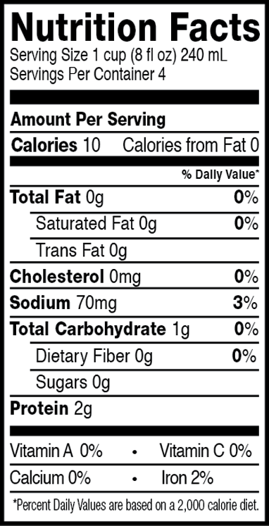
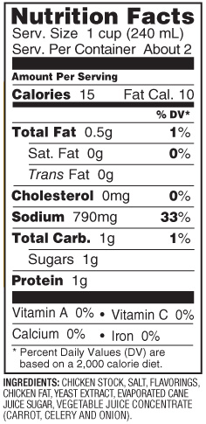

Health Canada Recommended Daily Intake for Sodium
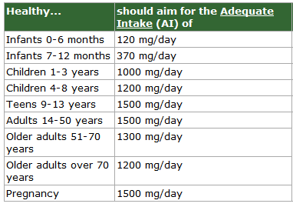

Work Sheet
Task 1: How many milligrams of sodium would a patient consume with one cup of the regular chicken broth?
Answer:

______________________________________________________
Task 2: How many milligrams of sodium would a patient consume with one cup of the low-sodium chicken broth?
Answer:

______________________________________________________
Task 3: How much more sodium would a patient consume with one cup of the regular chicken broth than with one cup of the low-sodium chicken broth?
Answer:

______________________________________________________
Task 4: According to Health Canada, how many milligrams of sodium per day is an adequate intake for a patient who is 80 years old?
Answer:

______________________________________________________

Task 5: For lunch, an 80-year-old patient consumes one cup of regular chicken broth. How many more milligrams of sodium can the patient eat that day before he or she reaches the recommended adequate intake (AI)?
Answer:

______________________________________________________

Answers
Task 1: How many milligrams of sodium would a patient consume with one cup of the regular chicken broth?
Answer: 790 mg

Task 2: How many milligrams of sodium would a patient consume with one cup of the low-sodium chicken broth?
Answer: 70 mg

Task 3: How much more sodium would a patient consume with one cup of the regular chicken broth than with one cup of the low-sodium chicken broth?
Answer: 790 mg – 70 mg = 720 mg

Task 4: According to Health Canada, how many milligrams of sodium per day is an adequate intake for a patient who is 80 years old?
Answer: 1200 mg/day

Task 5: For lunch, an 80-year-old patient consumes one cup of regular chicken broth. How many more milligrams of sodium can the patient eat that day before he or she reaches the recommended adequate intake (AI)?
Answer: 1,200 – 790 = 410 mg

Performance Descriptors
Levels | Performance Descriptors | Needs Work | Completes task with support from practitioner | Completes task independently
C3.1 | adds and subtracts whole number measurements
 | identifies and performs required operation
 | interprets and represents measures using whole numbers, decimals and simple, common fractions (e.g. ½, ¼)
 | interprets and represents measures using symbols and abbreviations
 | follows apparent steps to reach solutions
 | uses strategies to check accuracy (e.g. estimating, using a calculator, repeating a calculation, using the reverse operation)

This task: Was successfully completed Needs to be tried again

Learner Comments:

Instructor (print): Learner (print):
__________________ _________________

