

Task Title: Create a Sign to Inform Visitors that Elevator is

Out of Order

OALCF Cover Sheet – Practitioner Copy

Learner Name: __________________________________________
Date Started: ___________________________________________
Date Completed: _________________________________________

Goal Path: | Employment | Apprenticeship
Secondary School | Post Secondary | Independence
Successful Completion: Yes No

Task Description: Create a safety sign in the workplace.
Main Competency/Task Group/Level Indicator:
- Communicate Ideas and Information/Complete and create documents/B3.1b
Materials Required:
- Pen/pencil and paper and/or digital device

Note for Instructor/Practitioner

Below you will find preparatory skill building activities and resources that can be used with learners.
Skill Building Activity 1:
Signs that are red usually tell a person to stop doing something. There is danger ahead. Caution and warning signs are yellow.
Skill Building Activity 2:
Here are two signs, taken from www.SafetySign.com, the official Occupational Safety and Health Administration (USA) signs website:
A sign similar to the first sign is most appropriate for something that is broken or out of order.
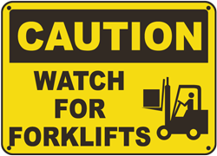
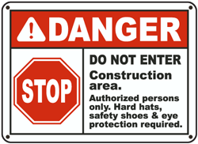

Link to Online Resources
Safety Signs: These two companies sell safety signs. Learners can explore symbols, colours and shapes. They can contrast different signs with each other.
- https://www.safetysign.com/
- https://www.canadiansafetysupplies.com

WHMIS Pictograms: This document explains different hazard signs used in the WHMIS system. Learners can explore how different hazards are identified in the workplace.
- https://www.ccohs.ca/oshanswers/chemicals/whmis_ghs/pictograms.pdf

Learner Information
Maintenance workers and other employees may need to create signs to share information with employees or customers. These signs are often related to safety. For example, a wet floor sign is usually placed after the floor has been mopped. This ensures that people won’t slip and fall.

Work Sheet
Task 1: One of the elevators in an office building is not working. Make a sign warning people the elevator is out of order. You can do this on paper or on the computer.

Answer: No written response required here.

Task completed: Yes:

Answers
Task 1: One of the elevators in an office building is not working. Make a sign warning people the elevator is out of order. You can do this on paper or on the computer.

Answers will vary. The sign should be in large print or font. The sign should clearly say “elevator out of order” or something similar. Signs in red usually alert people to something they should or should not do. The sign should be in red if possible; for example, a red “STOP” or “DANGER”.

Performance Descriptors
Levels | Performance Descriptors | Needs Work | Completes task with support from practitioner | Completes task independently
B3.1b | follows conventions to display information in lists, labels, simple forms, signs (e.g. images support the message, text is legible)
 | includes titles where required
 | uses labels and headings to organize content

This task: Was successfully completed Needs to be tried again
Learner Comments:

Instructor (print): Learner (print):
__________________ _________________

