

Task Title: These Boots are Made for Working

OALCF Cover Sheet – Practitioner Copy

Learner Name: __________________________________________
Date Started: ___________________________________________
Date Completed: _________________________________________

Goal Path: | Employment | Apprenticeship
Secondary School | Post Secondary | Independence
Successful Completion: Yes No

Task Description: The learner will compare the costs of different work boots and calculate totals including sales tax.
Main Competency/Task Group/Level Indicator:
- Find and Use Information/Read continuous text/A1.2
- Understand and Use Numbers/Manage money/C1.2
Materials Required:
- Pen/pencil and paper and/or digital device
- Calculator or digital device with calculator function

Learner Information
People working in construction, manufacturing, and many other environments must have work boots before going to a job site.

Scan the advertisements for Workboots #1, Workboots #2 and Workboots #3.

Work Boots #1

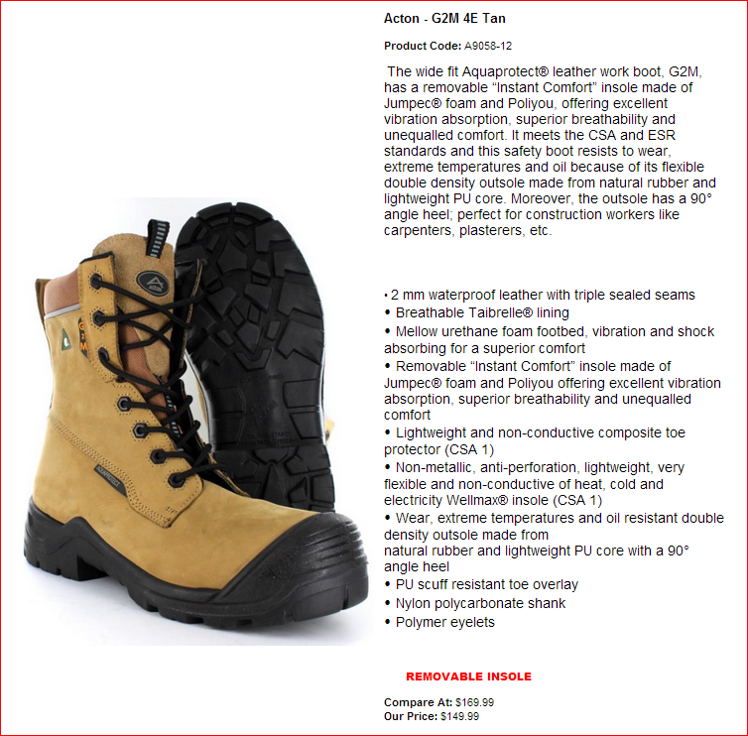

Work Boots #2

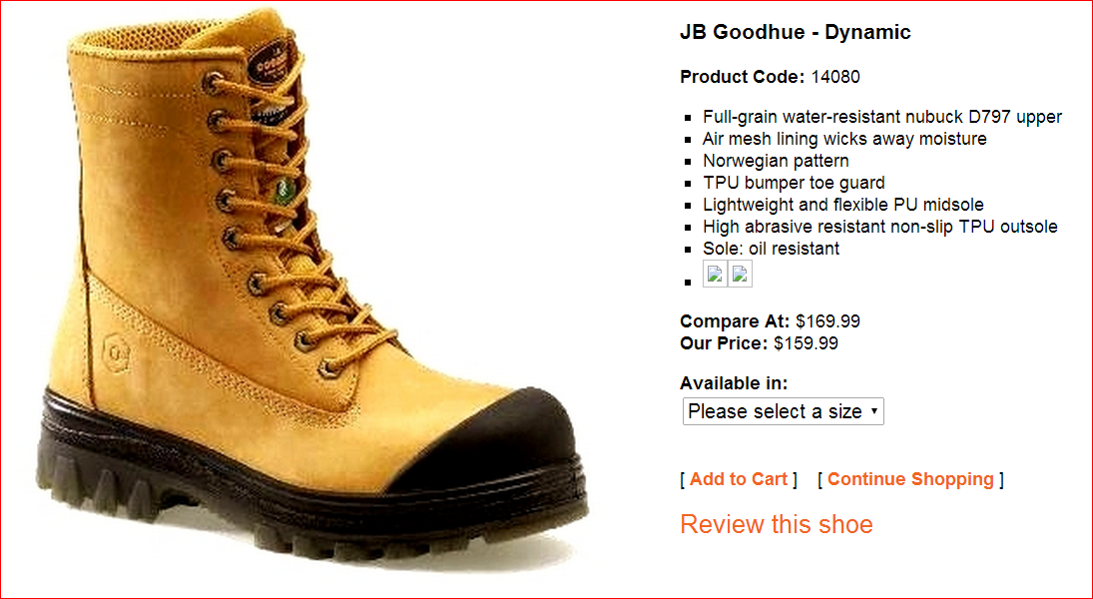

Work Boots #3

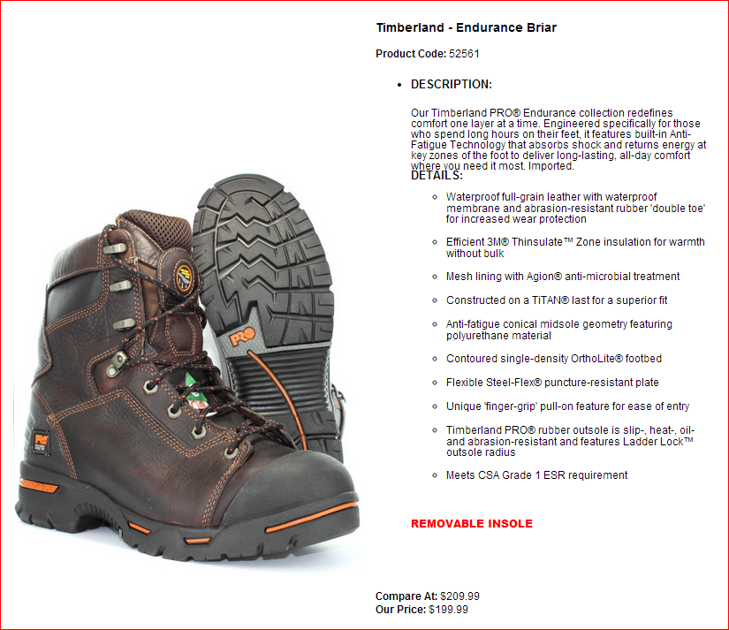

Work Sheet
Task 1: List the boots that are waterproof.
Answer:

______________________________________________________
Task 2: List the boots that have a removable insole.
Answer:

______________________________________________________
Task 3: List the boots that have a TPU bumper toe guard.
Answer:

______________________________________________________
Task 4: Calculate the total price for each pair of boots including sales tax (13%).
Answer:

______________________________________________________

Task 5: Calculate how much a customer would save if they purchase boot #1 instead of boot #3.
Answer:

______________________________________________________
Answers
Task 1: List the boots that are waterproof.
Answer: #1 and #3 OR Acton - 2GM 4E Tan and Timberland - Endurance Briar

Task 2: List the boots that have a removable insole.
Answer: #1 and #3 OR Acton - 2GM 4E Tan and Timberland - Endurance Briar

Task 3: List the boots that have a TPU bumper toe guard.
Answer: #2 OR JB Goodhue - Dynamic

Task 4: Calculate the total price for each pair of boots including sales tax (13%).
Answer:
#1: $149.99 x 0.13 = $19.50. $149.99 + $19.50 = $169.49 total
#2: $159.99 x 0.13 = $20.80. $159.99 + $20.80 = $180.79 total
#3: $199.99 x 0.13 = $26.00. $199.99 + $26.00 = $225.99 total

Task 5: Calculate how much a customer would save if they purchase boot #1 instead of boot #3.
Answer: $225.99 - $169.49 = $56.50 savings

Performance Descriptors
Levels | Performance Descriptors | Needs Work | Completes task with support from practitioner | Completes task independently
A1.2 | scans text to locate information
 | locates multiple pieces of information in simple texts
 | makes low-level inferences
 | makes connections between sentences and between paragraphs in a single text
 | reads more complex texts to locate a single piece of information
 | follows the main events of descriptive, narrative and informational texts
 | obtains information from detailed reading
 | begins to identify sources and evaluate information
C1.2 | calculates using numbers expressed as whole numbers, fractions, decimals, percentages and integers
 | calculates percentages
 | chooses and performs required operation(s); may make inferences to identify required operation(s)

Levels | Performance Descriptors | Needs Work | Completes task with support from practitioner | Completes task independently
 | selects appropriate steps to reach solution(s); represents costs and rates using monetary symbols, decimals and percentages
 | interprets, represents and converts amounts using whole numbers, decimals, percentages, ratios and simple common fractions (e.g. 1/2, 1/4)
 | uses strategies to check accuracy (e.g. estimating, using a calculator, repeating a calculation, using the reverse operation)

This task: Was successfully completed Needs to be tried again
Learner Comments:

Instructor (print): Learner (print):
__________________ _________________

