

Task Title: Purchase Furniture on a Budget

OALCF Cover Sheet – Practitioner Copy

Learner Name: __________________________________________
Date Started: ___________________________________________
Date Completed: _________________________________________

Goal Path: | Employment | Apprenticeship
Secondary School | Post Secondary | Independence
Successful Completion: Yes No

Task Description: The learner will use a price list from a second-hand store to purchase furniture for a family room within a predetermined budget.
Main Competency/Task Group/Level Indicator:
- Find and Use Information/Interpret documents/A2.1
- Communicate Ideas and Information/Complete and create documents/B3.1a
- Understand and Use Numbers/Manage money/C1.2

Materials Required:
- Pen/pencil and paper and/or digital device
- Calculator or digital device with calculator function (optional)

Learner Information
Purchasing furniture can take a lot of time, planning, and money.
Read the “Scenario” and the “Furniture List” from a local second-hand store (2 pages).

Scenario
The Talbot family has a $2,000 budget to furnish their entire family room. They cannot spend more than this amount.
The family has two adults, two children, one dog, and one bird.

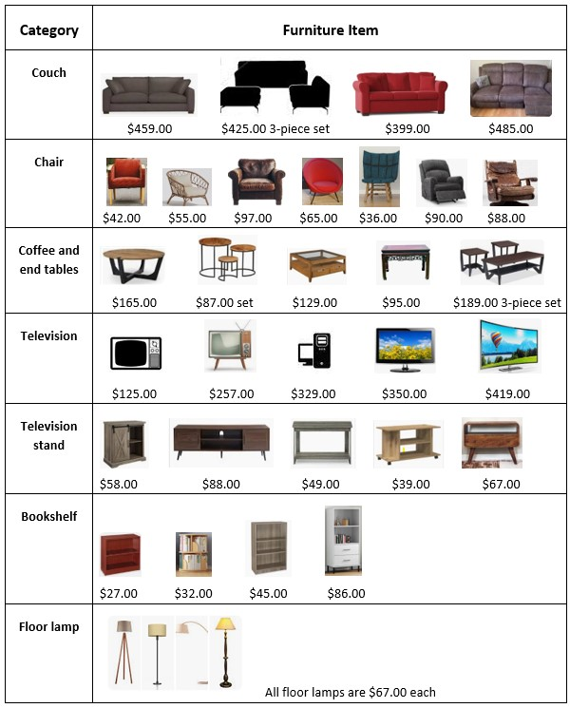
Furniture List
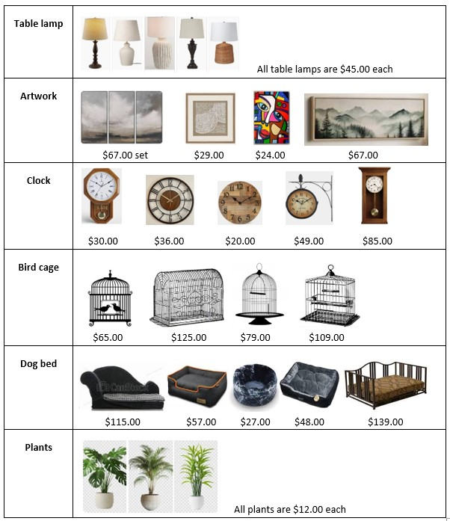
Work Sheet
Task 1: Without spending more than $2,000, choose at least one item from each category on the Furniture List to furnish the Talbot’s family room. Fill in the chart with the items you have chosen. Calculate the total cost with tax and delivery fee.
Answer:
Category | Furniture Item | Cost of Item | 13% Sales Tax | Total Cost of Item
Couch
Chair
Coffee and end tables
Television
Television Stand
Bookshelf
Floor lamp
Table lamp
Artwork
Clock
Bird cage
Dog bed
Plants
Delivery Fee |  |  |  | $75.00
Total Cost of Furniture with Tax and Delivery

Task 2: How much money do you have left from your $2,000 budget?
Answer:

______________________________________________________
Task 3: How much sales tax would you pay on the 3-piece couch set?
Answer:

______________________________________________________
Task 4: How much would three floor lamps cost with sales tax?
Answer:

______________________________________________________

Answers
Task 1: Without spending more than $2,000, choose at least one item from each category on the Furniture List to furnish the Talbot’s family room. Fill in the chart with the items you have chosen. Calculate the total cost with tax and delivery fee.
Answers will vary.

Task 2: How much money do you have left from your $2,000 budget?
Answers will vary.

Task 3: How much sales tax would you pay on the 3-piece couch set?
Answer: $425 x 0.13 = $55.25 tax

Task 4: How much would three floor lamps cost with sales tax?
Answer:
$67 x 3 = $201
$201 x 0.13 = $26.13
$201 + $26.13 = $227.13

Performance Descriptors
Levels | Performance Descriptors | Needs Work | Completes task with support from practitioner | Completes task independently
A2.1 | scans to locate specific details
 | interprets brief text and common symbols
 | locates specific details in simple documents, such as labels and signs
 | identifies how lists are organized (e.g. sequential, chronological, alphabetical)
B3.1a | makes a direct match between what is requested and what is entered
C1.2 | calculates using numbers expressed as whole numbers, fractions, decimals, percentages, and integers
 | calculates percentages
 | chooses and performs required operation(s); may make inferences to identify required operation(s)
 | selects appropriate steps to reach solutions
 | represents costs and rates using monetary symbols, decimals and percentages
 | uses strategies to check accuracy (e.g. estimating, using a calculator, repeating a calculation, using the reverse operation)

This task: Was successfully completed Needs to be tried again
Learner Comments:

Instructor (print): Learner (print):
__________________ _________________

