

Task Title: Using a POS (Point of Sale) Terminal

OALCF Cover Sheet – Practitioner Copy

Learner Name:
Date Started:
Date Completed:

Goal Path: | Employment | Apprenticeship
Secondary School | Post Secondary | Independence
Successful Completion: Yes No

Task Description: The learner reads a Point Of Sale (POS) terminal screen to answer questions about a restaurant.
Main Competency/Task Group/Level Indicator:
- Find and Use Information/Interpret documents/A2.2
- Understand and Use Numbers/Manage money/C1.1

Materials Required:
- Pen/pencil and paper and/or digital device

Learner Information

To work in the service industry, you may need to use a POS (sometimes called Point of Service or Point of Sale) terminal to serve your customers. This will help you take orders, send orders to the kitchen and help giving customers their bill.

Scan the document “POS (Point of Service).”

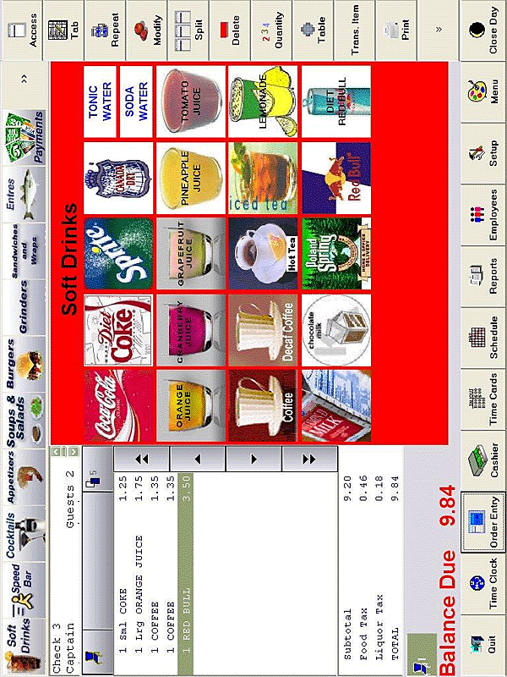
POS (Point of Service)

Work Sheet
Task 1: What three hot drinks can be served?
Answer:

______________________________________________________
Task 2: What are the names of the two taxes that are charged?
Answer:

______________________________________________________
Task 3: Circle, highlight or underline the subtotal of the bill.
Answer:

______________________________________________________
Task 4: A customer would like to order two coffees. How much will it cost?
Answer:

______________________________________________________
Task 5: What are three juices that can be served?
Answer:

______________________________________________________
Task 6: A customer is ready to pay their bill. Circle a button that will allow them to pay.
Answer:

______________________________________________________

Answers
Task 1: What three hot drinks can be served?
Answer: coffee, decaf coffee and hot tea.

Task 2: What are the names of the two taxes that are charged?
Answer: food tax and liquor tax.

Task 3: Circle, highlight or underline the subtotal of the bill.
Answer: $9.20

Task 4: A customer would like to order two coffees. How much will it cost?
Answer: $2.70

Task 5: What are three juices that can be served?
Answer: And three of: orange, cranberry, grapefruit, pineapple, tomato.

Task 6: A customer is ready to pay their bill. Circle a button that will allow them to pay.
Answer: Learner will circle the button marked “payments” or “cashier”.

Performance Descriptors
Levels | Performance Descriptors | Needs Work | Completes task with support from practitioner | Completes task independently
A2.2 | performs limited searches using one or two search criteria
 | extracts information from tables and forms
 | locates information in simple graphs and maps
 | uses layout to locate information
 | makes connections between parts of documents
 | makes low-level inferences
C1.1 | adds and subtracts whole numbers and decimals
 | understands numerical order
 | recognizes values in number and word format
 | identifies and performs required operation
 | follows apparent steps to reach solutions
 | interprets and represents costs using monetary symbols and decimals

This task: Was successfully completed Needs to be tried again
Learner Comments:

Instructor (print): Learner (print):
__________________ _________________

