

Task Title: Set Up an Email Account

OALCF Cover Sheet – Practitioner Copy

Learner Name:___________________________________________
Date Started:____________________________________________
Date Completed: _________________________________________

Goal Path: | Employment | Apprenticeship
Secondary School | Post Secondary | Independence
Successful Completion: Yes No

Task Description:
The learner will read instructions for setting up an email account, and answer questions.
Main Competency/Task Group/Level Indicator:
- Find and Use Information/Read continuous text/A1.2
Materials Required:
- Pen/pencil and paper or digital device

Learner Information
Having an email account is important for everyone including students, jobseekers, and people in the workplace.
Scan the article “Setting up a Free Email Account”.

Setting up a Free Email Account
In the world of job searching today it has become necessary to have an email account. Many employers will only accept resumes through email. If you don't have an email account you will have to create one. If you don't have a computer at home, you will have access to a computer at an employment centre where you will be able to create an email account and it's free.
Setting up a free email account is a straightforward process. There are many options available on the internet to do this. For this example, we will be using Gmail. Gmail is the email service provided by Google. Most people are familiar with Google even if they have not used it. It is a widely used search engine (a tool that helps you find information on the internet) that provides many services. Some of those services include storage for files, calendars for scheduling and email. Gmail is often preferred because it automatically filters spam or junk mail.
There are two ways to locate the website you are looking for:
#1
Go to the Google search engine and type in mail.google.com
Search the results for mail.google.com and select the correct site
This will take you to the page to sign in or create an account
#2
Type the exact address in the location bar at the top of the screen. http://mail.google.com
It will look similar to the picture below. This will take you directly to the website without having to determine the correct website as above.
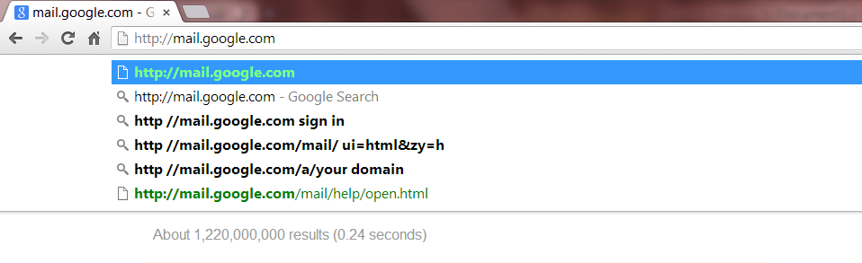
This will take you to the page to sign in or create an account.
Once you are at the website you will be asked for personal information to create an account. The information requested will include the following:
Your name: First name and last name.
User name: You may use letters, numbers or periods. You may not use any other symbols. Your user name is your online identity and is the first thing people will see when you send an email. For example, an email that says "lucygoosy@gmail.com" may not be appropriate. Some variation of your name may be appropriate. For example, your name may be Lesley so you might use LesterB99 or some other combination. If your username has already been taken don't be discouraged keep trying. Gmail has millions of account users.
Password: Choose a password that contains letters, numbers and symbols. Do not use birthdates, pet names or anything that is related to your personal information. Passwords that are simple for you to remember may be easily cracked by hackers. For Google mail you will need to use at least 8 characters which contain letters, numbers and symbols.
Confirm Password: Anytime you create an account you will be asked to confirm your password. The intent of this is to ensure that you have not made a mistake when typing. If the password does not match it will not let you proceed.
Birthday: This allows Google to provide you with age-appropriate settings and will not be displayed without your permission.
Gender: This is used to ensure the content you share has the appropriate term. For example, if you share a photo, it will include she/he if you have identified your gender. If you choose "other", it will be gender neutral. For example: It will say that Lester has shared a photo with you.
Prove you are not a robot: This field is for typing in the words that are displayed. This is a security protection for Google to ensure that you are an actual person creating an account. There are many automated programs out on the web searching to create fake accounts.
I agree to the Google Terms of Service and Privacy Policy: This is a check box that must be complete to set up your new account. If you click on the Terms of Service and Privacy Policy you will be able to read through them entirely.

Account Sign Up Form
Name
First |  | Last
Username
@gmail.com
Password
Confirm Password
Birthday
Month | Day |  | Year
Gender
Prove you are not a robot  Type the text |  | RYHL LERNA
Location
Country
□I agree to the Terms of Service and Privacy Policy

Work Sheet
Task 1: List the information Gmail will request when creating an email account.
Answer:

_____________________________________________________________
Task 2: What can you use for your passwords that you cannot use for your username?
Answer:

_____________________________________________________________
Task 3: Why is it important to confirm your password?
Answer:

_____________________________________________________________
Task 4: Why is it important to type in the words displayed in the section “Prove you are not a Robot”?
Answer:

_____________________________________________________________

Answers
Task 1: List the information Gmail will request when creating an email account.
Answer: Name, Username, Password, Birthday, Gender, Country (location)

Task 2: What can you use for your passwords that you cannot use for your username?
Answer:
You can use symbols for passwords but not for usernames.
For passwords - letters, numbers and symbols
For usernames - letters, numbers and periods

Task 3: Why is it important to confirm your password?
Answer: In case you make a mistake typing it in the first time, it will not let you proceed. If you thought you typed one thing in and had accidentally hit the key beside it you may not know it. Not knowing the correct password would prevent you from signing into your account in the future.

Task 4: Why is important to type in the words displayed in the section “Prove you are not a Robot”?
Answer: This lets Google know that you are a real person creating an account.

Performance Descriptors
Levels | Performance Descriptors | Needs Work | Completes task with support from practitioner | Completes task independently
A1.2 | scans text to locate information
 | locates multiple pieces of information in simple texts
 | makes low-level inferences
 | follows the main events of descriptive, narrative and informational texts
 | obtains information from detailed reading

This task: Was successfully completed Needs to be tried again
Learner Comments:

Instructor (print): Learner (print):
__________________ _________________

