

Task Title: Reading a Geocaching Brochure

OALCF Cover Sheet – Practitioner Copy

Learner Name: __________________________________________
Date Started: ___________________________________________
Date Completed: _________________________________________

Goal Path: | Employment | Apprenticeship
Secondary School | Post Secondary | Independence
Successful Completion: Yes No

Task Description: The learner will read a brochure about Geocaching and answer questions.
Main Competency/Task Group/Level Indicator:
- Find and Use Information/Read continuous text/A1.2
- Communicate Ideas and Information/Write continuous text/B2.2
Materials Required:
- Pen/pencil and paper and/or digital device

Learner Information
When choosing a new activity, it is often helpful to do research first.
Read the brochure “A Guide to Geocaching”.

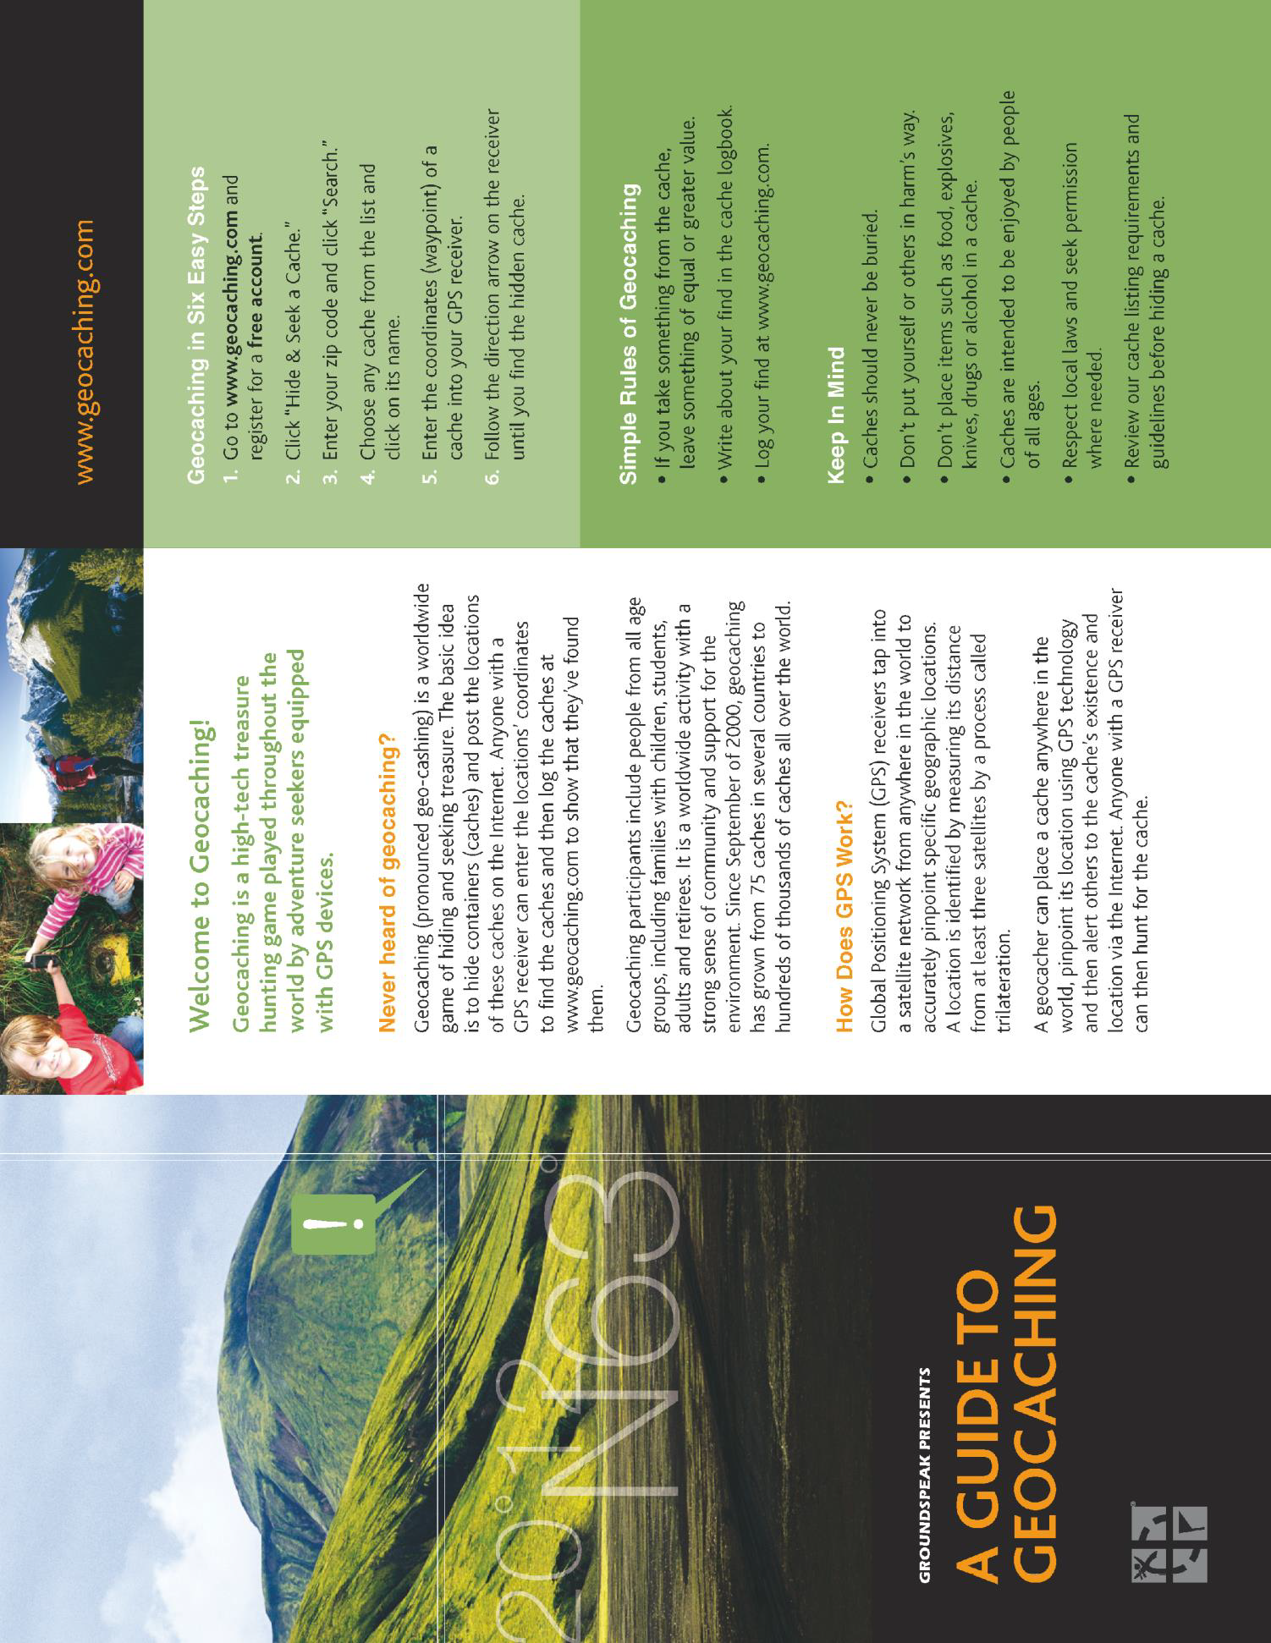
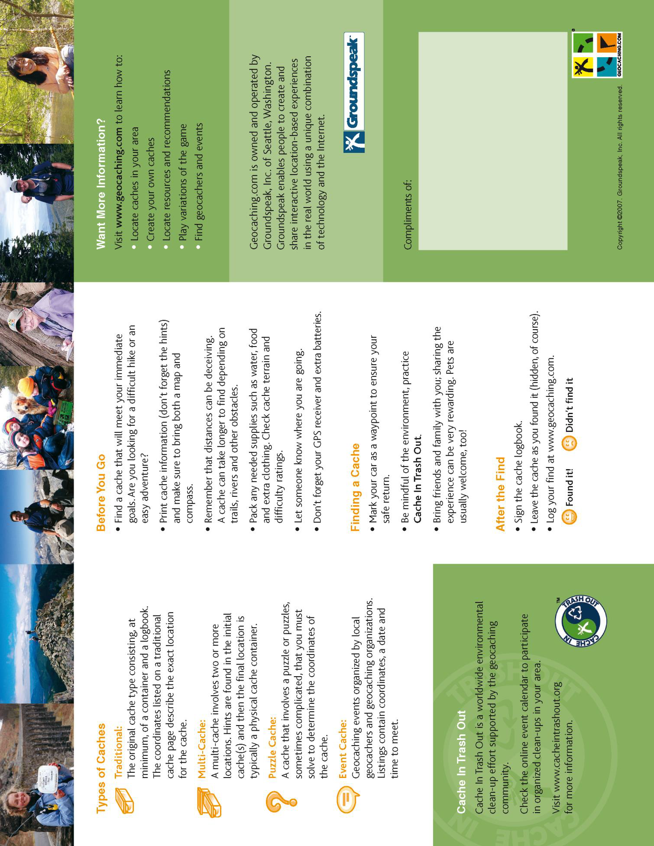

Work Sheet
Task 1: What is Geocaching?
Answer:

______________________________________________________
Task 2: What do the initials GPS stand for?
Answer:

______________________________________________________
Task 3: List the rules of Geocaching.
Answer:

______________________________________________________
Task 4: Who can be a Geocacher?
Answer:

______________________________________________________
Task 5: What is trilateration?
Answer:

______________________________________________________
Task 6: Name two ways a Geocacher could use a GPS.
Answer:

______________________________________________________
Task 7: Why would it be important to let someone else know where you are going when Geocaching?
Answer:

______________________________________________________
Task 8: In your opinion, what are some benefits of Geocaching? Describe two or three benefits in at least three sentences.
Answer:

______________________________________________________

Answers
Task 1: What is Geocaching?
Answer: Geocaching is a high-tech treasure hunting game played throughout the world by adventure seekers equipped with GPS devices.
Task 2: What do the initials GPS stand for?
Answer: Global Positioning System
Task 3: List the rules of Geocaching.
Answer:
• If you take something from the cache, leave something of equal or greater value
• Write about your find in the cache logbook
• Log your find at www.geocaching.com

Task 4: Who can be a Geocacher?
Answer: Geocaching participants include people from all age groups, including families with children, students, adults and retirees.
Task 5: What is trilateration?
Answer: When a location is identified by measuring its distance from at least three satellites.
Task 6: Name two ways a Geocacher could use a GPS.
Answer: Any two of
- Enter the geocaches coordinates to find or hunt for the cache
- Enter the geocache coordinates when you are hiding a cache
- For marking your car as a waypoint

Task 7: Why would it be important to let someone else know where you are going when Geocaching?
Answer: Answers will vary, but they should be about safety.

Task 8: In your opinion, what are some benefits of Geocaching? Describe two or three benefits in at least three sentences.
Answers will vary, but may include
- A sense of community and belonging with other people who participate
- Opportunity to socialize and try something new
- Exercise and outdoor time
- Opportunity to explore new places
- Opportunity to learn about now to navigate with a GPS

Performance Descriptors
Levels | Performance Descriptors | Needs Work | Completes task with support from practitioner | Completes task independently
A1.2 | scans text to locate information
 | locates multiple pieces of information in simple texts
 | makes low-level inferences
 | makes connections between sentences and between paragraphs in a single text
 | reads more complex texts to locate a single piece of information
 | follows the main events of descriptive, narrative and informational texts
 | obtains information from detailed reading
B2.2 | writes texts to explain and describe

begins to sequence writing with some attention to
principles (e.g. time, importance)
 | uses limited range of vocabulary and punctuation appropriate to the task
 | begins to select words and tone appropriate to the task
B2.2 cont’d | begins to organize writing to communicate effectively

This task: Was successfully completed Needs to be tried again
Learner Comments:

Instructor (print): Learner (print):
__________________ _________________

