

Task Title: Medicine Label

OALCF Cover Sheet – Practitioner Copy

Learner Name: __________________________________________
Date Started: ___________________________________________
Date Completed: _________________________________________

Goal Path: | Employment | Apprenticeship
Secondary School | Post Secondary | Independence
Successful Completion: Yes No

Task Description: Read a medicine label and interpret directions and correct dosage.
Main Competency/Task Group/Level Indicator:
- Find and Use Information/Interpret documents/A2.2
- Understand and Use Numbers/Manage time/C2.1
- Understand and Use Numbers/Use measures/C3.1
Materials Required:
- Pen/pencil and paper and/or digital device
- Calculator or digital device with calculator function (optional)

Learner Information
Many people need to accurately read and dispense medication for their work and in their daily lives.

Scan the “Adult Robitussin” cough medicine label.

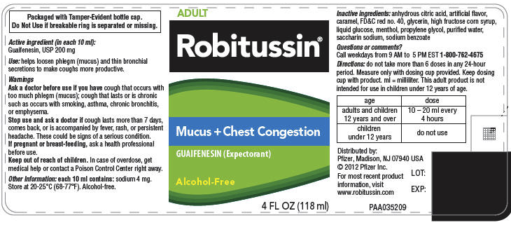

Work Sheet
Task 1: What is this medication used for?
Answer:

______________________________________________________
Task 2: When should someone see a doctor or seek advice from a healthcare professional?
Answer:

______________________________________________________
Task 3: At what temperature should this medicine be stored?
Answer:

______________________________________________________
Task 4: What is the maximum dosage for an adult in a 24-hour period?
Answer:

______________________________________________________
Task 5: What is the maximum dosage for a child under 12 in a 24-hour period?
Answer:

______________________________________________________
Task 6: If you give someone a dose of this medication at 10:30am, what is the earliest time you can give another dose? Assume the person has not yet reached the maximum dosage within a 24-hour period.
Answer:

______________________________________________________

Answers
Task 1: What is this medication used for?
Answer: “helps loosen phlegm (mucus) and thin bronchial secretions to make coughs more productive” or “mucus + chest congestion” or “expectorant”.
Task 2: When should someone see a doctor or seek advice from a healthcare professional?
Answer: If the cough lasts more than 7 days, comes back, or is accompanied by fever, rash, or persistent headache. If pregnant or breast-feeding, ask a healthcare professional before use.
Task 3: At what temperature should this medicine be stored?
Answer: 20-25 degrees Celsius (68-77 degrees Farenheit)
Task 4: What is the maximum dosage for an adult in a 24-hour period?
Answer: Maximum 6 doses in a 24-hour period. An adult dose is 10-20mL every 4 hours = 60-120mL maximum (6 doses over a 24-hour period).
Task 5: What is the maximum dosage for a child under 12 in a 24-hour period?
Answer: Zero. This medication is not suitable for children under 12.
Task 6: If you give someone a dose of this medication at 10:30am, what is the earliest time you can give another dose? Assume the person has not yet reached the maximum dosage within a 24-hour period.
Answer: 2:30pm

Performance Descriptors
Levels | Performance Descriptors | Needs Work | Completes task with support from practitioner | Completes task independently
A2.2 | extracts information from tables and forms
 | uses layout to locate information
 | makes connections between parts of documents
 | makes low-level inferences
C2.1 | adds, subtracts, multiplies, and divides whole number and decimals
 | recognizes values in number and word format
 | interprets and represents time using whole numbers, decimals (e.g. .25, .5) and simple common fractions (e.g. ½, ¼ hour)
 | identifies and performs required operation
C3.1 | adds and subtracts whole number measurements
 | interprets and represents measures using whole numbers, decimals and simple, common fractions (e.g. ½, ¼)
 | interprets and represents measures using symbols and abbreviations
 | follows apparent steps to reach solutions

This task: Was successfully completed Needs to be tried again
Learner Comments:

Instructor (print): Learner (print):
__________________ _________________

