

Task Title: Interpret Documents to Find Electrical Information

OALCF Cover Sheet – Practitioner Copy

Learner Name: __________________________________________
Date Started: ___________________________________________
Date Completed: _________________________________________

Goal Path: | Employment | Apprenticeship
Secondary School | Post Secondary | Independence
Successful Completion: Yes No

Task Description: Learner will interpret diagrams and read tables that are commonly used by electricians to plan their work.
Main Competency/Task Group/Level Indicator:
- Find and Use Information/Interpret documents/A2.2
Materials Required:
- Pen/pencil and paper and/or digital device

Learner Information
Electricians interpret diagrams and read tables to plan work and complete tasks.

Scan the “Hot Water Tank Label”, “Electrical Schematic”, and “Cable Chart”.

Hot Water Tank Label
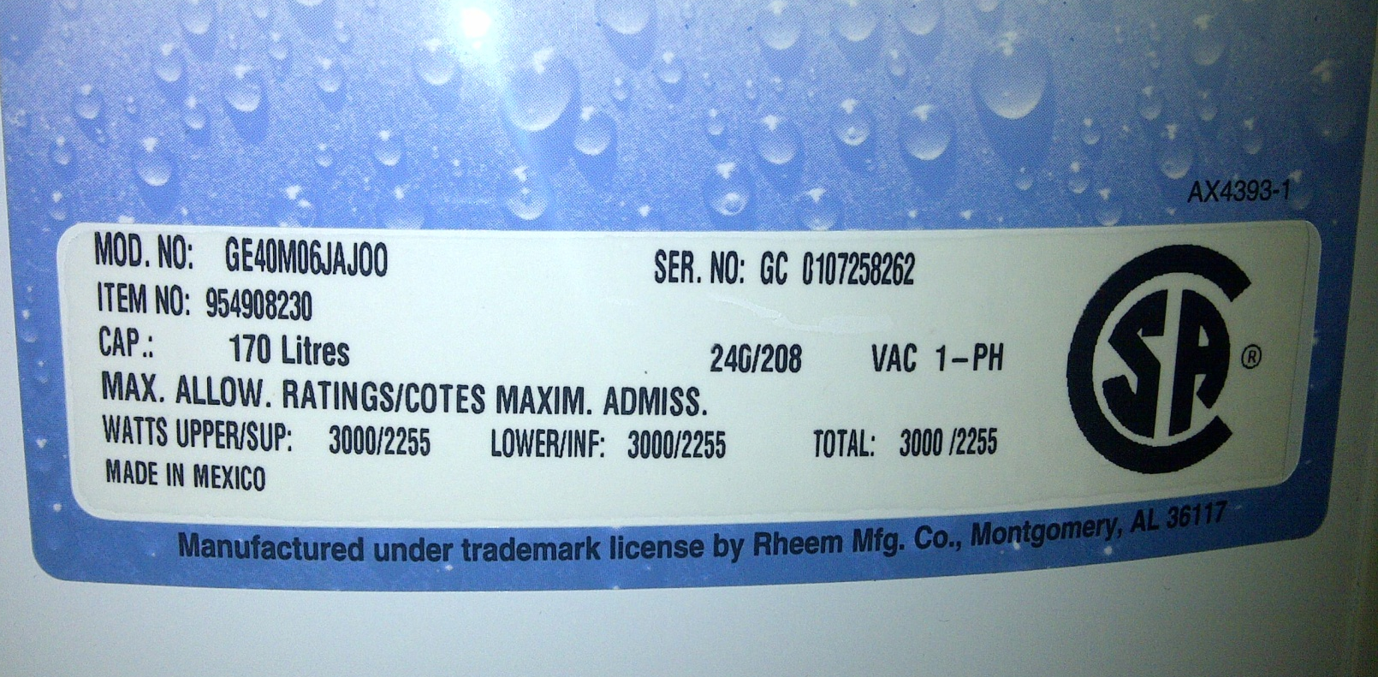
Electrical Schematic
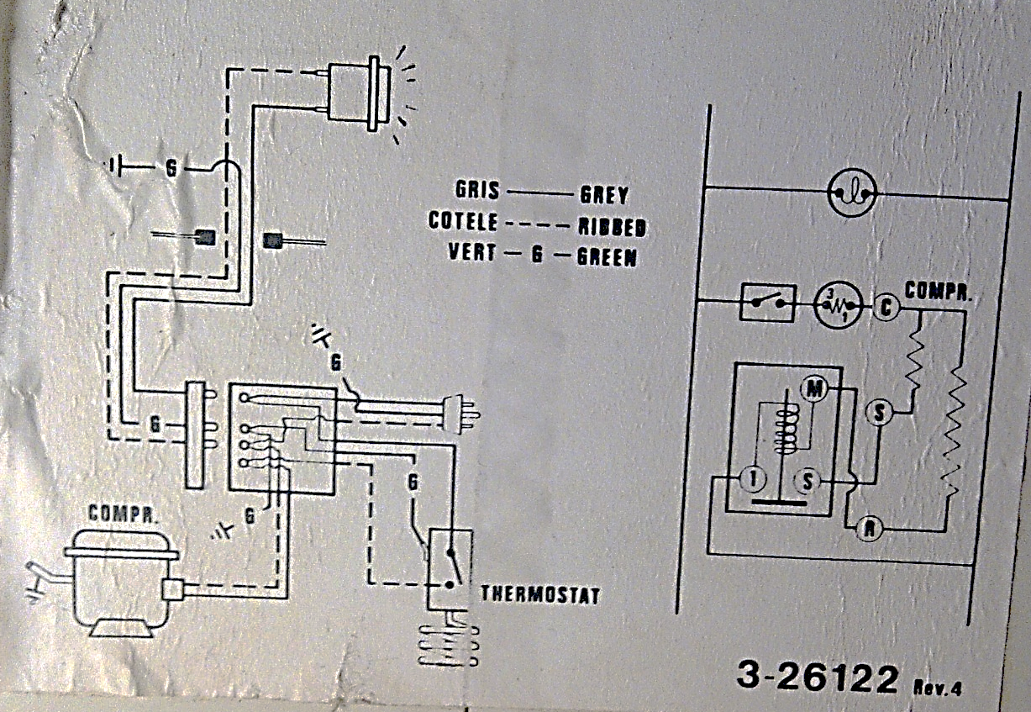
Cable Chart
Code | No. of Wires | Uses
#14-2 | 2 w/gnd | general lighting and receptacles
#14-3 | 3 w/gnd | 3-way switches, split receptacles
#12-2 | 2 w/gnd | kitchen and bath circuits
#12-3 | 3 w/gnd | 3-way switches on 20 amp services
#10-3 | 3 w/gnd | Dryers, cook top ovens
#4 |  | 70 amp services, 100 amp neutral conductor
#2 |  | main conductor for 100 amp services

Code: Gauge – number of wires. For example, #14-2 means 2 14 gauge wires.
Note: w/gnd means ‘with ground wire’. In these cases, the ground wire is not included in the wire count

Work Sheet
Task 1: Circle, underline, or highlight the upper allowable wattage rating on the Hot Water Tank Label. If you are doing this task online, write the answer below.
Answer:

______________________________________________________
Task 2: On the Electrical Schematic, how many wires are required for the thermostat to function?
Answer:

______________________________________________________
Task 3: Use the Cable Chart to determine the minimum requirements. Identify the cable by its code.
- The cable to supply a dryer.
Answer:

- The cable to provide 100 amp service to a home.
Answer:

c) The 3-wire cable that is required to connect 2 switches (one on main floor and the other on the second) to a light over the stairs.
Answer:
______________________________________________________

Answers
Task 1: Circle, underline, or highlight the upper allowable wattage rating on the Hot Water Tank Label. If you are doing this task online, write the answer below.
Answer: 3000/2225

Task 2: On the Electrical Schematic, how many wires are required for the thermostat to function?
Answer: 3

Task 3: Use the Cable Chart to determine the minimum requirements. Identify the cable by its code.
a) The cable to supply a dryer.
Answer: #10-3
b) The cable to provide 100 amp service to a home.
Answer: #2
c) The 3-wire cable that is required to connect 2 switches (one on main floor and the other on the second) to a light over the stairs.
Answer: #14-3

Performance Descriptors
Levels | Performance Descriptors | Needs Work | Completes task with support from practitioner | Completes task independently
A2.2 | performs limited searches using one or two search criteria
 | extracts information from tables and forms
 | uses layout to locate information
 | makes low-level inferences

This task: Was successfully completed Needs to be tried again
Learner Comments:

Instructor (print): Learner (print):
__________________ _________________

