

Task Title: Grocery Store Job Application

OALCF Cover Sheet – Practitioner Copy

Learner Name: __________________________________________
Date Started: ___________________________________________
Date Completed: _________________________________________

Goal Path: | Employment | Apprenticeship
Secondary School | Post Secondary | Independence
Successful Completion: Yes No

Task Description: The learner will enter basic information into a job application form.
Main Competency/Task Group/Level Indicator:
- Find and Use Information/Interpret documents/A2.2
- Communicate Ideas and Information/Complete and create documents/B3.1a
Materials Required:
- Pen/pencil and/or digital device

Learner Information
Many companies ask prospective employees to fill out a job application. For stores with multiple shifts or departments, people may be asked to select times they are available for work or departments that interest them.
Scan the “Zehrs Application Form”.

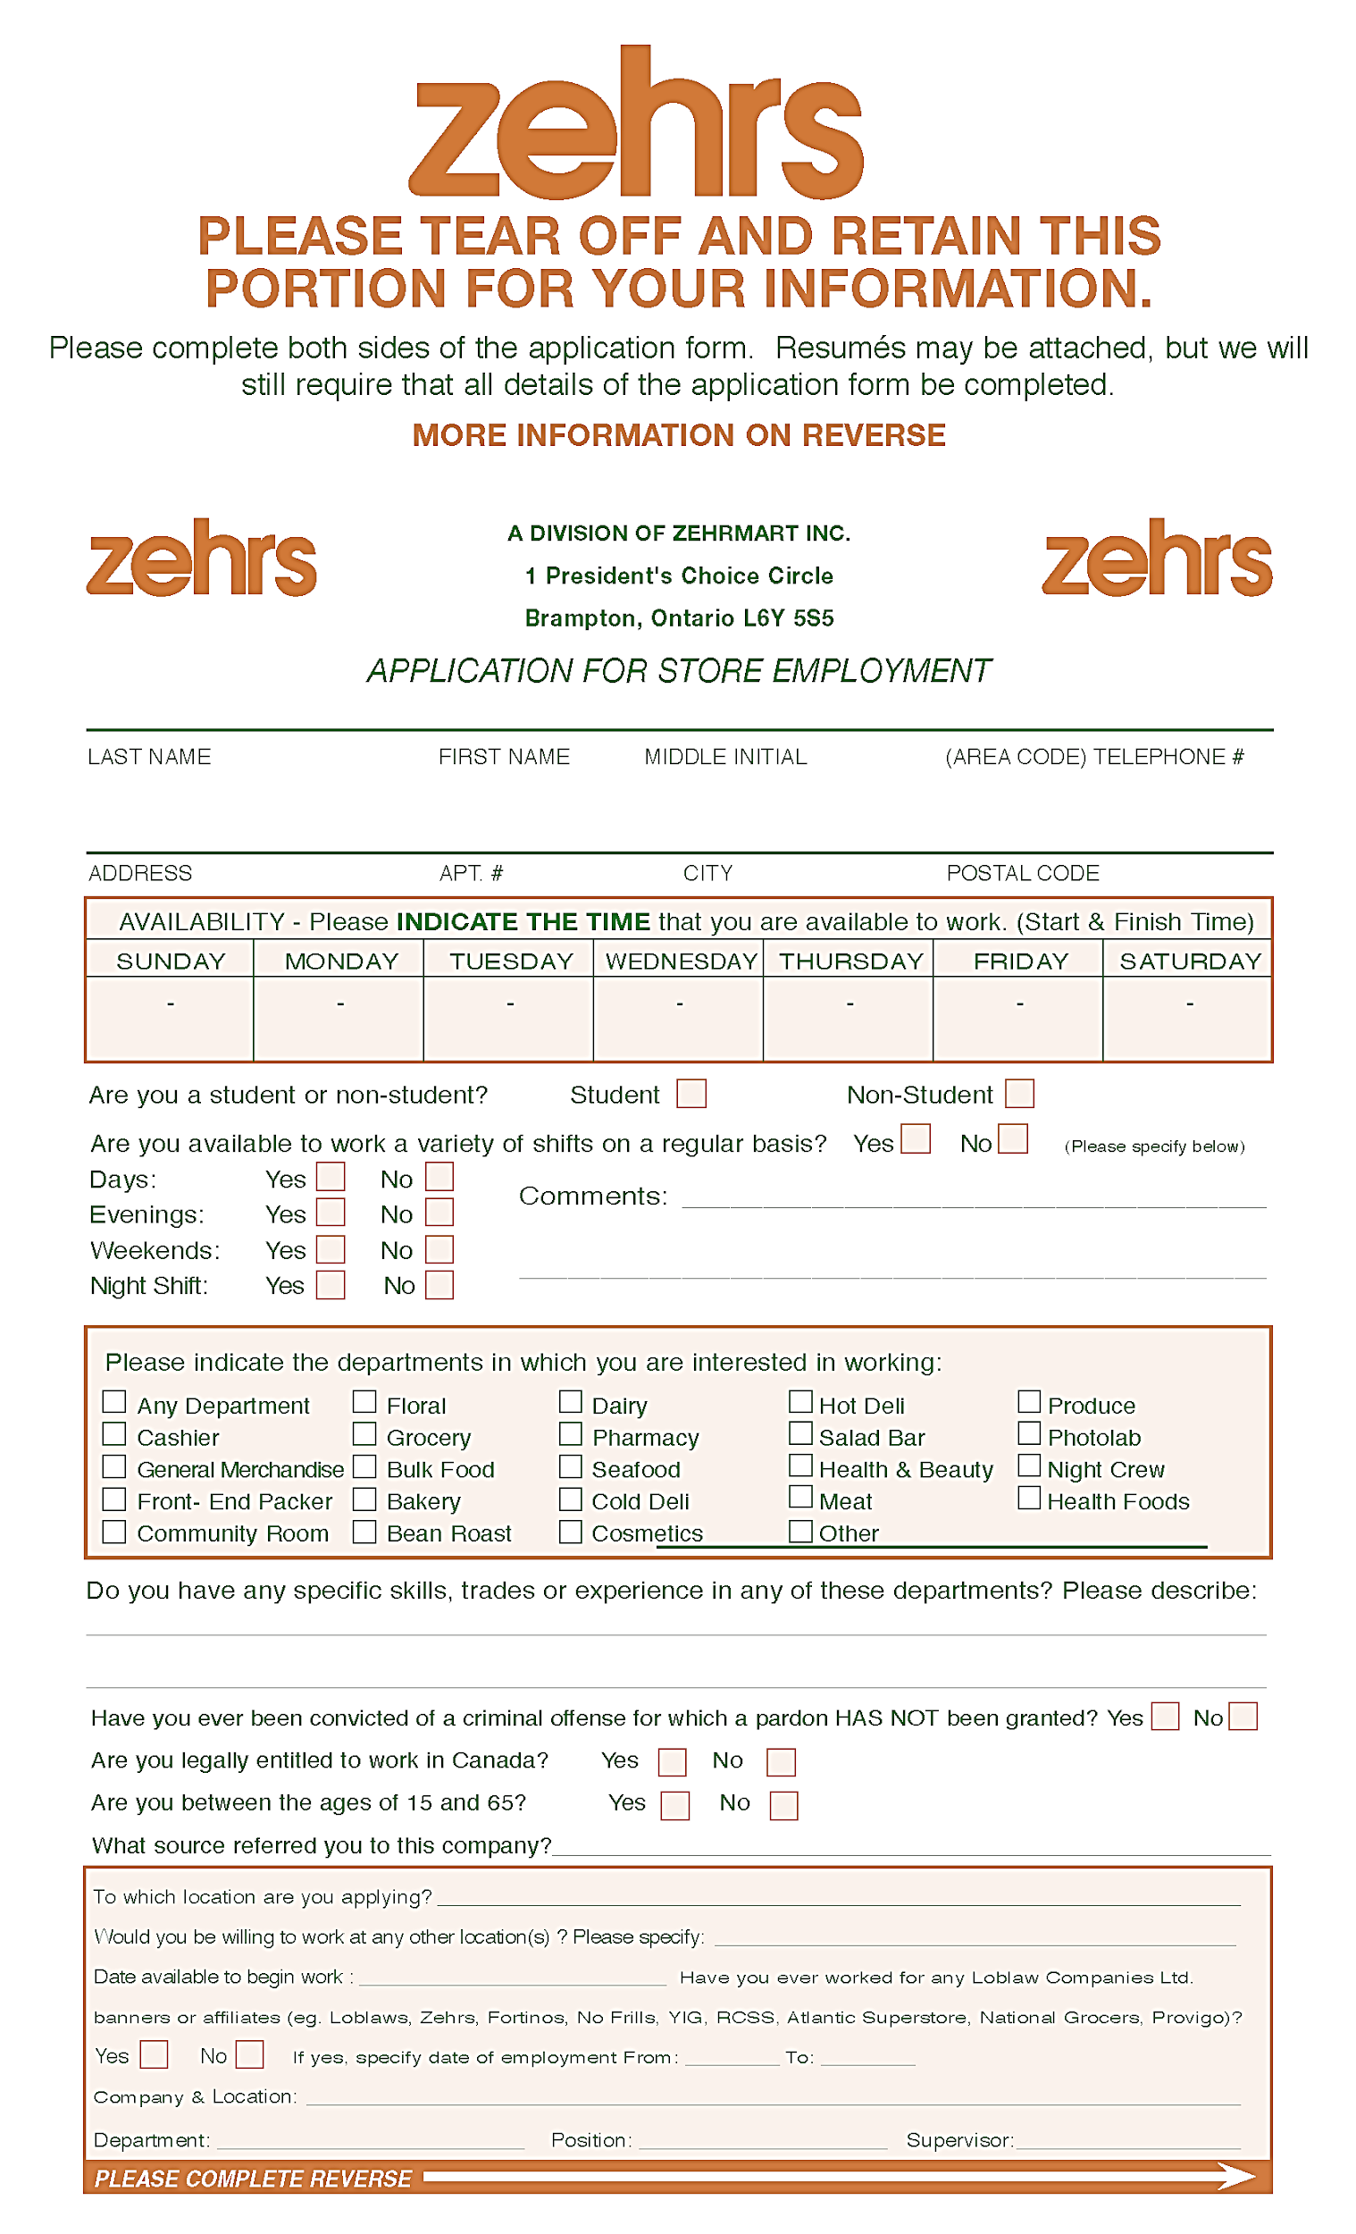

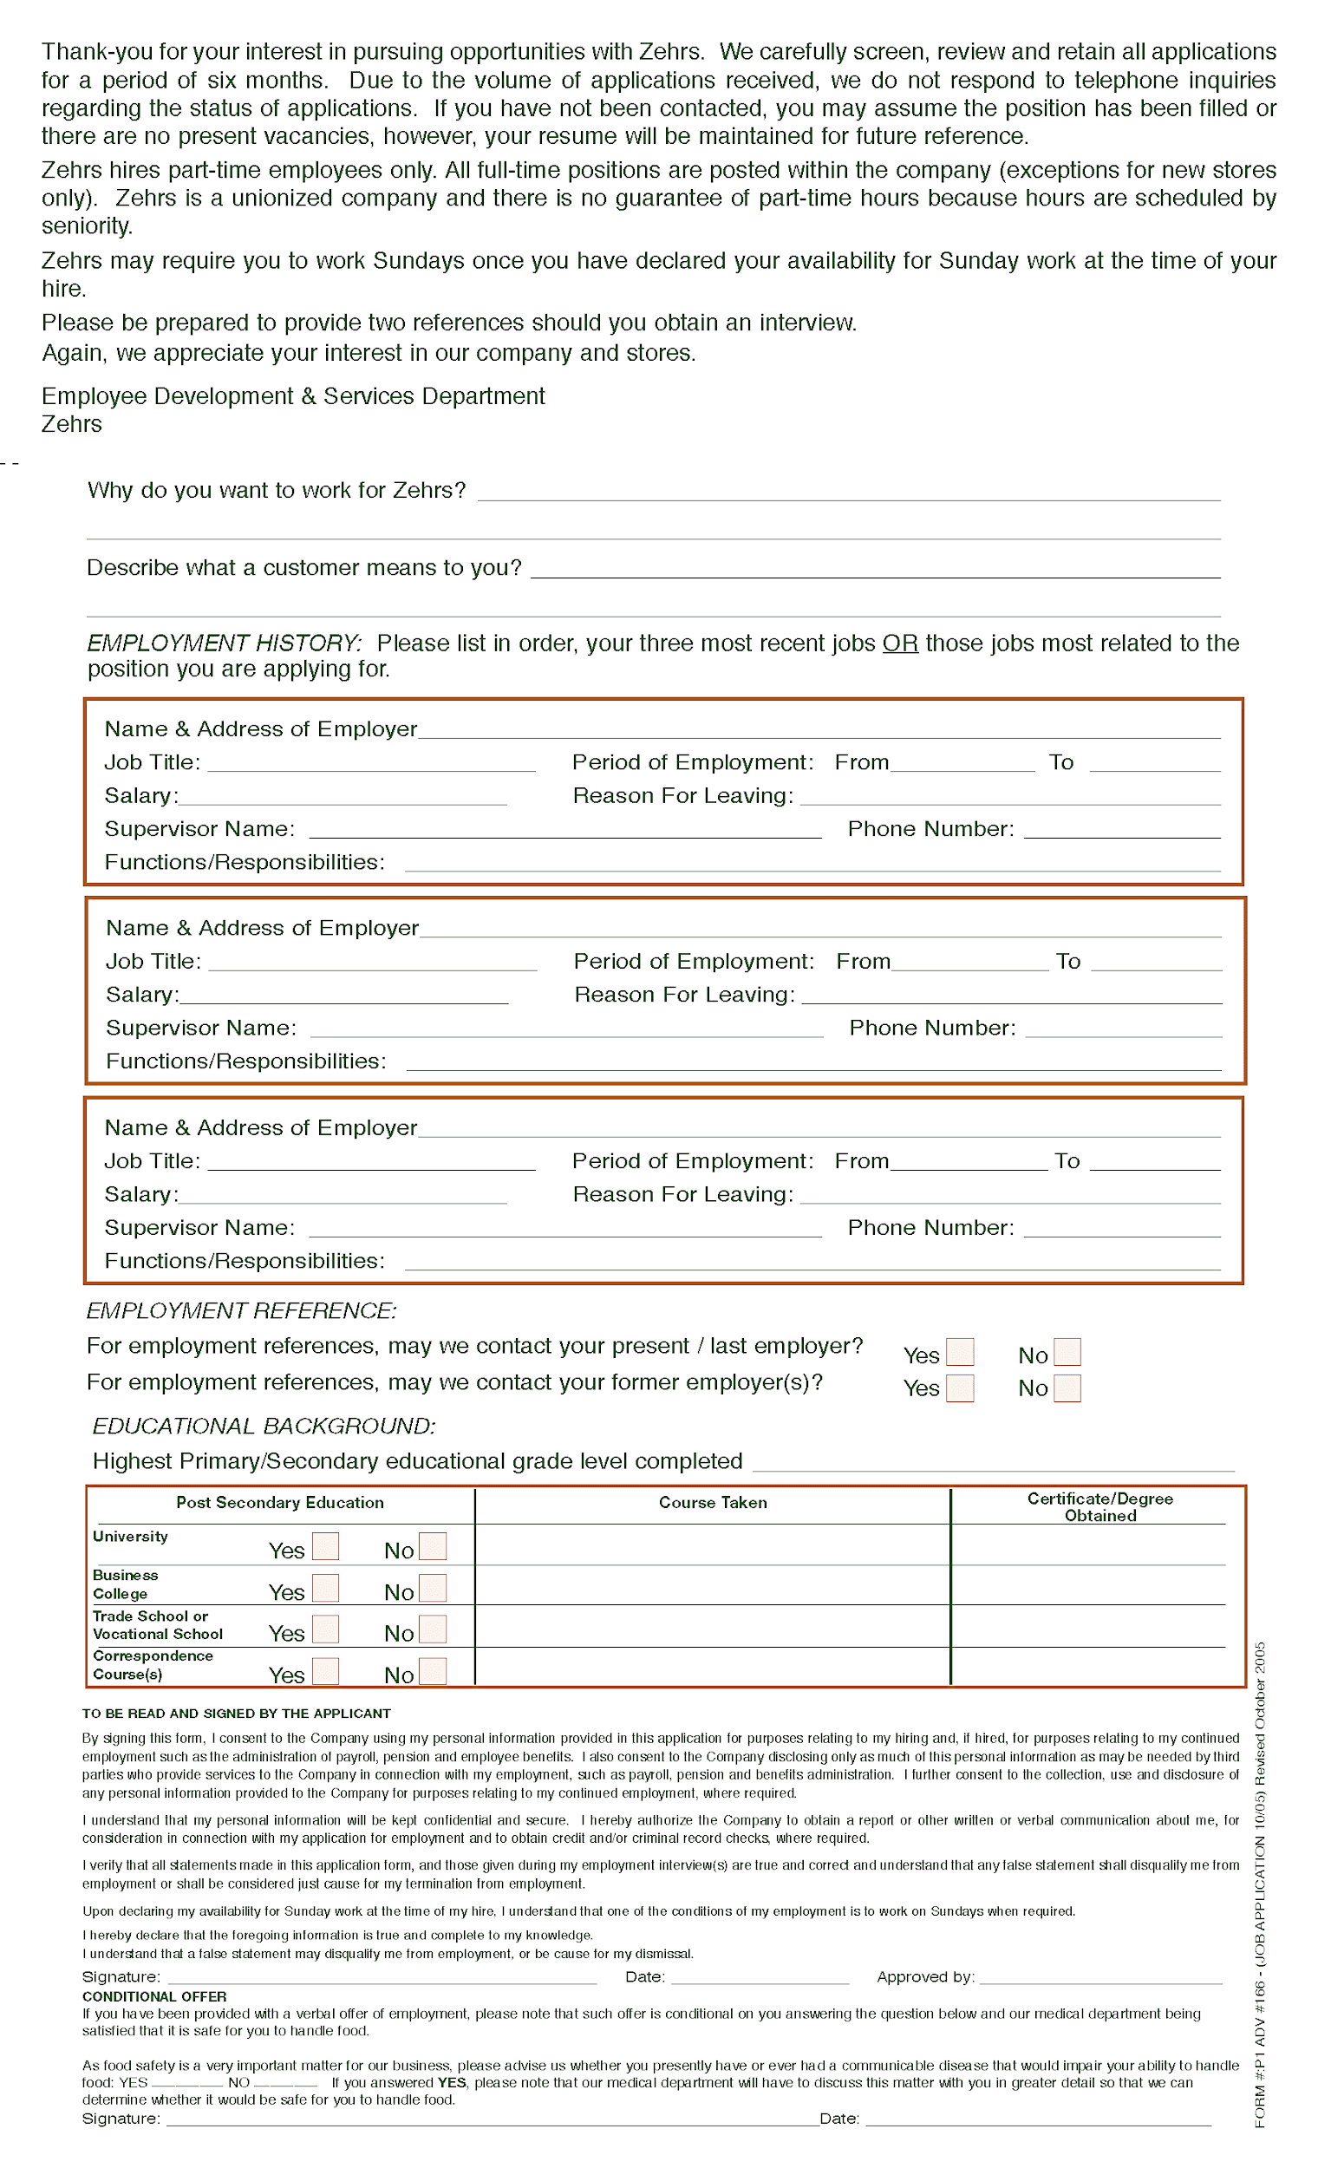

Work Sheet
Task 1: Fill out the following sections of the application form using your own information, availability and preferences:
- Name, phone number and address
- Shift availability
- Departments of interest (select at least two)
- Previous experience
- Educational background

If you are uncomfortable using your own information, fill out the application form using the following information:
- Andrea Thompson, 519-555-1234, 246 Main Street Goderich Ontario N2Z 121
- Available to work: Saturday and Sunday 8am-5pm
- Not available to work a variety of shifts
- Interested in: Seafood, cold deli, meat
- Previous work experience at a local coffee shop preparing food and serving customers
- High School completion (OSSD) in 2023

Answer: No written response required here.

Task completed: Yes:

Answers
Answers will vary. Ensure the learner has correctly entered their information into the appropriate sections of the application form.

Performance Descriptors
Levels | Performance Descriptors | Needs Work | Completes task with support from practitioner | Completes task independently
A2.2 | Uses layout to locate information
 | Makes connections between parts of documents
 | Makes low-level inferences
B3.1a | Makes a direct match between what is requested and what is entered
 | Makes entries using familiar vocabulary

This task: Was successfully completed Needs to be tried again
Learner Comments:

Instructor (print): Learner (print):
__________________ _________________

