

Task Title: Employment Workshop Calendar

OALCF Cover Sheet – Practitioner Copy

Learner Name: __________________________________________
Date Started: ___________________________________________
Date Completed: _________________________________________

Goal Path: | Employment | Apprenticeship
Secondary School | Post Secondary | Independence
Successful Completion: Yes No

Task Description: In this task, a learner is asked to respond to questions relating to a workshop calendar from an Employment Services organization.
Main Competency/Task Group/Level Indicator:
- Find and Use Information/Read continuous text/A1.2
- Find and Use Information/Interpret documents/A2.2
Materials Required:
- Pen/pencil and paper and/or digital device

Learner Information

When searching for a job, or looking at courses related to your hobbies or interests, you may need to review workshop calendars to find the best options.

Scan the “Career Solutions Monthly Calendar for March 2025”.

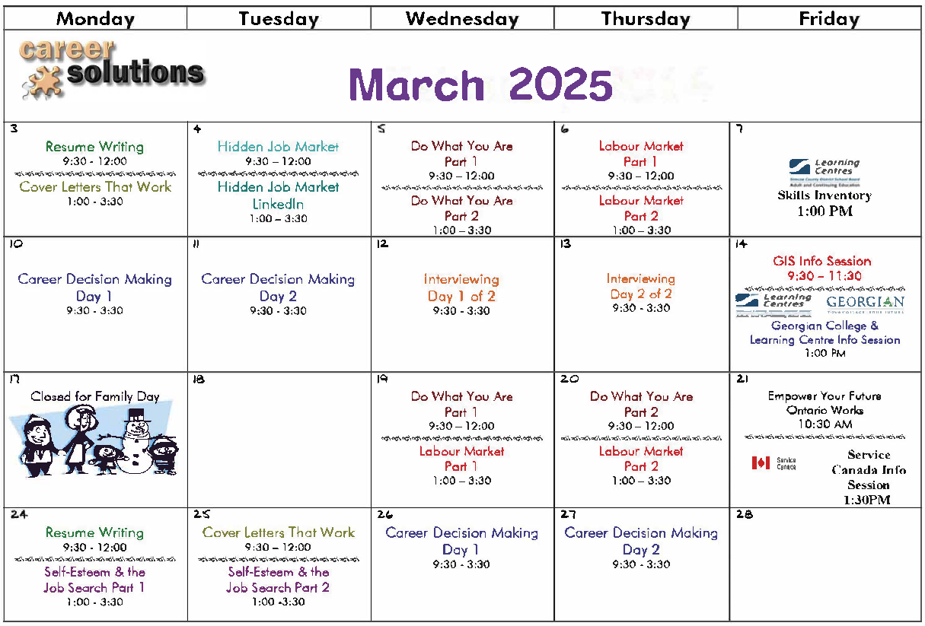

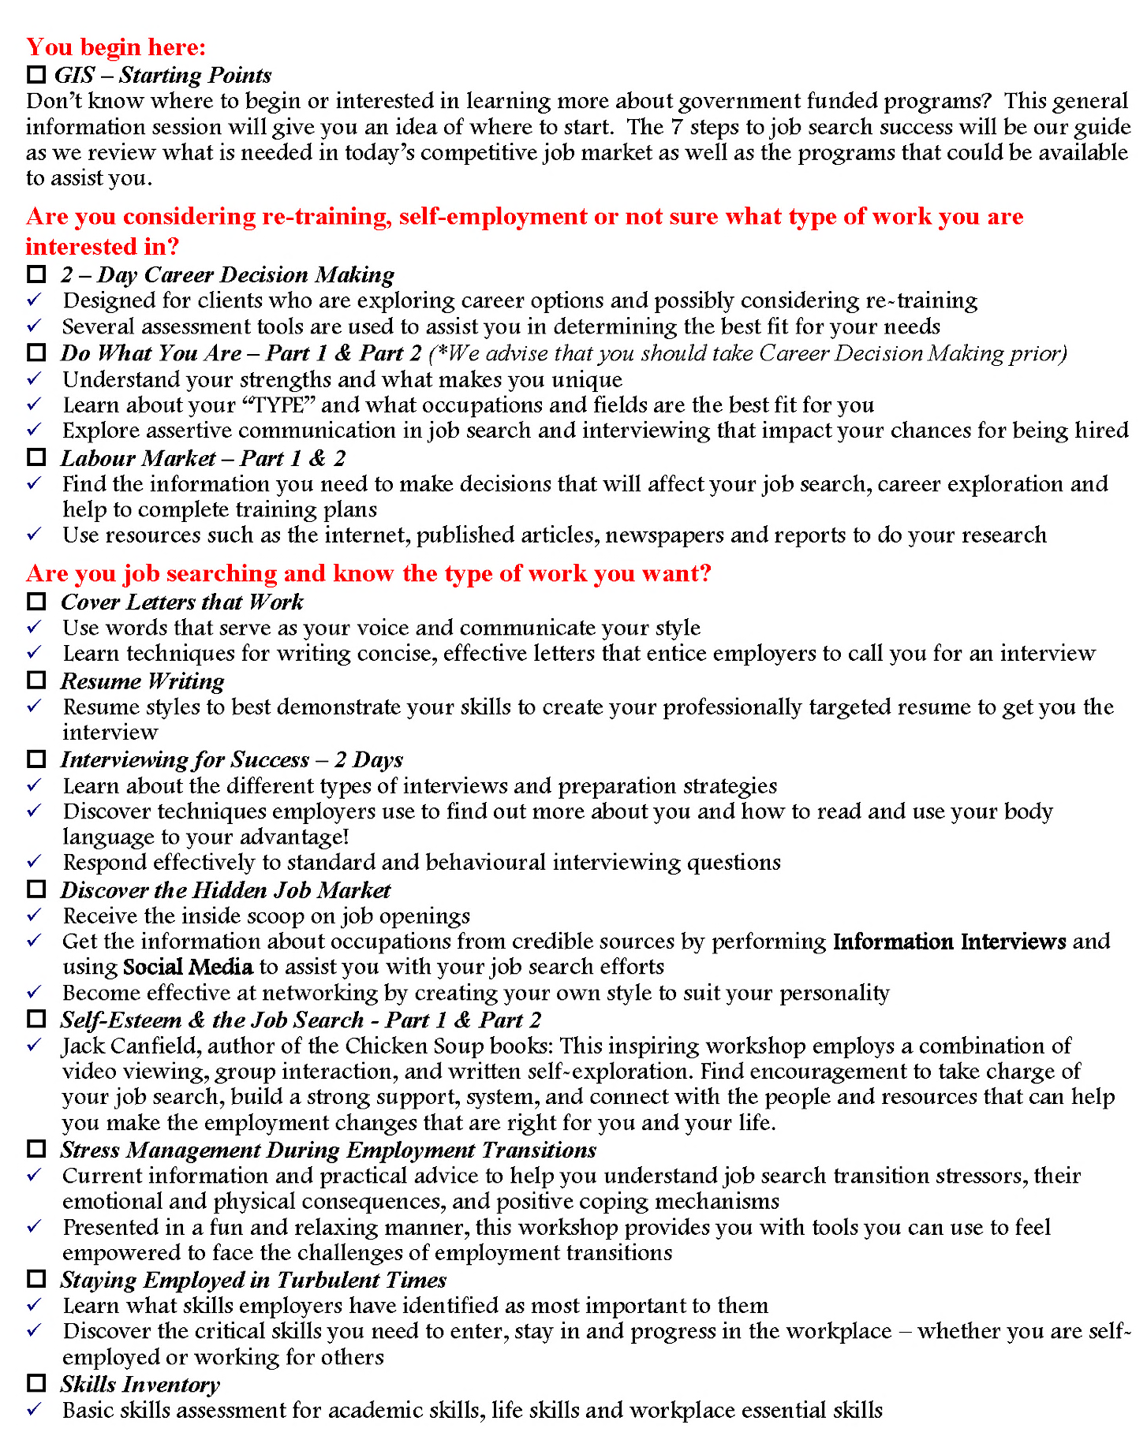

Work Sheet
Task 1: What is the month on the calendar?
Answer:

______________________________________________________
Task 2: What dates are the resume writing workshops offered?
Answer:

______________________________________________________
Task 3: List two of the two-part workshops.
Answer:

______________________________________________________
Task 4: What employment-related topics are two full-day workshops?
Answer:

______________________________________________________

Task 5: Which two-part workshop promotes finding a job that reflects your personal interests?
Answer:

______________________________________________________
Answers
Task 1: What is the month on the calendar?
Answer: March.

Task 2: What dates are the resume writing workshops offered?
Answer: March 3 and March 24.

Task 3: List two of the two-part workshops.
Answer: Any two of:
- Do What You Are
- Labour Market
- Self-Esteem and the Job Search

Task 4: What employment-related topics are two full-day workshops?
Answer: Career Decision Making and Interviewing

Task 5: Which two-part workshop promotes finding a job that reflects your personal interests?
Answer: Do What You Are

Performance Descriptors
Levels | Performance Descriptors | Needs Work | Completes task with support from practitioner | Completes task independently
A1.2 | scans text to locate information
 | locates multiple pieces of information in simple texts
 | reads more complex texts to locate a single piece of information
A2.2 | extracts information from tables and forms
 | uses layout to locate information

This task: Was successfully completed Needs to be tried again
Learner Comments:

Instructor (print): Learner (print):
__________________ _________________

