

Task Title: Dealing with Customer Complaints

OALCF Cover Sheet – Practitioner Copy

Learner Name:___________________________________________
Date Started (m/d/yyyy):__________________________________
Date Completed (m/d/yyyy): _______________________________
Successful Completion: Yes ☐ No ☐
Goal Path: | Employment ☒ | Apprenticeship ☐
Secondary School ☐ | Post Secondary ☐ | Independence ☐

Task Description: Read a staff checklist to understand how to deal with client complaints.
Main Competency / Task Group/ Level Indicator:
- Find and Use Information/Read continuous text/A1.2

Performance Descriptors: See chart on last page
Materials Required:
- Pen/pencil or digital device

Learner Information
In many workplaces employees must deal with customer complaints.
Scan the “Dealing with complaints – checklist for staff.”
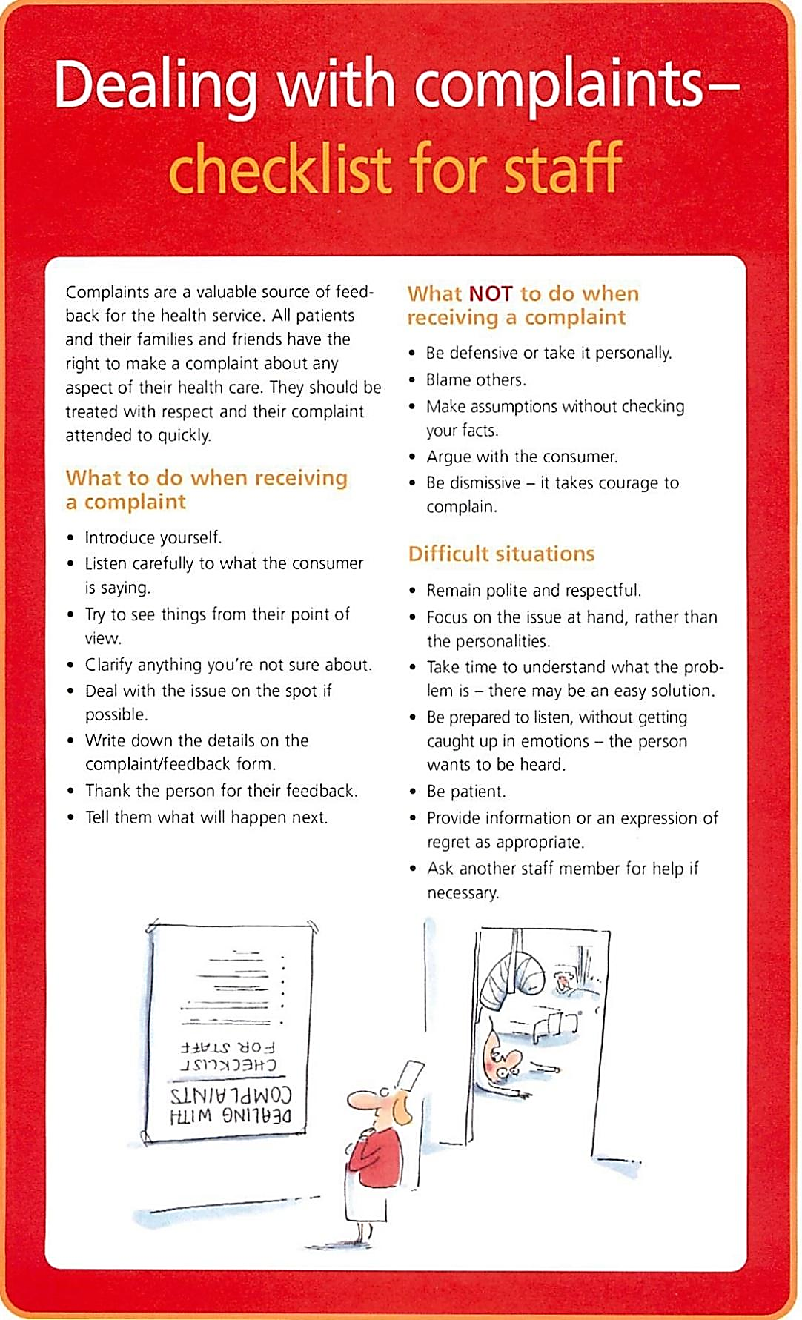

Work Sheet
Task 1: What are the three main categories for dealing with
customer complaints?
Answer:

____________________________________________________________
Task 2: Who has the right to make a complaint about any aspect
of health care at this facility?
Answer:

_____________________________________________________________
Task 3: What are three things employees must NOT do when
receiving a complaint?
Answer:

_____________________________________________________________
Task 4: When an employee encounters a difficult situation, why is
it important to take time to understand what the problem
is?
Answer:

_____________________________________________________________
Task 5: Where should an employee write down the details of the
complaint?
Answer:

_____________________________________________________________

Answers
Task 1: What are the three main categories for dealing with customer complaints?
Answer: The three categories are:
- What to do when receiving a complaint
- What NOT to do when receiving a complaint
- Difficult situations

Task 2: Who has the right to make a complaint about any aspect
of health care at this facility?
Answer: All patients and their families and friends have the right
to make a complaint about any aspect of their health
care.

Task 3: What are three things employees must NOT do when
receiving a complaint?
Answer: Any three of the following are acceptable:
- Be defensive or take it personally
- Blame others
- Make assumptions without checking your facts
- Argue with the consumer
- Be dismissive

Task 4: When an employee encounters a difficult situation, why is
it important to take time to understand what the problem
is?
Answer: It is important to take time to understand because there may be
an easy solution.

Task 5: Where should an employee write down the details of the
complaint?
Answer: Write down the details on the complaint/feedback form.

Performance Descriptors
Levels | Performance Descriptors | Needs Work | Completes task with support from practitioner | Completes task independently
A1.2 | Makes connections between sentences and between paragraphs in a single text
 | Scans text to locate information
 | Locates multiple pieces of information in simple texts
 | Reads more complex texts to locate a single piece of information
 | Makes low-level inferences
 | Follows the main events of descriptive, narrative, and informational texts
 | Obtains information from detailed reading

This task:
Was successfully completed ☐ Needs to be tried again ☐

Learner Comments:

Instructor (print): Learner Signature:

_________________________ ________________________

