

Task Title: Calculating Offsets in Plumbing

OALCF Cover Sheet – Practitioner Copy

Learner Name: __________________________________________
Date Started: ___________________________________________
Date Completed: _________________________________________

Goal Path: | Employment | Apprenticeship
Secondary School | Post Secondary | Independence
Successful Completion: Yes No

Task Description: The learner will calculate offsets using multiple step formulas to determine measurements of pipes when installing around obstacles.
Main Competency/Task Group/Level Indicator:
- Find and Use Information/Interpret documents/A2.2
- Understand and Use Numbers/Use measures/C3.3

Materials Required:
- Pen/pencil and paper and/or digital device
- Calculator or digital device with calculator function that includes a square root

Learner Information
Plumbers encounter obstacles when installing pipes and must always calculate offsets to determine where pipes should be located and to ensure the correct elbows are used for fittings. Calculating an offset is one of the math skills needed to pass the journeyman plumber test according to the international plumbing code.

Read “Understanding Offsets in Plumbing”.

Understanding Offsets in Plumbing
In plumbing, an offset is a way to change the direction of a pipe while maintaining its general alignment. It involves a fitting or combination of fittings and bends, often 45-degree or 90-degree elbows, to shift the pipe’s center line without changing its overall direction. An offset permits an abrupt change in the direction of a pipe to avoid an obstruction for example, and continue in the same direction.
When two pipes are parallel to each other they are an offset distance apart. They may both be horizontal or vertical. The distance between the centerlines of the two parallel pipes is called the offset. If two parallel pipes are connected by fittings other than 90 degrees then the centre-to-centre length of the connecting pipe is a diagonal.
A rolling offset refers to the changes in direction that a pipe can make in a piping system.
Calculating the offset example
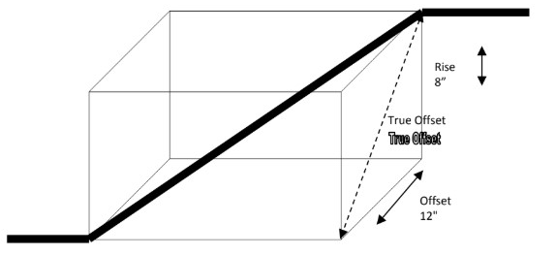
Step 1 - Calculate the True Offset
Use the Pythagoras Theorem > Offset² + Rise² = True Offset²
True Offset = Square Root of True Offset
- 12² + 8² = True Offset²
- (12” x 12”) + (8” x 8”) = 144” + 64” = 208”
- True Offset= Square Root of 208” = 14.42”

Step 2 - Calculate the Setback and Diagonal
Use the Common Fitting Constants Table below.

Fitting Angle | 60°  Constant | 45°  Constant | 22.5 or 22 1/2°  Constant
Diagonal = true offset x constant | 1.155 | 1.414 | 2.613
Setback = true offset x constant | 0.577 | 1.000 | 2.414

Diagonal = True Offset x 45° angle constant
= 14.42 x 1.414 = 20.39
20.39" is the diagonal measurement for the rolling offset

Setback = true offset x 60° angle constant
Setback = 14.42 x 0.577 = 8.32
8.32" is the setback measurement for the offset

Work Sheet
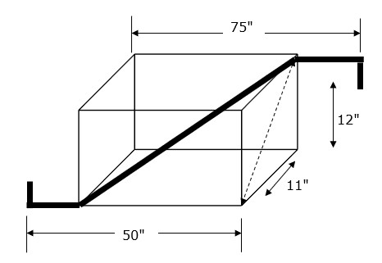
Task 1: Calculate the setback and diagonal for the following pipe schematic using a
- 45° angle
- 22½° angle

Answer:

______________________________________________________

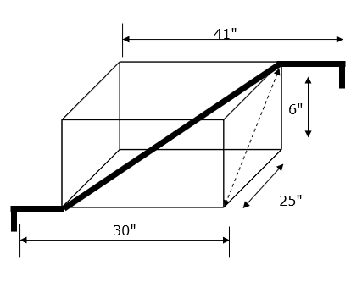
Task 2: Calculate the setback and diagonal for the following pipe schematic using a
- 45° angle
- 22½° angle

Answer:

______________________________________________________

Answers
Task 1: Calculate the setback and diagonal for the following pipe schematic using a
- 45° angle
Answer: 12² + 11² = 144 + 121 = 265
265 squared = 16.28
16.28 x 1.414 = 23.02 The diagonal is 23.02"
16.28 x 1.000 = 16.28
The setback is 16.28"

- 22½° angle
Answer: 12² + 11² = 144 + 121 = 265
265 squared = 16.28
16.28 x 2.613 = 42.54 The diagonal is 42.54"
16.28 x 2.414 = 39.3
The setback is 39.3"

Task 2: Calculate the setback and diagonal for the following pipe schematic using a
- 45° angle
Answer: 252 + 62 = 625 + 36 = 661
661 squared = 25.71
25.71 x 1.414 = 36.35 The diagonal is 36.35"
25.71 x 1.000 = 25.71
The setback is 25.71"

- 22½° angle
Answer: 252 + 62 = 625 + 36 = 661
661 squared = 25.71
25.71 x 2.613 = 67.18 The diagonal is 67.18"
25.71 x 2.414 = 62.06
The setback is 62.06"

Performance Descriptors
Levels | Performance Descriptors | Needs Work | Completes task with support from practitioner | Completes task independently
A2.2 | performs limited searches using one or two search criteria
 | extracts information from tables and forms
 | uses layout to locate information
 | makes connections between parts of documents
 | makes low-level inferences
C3.3 | calculates using numbers expressed as whole numbers, fractions, decimals, percentages and integers
 | understands and uses properties of angles and triangles to solve problems
 | understands and uses formulas for finding the perimeter, area and volume of non-rectangular, composite shapes
 | manages unfamiliar elements (e.g. context, content) to complete tasks
 | makes estimates involving many factors where precision is required
C3.3 cont’d | chooses and performs required operations; makes inferences to identify required operations
 | selects appropriate steps to solutions from among options
 | interprets, represents and converts measures using whole numbers, decimals, percentages, ratios and fractions
 | uses strategies to check accuracy (e.g. estimating, using a calculator, repeating a calculation, using the reverse operation)

This task: Was successfully completed Needs to be tried again
Learner Comments:

Instructor (print): Learner (print):
__________________ _________________

