

Task Title: Calculate Volumes of Concrete Required

OALCF Cover Sheet – Practitioner Copy

Learner Name: __________________________________________
Date Started: ___________________________________________
Date Completed: _________________________________________

Goal Path: | Employment | Apprenticeship
Secondary School | Post Secondary | Independence
Successful Completion: Yes No

Task Description: Carpenters calculate volumes of window sills, thrust blocks and columns to determine the amount of concrete required.

* Tasks 1, 3, & 4 ‘C3’ tasks are higher than Level 3 OALCF
* Task 3 has been identified as authentic to this particular trade and may need some prior knowledge of the trade to complete.
Main Competency/Task Group/Level Indicator:
- Find and Use Information/Interpret documents/A2.1
- Understand and Use Numbers/Use measures/C3.3
- Understand and Use Numbers/Manage data/C4.1
Materials Required:
- Pen/pencil and paper and/or digital device
- Calculator or digital device with calculator function

Practitioner/Instructor Information
* Tasks 1, 3, & 4 ‘C3’ tasks are higher than Level 3 OALCF
* Task 3 has been identified as authentic to this particular trade and may need some prior knowledge of the trade to complete.

Learner Information

The carpenter calculates the volume (V) of concrete required for building objects.
For square or rectangular objects:
V = L x W x D, where V = volume, L = length, W = width and D = depth.
For round objects:
V = ∏r² x H, where V = volume, ∏ = 3.14, r = radius of circle* and H = height
* Radius is ½ of the diameter (diameter = distance across the circle)
1 cubic foot = 0.037 cubic yard

Review the Concrete Building Objects Diagrams.

Concrete Building Objects Diagrams
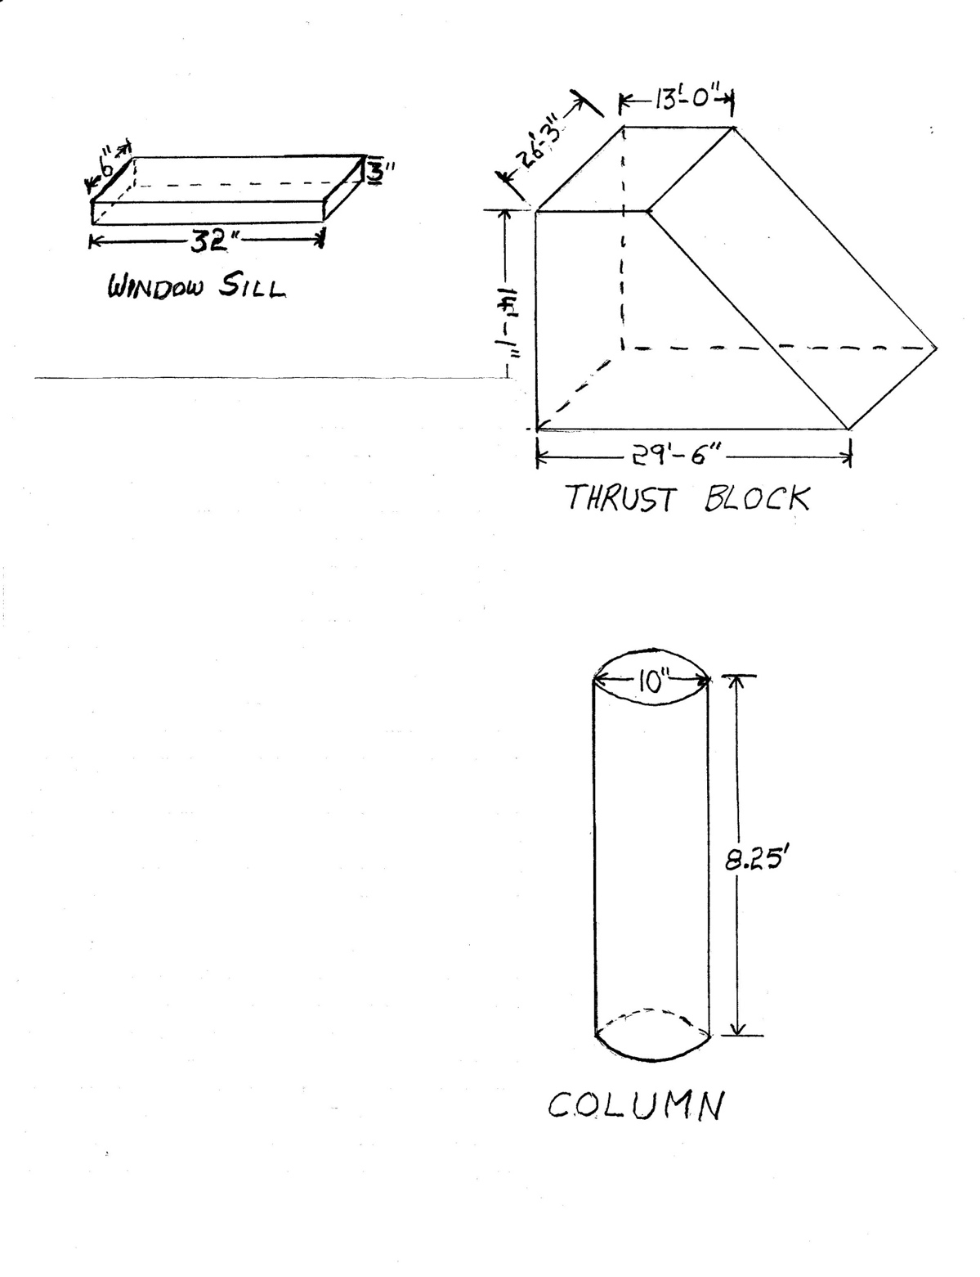

Work Sheet
Task 1: Calculate the volume (V) of concrete required for the window sill in cubic feet (ft³).
Answer:

______________________________________________________
Task 2: A garage floor measures 12’ 6” by 13.75’. The concrete pad will be 4” deep. The cement truck contains 1 cubic yard of concrete. Will you need to order more concrete to complete the garage floor? Concrete can be ordered by ½ and full cubic yards.
Answer:

______________________________________________________
Task 3: Calculate the volume of concrete required for the thrust block, in cubic yards (yd³). The thrust block is an odd shape. Consider it as a rectangle (13’ x 14’ 1” x 26’3”) plus half of another rectangle ((29’6” – 13’) x 14’ 1”x 26’ 3”).
Answer:

______________________________________________________
Task 4: Calculate the volume of concrete required for 8 columns, in cubic yards (yd³); 1 ft³ = 0.037 yd³).
Answer:

______________________________________________________

Answers
Task 1: Calculate the volume (V) of concrete required for the window sill in cubic feet (ft³).
Answer:
V = L x W x H
Convert measurements to feet
32” = 32 / 12 = 2.67’
6” = .5’
3” = .25’
V = 2.67’ x .5’ x .25’
V = .334 cubic feet (or .334 ft³)

Task 2: A garage floor measures 12’ 6” by 13.75’. The concrete pad will be 4” deep. The cement truck contains 1 cubic yard of concrete. Will you need to order more concrete to complete the garage floor? Concrete can be ordered by ½ and full cubic yards.
Answer:
V = L x W x H
Convert measures to feet.
12’ 6” = 12.5’
4” = .33’
V = 13.75’ x 12.5’ x .33’
= 56.72 ft³ x .037 = 2.09 yd³

Since you only have 1 cubic yard of concrete and you need 2.09 yd³, you will need to order more concrete.

Task 3: Calculate the volume of concrete required for the thrust block, in cubic yards (yd³). The thrust block is an odd shape. Consider it as a rectangle (13’ x 14’ 1” x 26’3”) plus half of another rectangle ((29’6” – 13’) x 14’ 1”x 26’ 3”).
Answer:
This is one method of solving the problem. The Thrust Block will be viewed as two geometric figures: a rectangle and a triangle (1/2 a rectangle).
V = L x W x H (Rectangle)
V = 13’ x 26’ 3” x 14’ 1”
= 13’ x 26.25’ x 14.08’
= 4804.8 ft³
V = (L x W x H) / 2 (Half Rectangle)
L = 29.5’ – 13’ = 16.5’
V = 16.5’ x 26.25’ x 14.08’ / 2 = 6098.4 ft³ / 2 = 3,049.2 ft³

The volume of the Thrust Block is 4804.8 + 3049.2 = 7854 ft³
Convert 7854 ft³ to yd³
7854 x .037 = 290.60 yd³
The volume of the Thrust Block is 290.60 yd³.
Note – Answer may vary depending on how many decimal places were used in the calculations.

Task 4: Calculate the volume of concrete required for 8 columns, in cubic yards (yd³); 1 ft³ = 0.037 yd³).
Answer:
V = ∏r² x H
V = 3.14 x 5”² x 8.25’
Convert 5” to a fraction of a foot : 5/12 = .417
V = 3.14 x .417² x 8.25’
= 1.309 ft² x 8.25 = 10.80 ft³
= 10.80 ft³

Convert ft³ to yd³:
V = 10.80 x 0.037
= 0.399 yd³ (for one Column)

Total concrete required for 8 columns is 8 x 0.399 yd³ or 3.192 yd³.

Note: Some rounding has been done so the answer provided is approximate.

Performance Descriptors
Levels | Performance Descriptors | Needs Work | Completes task with support from practitioner | Completes task independently
A2.1 | Scans to locate specific details
 | Interprets brief text and common symbols
C3.3 | Calculates using numbers expressed as whole numbers, fractions, decimals, percentages and integers
 | Calculates the radius, diameter and circumference of circles
 | Understands and uses properties of angles and triangles to solve problems
 | Understands and uses formulas for finding the perimeter, area and volume of non-rectangular, composite shapes
 | Chooses and performs required operations; makes inferences to identify required operations
 | Selects appropriate steps to solutions from among options
 | Interprets, represents and converts measures using whole numbers, decimals, percentages, ratios and fractions
 | Uses strategies to check accuracy (e.g. estimating, using a calculator, repeating a calculation, using the reverse operation)
C4.1 | adds, subtracts, multiplies and divides whole numbers and decimals
 | identifies and compares quantities of items
 | identifies and performs required operation
 | interprets and represents values using whole numbers, decimals, percentages and simple, common fractions (e.g. ½, ¼)
 | follows apparent steps to reach solutions

This task: Was successfully completed Needs to be tried again
Learner Comments:

Instructor (print): Learner (print):
__________________ _________________

