

Task Title: Banquet Event Order

OALCF Cover Sheet – Practitioner Copy

Learner Name: __________________________________________
Date Started: ___________________________________________
Date Completed: _________________________________________

Goal Path: | Employment | Apprenticeship
Secondary School | Post Secondary | Independence
Successful Completion: Yes No

Task Description: Find information and make calculations based on a banquet event order form.
Main Competency/Task Group/Level Indicator:
- Find and Use Information/Interpret documents/A2.2
- Understand and Use Numbers/Manage money/C1.2
Materials Required:
- Pen/pencil and paper and/or digital device
- Calculator or digital device with calculator function

Learner Information
Cooks and event staff at banquet facilities need to use information recorded on event forms. This ensures that enough food is prepared and that meeting spaces have enough chairs, tables and other equipment for each event.

Scan the “Banquet Event Order” form.

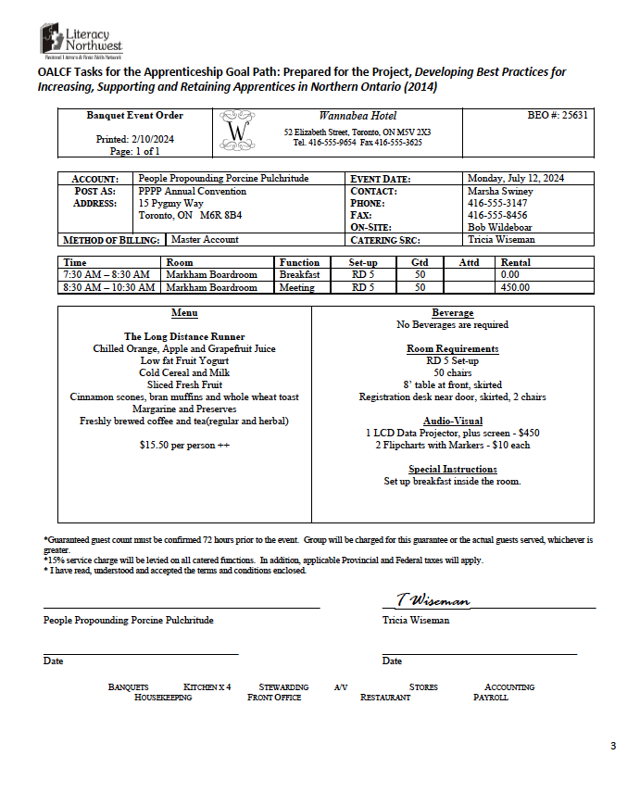

Work Sheet
Task 1: Circle the expected number of guests to attend (GTD).
Answer:

______________________________________________________
Task 2: Highlight or underline the event date and times of the meal and meeting.
Answer:

______________________________________________________
Task 3: If 50 guests attend the event, calculate the total for the Long Distance Runner event. The total should include the food cost plus the room rental cost for the meeting. HST (13%) is added to both the food and room rental. A Gratuity of 15% is added to the food total only.
Answer:

______________________________________________________
Task 4: If this group wants to add a flipchart with markers, what will be the new total? 13% HST will need to be added for these rental items.
Answer:

______________________________________________________
Answers
Task 1: Circle the expected number of guests to attend (GTD).
Answer: 50 should be circled on the form

Task 2: Highlight or underline the event date and times of the meal and meeting.
Answer: The following should be highlighted or underlined on the form: Monday July 12, 2024; 7:30am-8:30am (breakfast); 8:30am-10:30am (meeting)

Task 3: If 50 guests attend the event, calculate the total for the Long Distance Runner event. The total should include the food cost plus the room rental cost for the meeting. HST (13%) is added to both the food and room rental. Gratuity of 15% is added to the food only.
Answer:
Food costs:
$15.50 per person x .13 HST = $2.02 HST
$15.50 per person x .15 gratuity = $2.33 gratuity
Total per person for food: $15.50 + $2.02 + $2.33 = $19.85
$19.85 x 50 people = $992.50 Total for food

Room rental cost:
$450 (room rental for meeting) x .13 (HST) = $58.50
Total room rental cost: $450 + $58.50 = $508.50
$992.50 (food) + $508.50 (room rental for meeting) = $1,501.00

Task 4: If this group wants to add a flipchart with markers, what will be the new total? 13% HST will need to be added for these rental items.
Answer:
Flip chart with markers: $10 x .13 HST = $1.13
Total for flipchart with markers: $10 + $1.13 = $11.13

New Total: $1,501.00 + $11.13 = $1,512.13

Performance Descriptors
Levels | Performance Descriptors | Needs Work | Completes task with support from practitioner | Completes task independently
A2.2 | extracts information from tables and forms
 | uses layout to locate information
 | makes connections between parts of documents
 | makes low-level inferences
C1.2 | calculates using numbers expressed as whole numbers, fractions, decimals, percentages and integers
 | represents costs and rates using monetary symbols, decimals and percentages
 | interprets, represents and converts amounts using whole numbers, decimals, percentages, ratios and simple, common fractions (e.g. ½, ¼)
 | uses strategies to check accuracy (e.g. estimating, using a calculator, repeating a calculation, using the reverse operation)

This task: Was successfully completed Needs to be tried again

Learner Comments:

Instructor (print): Learner (print):
__________________ _________________

