

Task Title: Automotive Repair Invoice

OALCF Cover Sheet – Practitioner Copy

Learner Name:___________________________________________
Date Started:____________________________________________
Date Completed: _________________________________________
Successful Completion: Yes No

Goal Path: | Employment | Apprenticeship
Secondary School | Post Secondary | Independence

Task Description: Use an automotive service invoice to calculate costs for repair work.

Main Competency/Task Group/Level Indicator:
- Find and Use Information/Interpret documents/A2.2
- Understand and Use Numbers/Manage money/C1.2

Materials Required:
- Pen/pencil and paper and/or digital device
- Calculator or digital device with calculator function (optional)

Learner Information

Automotive service technicians calculate the cost of repair jobs. The total cost of a repair job may include taxes, labour rates, and parts. Look at the “ABC Auto Repair” invoice.
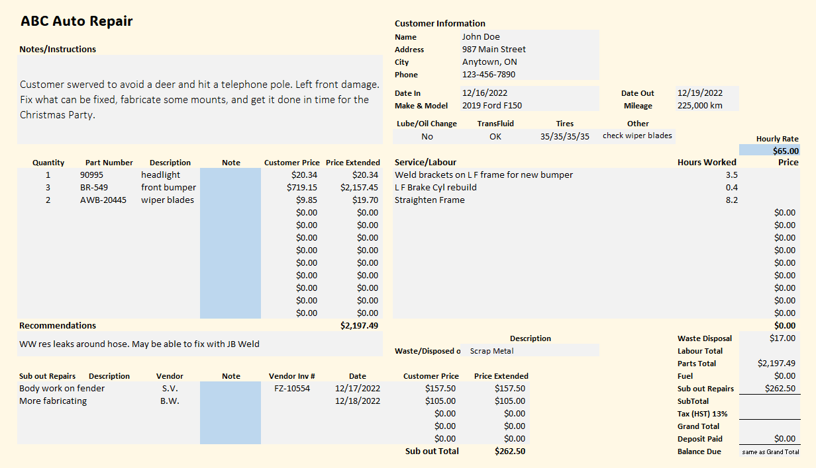

Work Sheet
Task 1: On the invoice, highlight, underline or circle the notes/instructions for this job. If doing this task online, write the notes/instructions below.
Answer: No written response required here.

Task completed: Yes:
OR
Answer:

_____________________________________________________________
Task 2: Calculate the cost for the repair shop to “weld brackets on L F for new bumper”. Enter the answer into the invoice.
Answer: No written response required here.

Task completed: Yes:
______________________________________________________
Task 3: Calculate the cost for the repair shop to “L F brake Cyl rebuild”. Enter the answer into the invoice.
Answer: No written response required here.

Task completed: Yes:
_____________________________________________________________
Task 4: Calculate the cost for the repair shop to “Straighten Frame”. Enter the answer into the invoice.
Answer: No written response required here.

Task completed: Yes:
_____________________________________________________________
Task 5: Calculate the Labour total. Enter the answer into the invoice.
Answer: No written response required here.

Task completed: Yes:
_____________________________________________________________
Task 6: Calculate the subtotal for waste disposal, labour total, parts total, fuel, and sub out for repairs. Enter the answer into the invoice.
Answer: No written response required here.

Task completed: Yes:
_____________________________________________________________
Task 7: Calculate the amount of tax (HST) that will be added to the subtotal. Enter the answer into the invoice.
Answer: No written response required here.

Task completed: Yes:
_____________________________________________________________
Task 8: Calculate the final total the customer will pay for this repair work. Enter the answer into the invoice.
Answer: No written response required here.

Task completed: Yes:
_____________________________________________________________

Answers
Note: Individual answers/images are provided for each task. Additionally, an image of the entire invoice correctly completed is also provided at the end.
Task 1: On the invoice, highlight, underline or circle the notes/instructions for this job. If doing this task online, write the notes/instructions below.
Learner will circle the instruction box in the top-left corner of the invoice or write: “Customer swerved to avoid a deer and hit a telephone pole. Left front damage. Fix what can be fixed, fabricate some mounts, and get it done in time for the Christmas Party.”
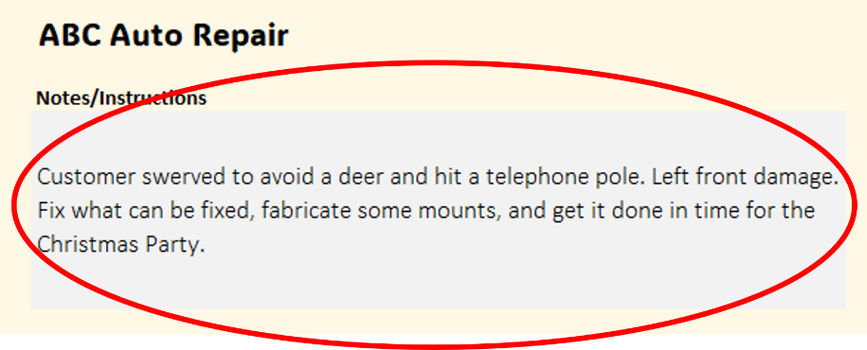
Task 2: Calculate the cost for the repair shop to “weld brackets on L F for new bumper”. Enter the answer into the invoice.
$65/hour x 3.5 hours = $227.50
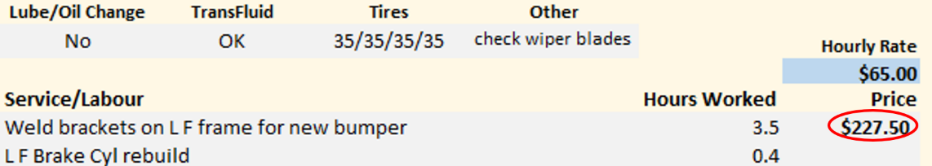
Task 3: Calculate the cost for the repair shop to “L F brake Cyl rebuild”. Enter the answer into the invoice.
$65/hour x 0.4 hours = $26.00
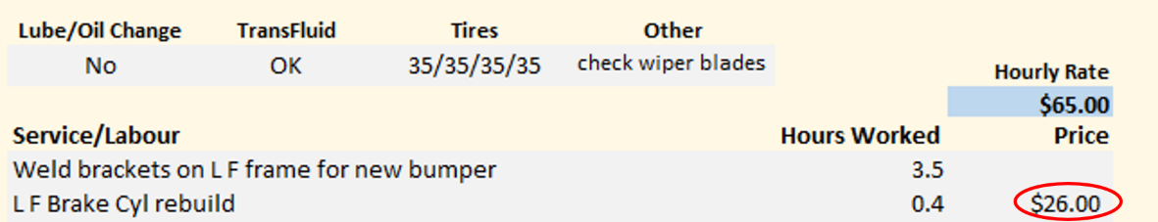
Task 4: Calculate the cost for the repair shop to “Straighten Frame”. Enter the answer into the invoice.
$65/hour x 8.2 = $533.00
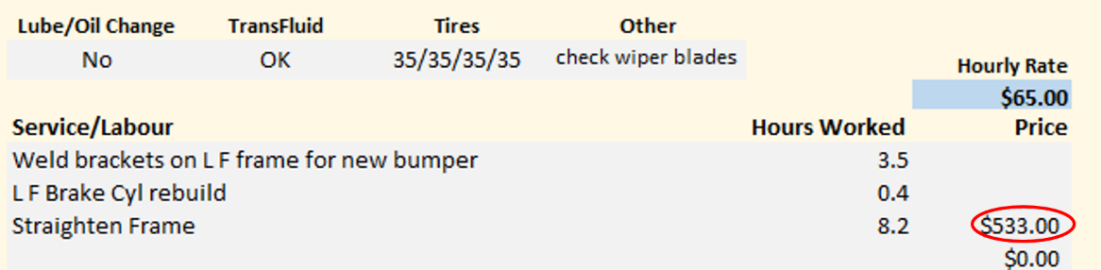

Task 5: Calculate the Labour total. Enter the answer into the invoice.
Add the total hours and multiply by the hourly rate: (3.5 + 0.4 + 8.2) x $65 = $786.50 OR
Add the answers to Tasks 2, 3 and 4 ($227.50 + $26.00 + $533.00) = $786.50

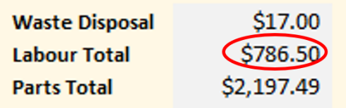

Task 6: Calculate the subtotal for waste disposal, labour total, parts total, fuel, and sub out for repairs. Enter the answer into the invoice.
Cal

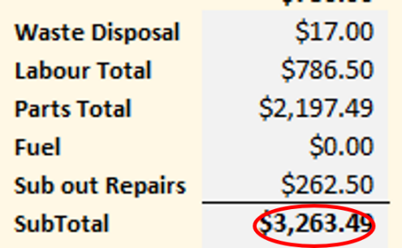

Task 7: Calculate the amount of tax (HST) that will be added to the subtotal. Enter the answer into the invoice.
Multiply the subtotal (calculated in Task 6) by 13% (.13):
$3,263.49 x 0.13 = $424.2537
Round down to $424.25
$424.25
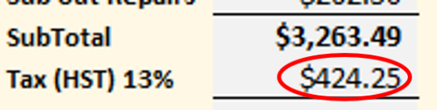
Task 8: Calculate the final total the customer will pay for this repair work. Enter the answer into the invoice.
Add the subtotal and the tax total together: $3,263.49 + $424.25 = $3,687.74
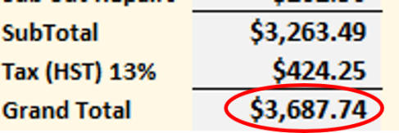
Correctly Completed Invoice
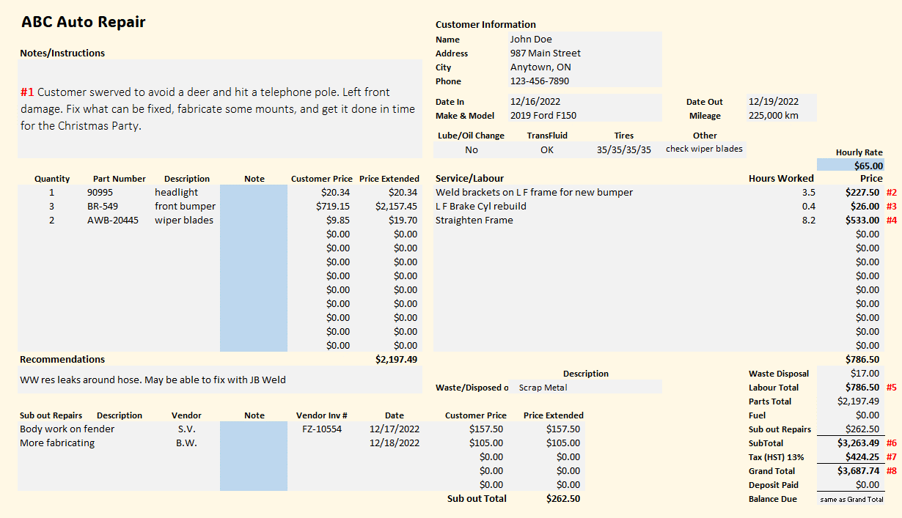

Performance Descriptors
Levels | Performance Descriptors | Needs Work | Completes task with support from practitioner | Completes task independently
A2.2 | performs limited searches using one or two search criteria
 | extracts information from tables and forms
 | uses layout to locate information
 | makes connections between parts of documents
 | makes low-level inferences
C1.2 | Calculates using numbers expressed as whole numbers, fractions, decimals, percentages and integers
 | Calculates percentages
 | Interprets and applies rates (e.g. $/kg, $/1)
 | Chooses and performs required operation(s); may make inferences to identify required operation(s)
 | Selects appropriate steps to reach solutions
C1.2 | Represents costs and rates using monetary symbols, decimals and percentages
 | Interprets, represents and converts amounts using whole numbers, decimals, percentages, ratios and simple, common fractions (e.g. ½, ¼)
 | Uses strategies to check accuracy (e.g. estimating, using a calculator, repeating a calculation, using the reverse operation)

This task: Was successfully completed Needs to be tried again

Learner Comments:

Instructor (print): Learner (print):
________________________ _______________________

