

Task Title: Interpret and Create Drawings

OALCF Cover Sheet – Practitioner Copy

Learner Name: __________________________________________
Date Started: ___________________________________________
Date Completed: _________________________________________

Goal Path: | Employment | Apprenticeship
Secondary School | Post Secondary | Independence
Successful Completion: Yes No

Task Description: The learner will use a Legend to interpret electrical features on a blueprint, and to determine materials needed for a job.
Main Competency/Task Group/Level Indicator:
- Find and Use Information/Interpret documents/A2.3
- Communicate Ideas and Information/Complete and create documents/B3.2a
- Understand and Use Numbers/Manage data/C4.1
Materials Required:
- Pen/pencil and paper

Learner Information
Electricians interpret, modify and create schematic drawings using standardized icons and legends. They use the drawing to plan tasks and determine materials needed for a job.
Scan the “Blueprint and Electrical Legend”, “Electrical Supplies Order Form” and “Schematic Drawing (Bedroom 1)”.

Blueprint and Electrical Legend
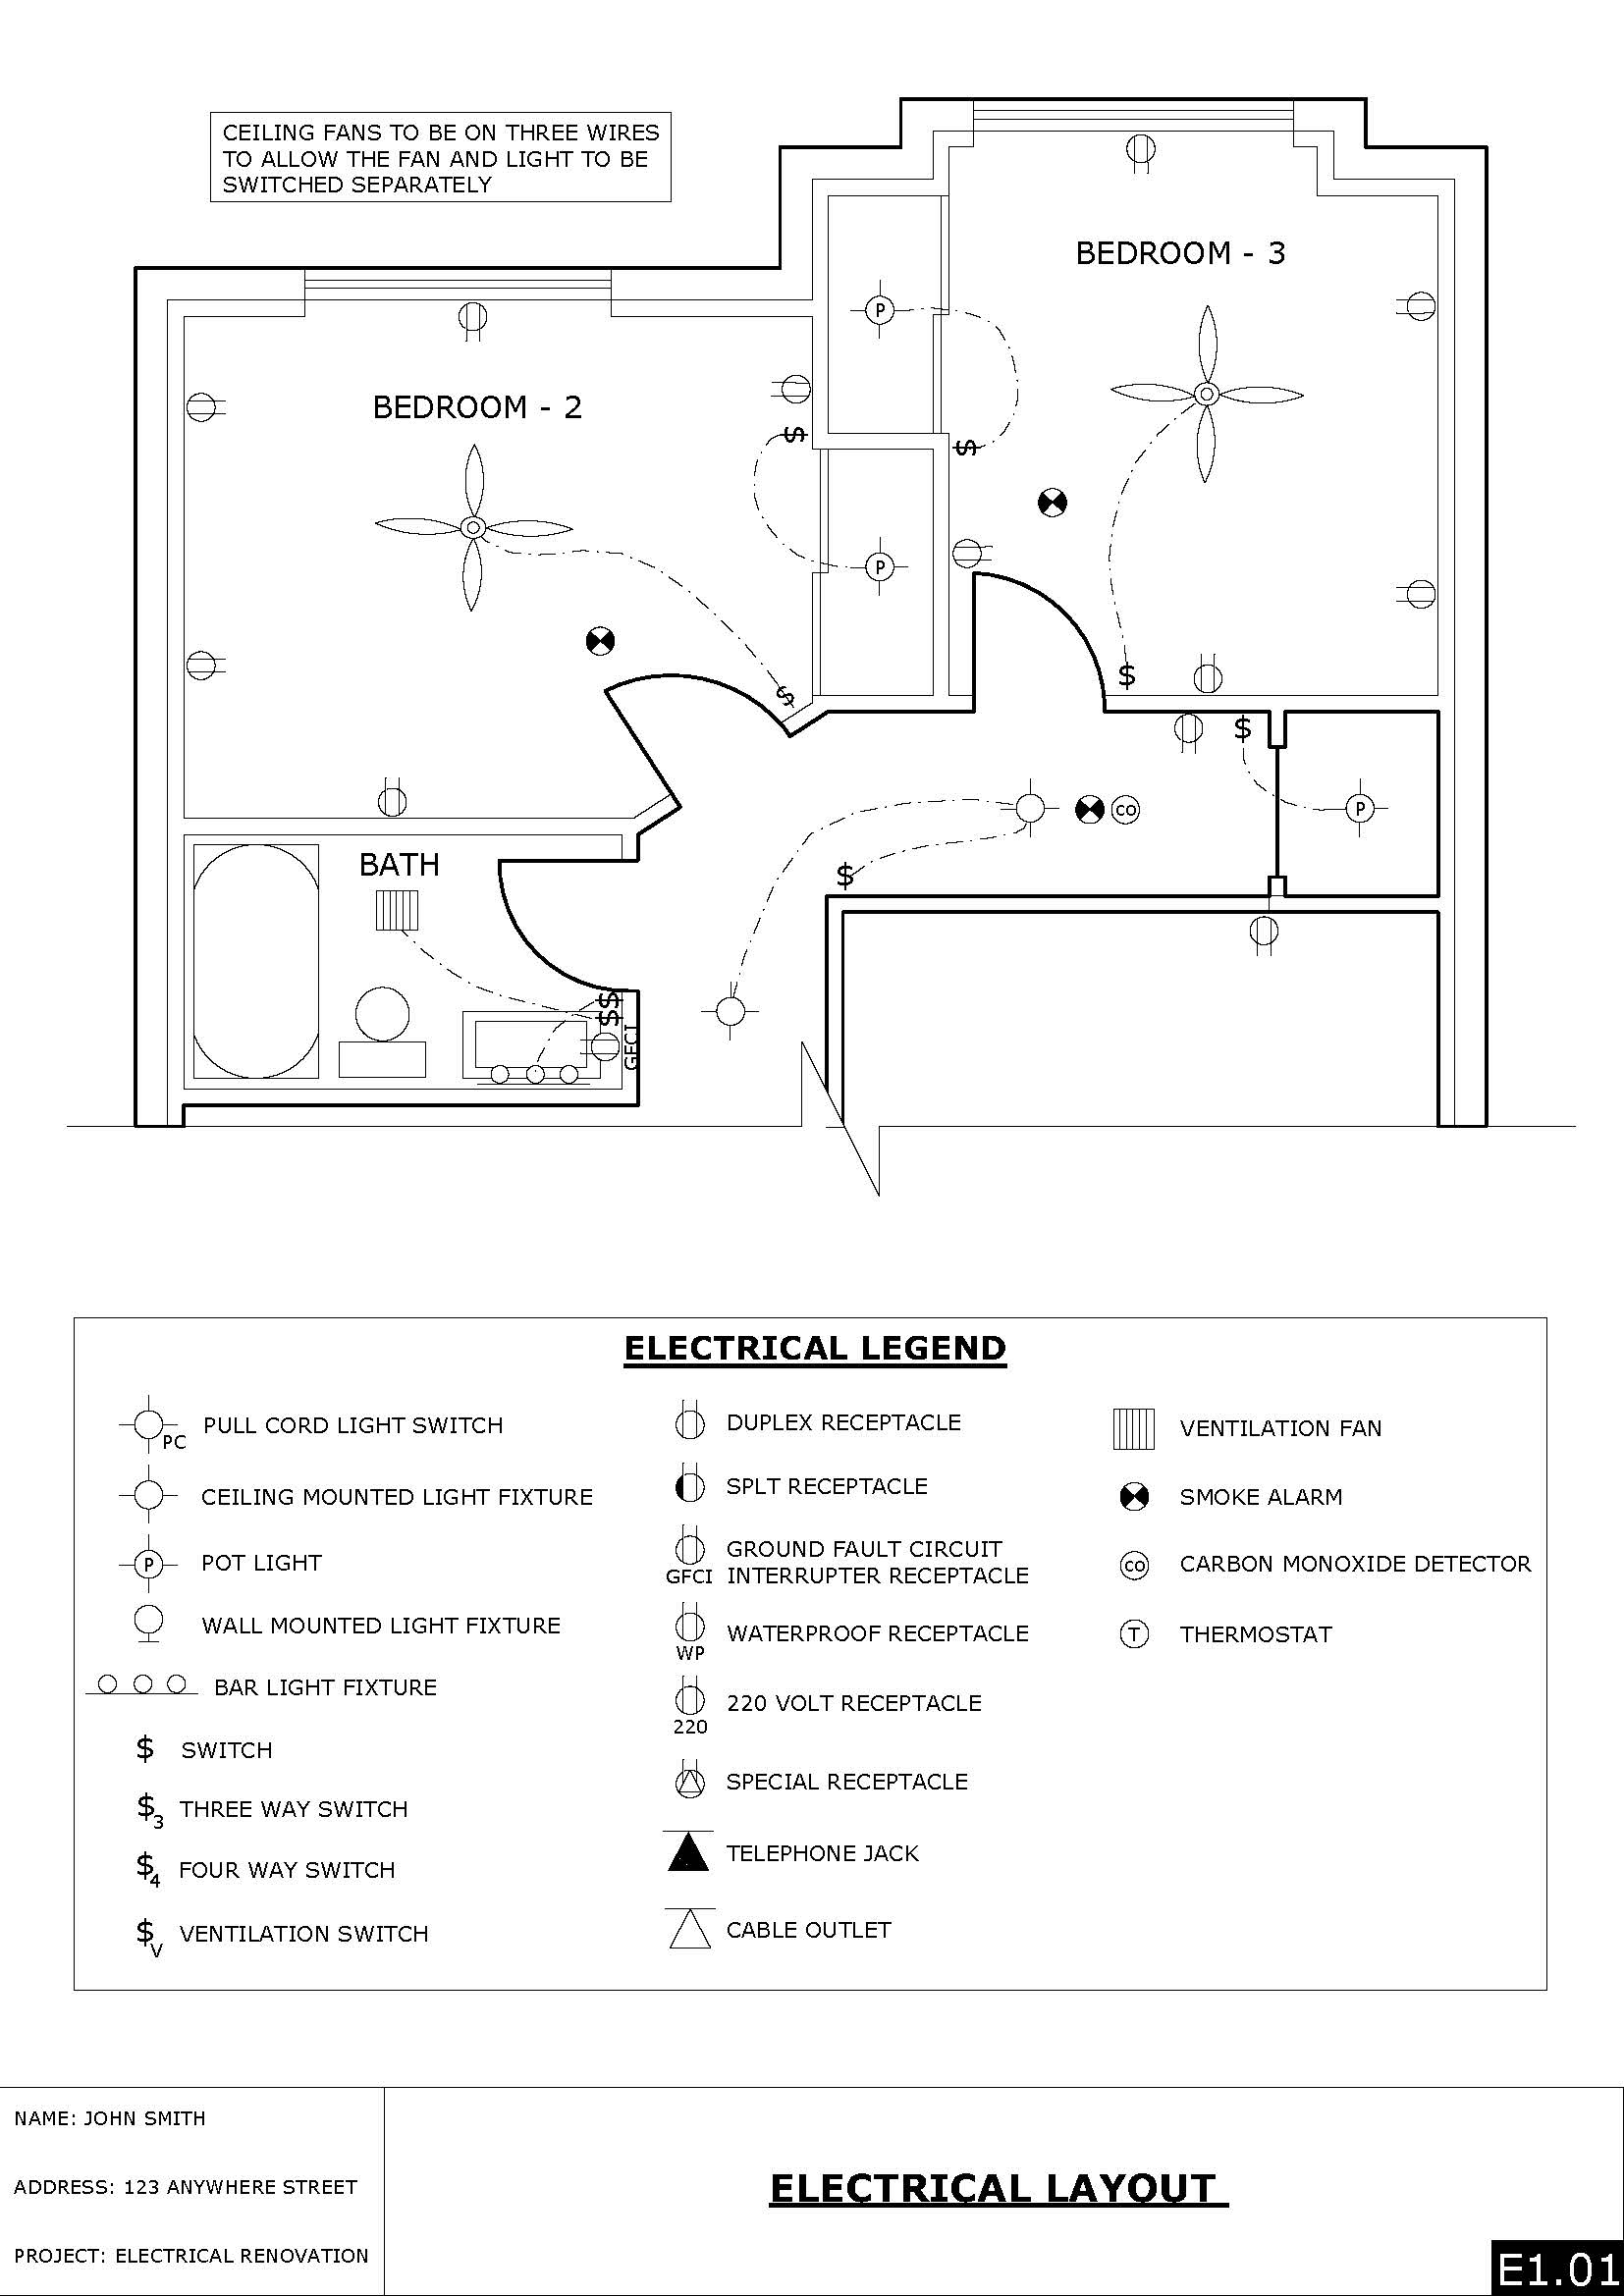
Electrical Supplies Order Form
Item | No. Requested
Pull cord light switch
Ceiling mounted light fixture
Pot light
Bar light fixture
Switch
Three-way switch
Ventilation fan switch
Duplex receptacle
Split receptacle
Ground fault circuit interrupter (GFCI)
Waterproof receptacle
220v receptacle
Phone jack
Cable outlet
Ventilation fan
Interconnected smoke alarm
Carbon Monoxide detector
Thermostat/circulation fan
Other

Schematic Drawing (Bedroom 1)
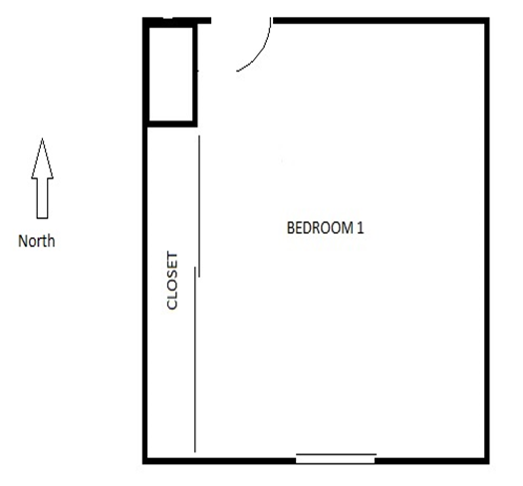

Work Sheet
Task 1: Interpret the Blueprint and Electrical Legend to complete the following tasks.
- How many switches are required for bedroom #2?
Answer:
_____________________________________________________________
- What is the electrical apparatus over the sink?
Answer:
_____________________________________________________________
Task 2: The electrician orders supplies. Use the Blueprint and Electrical Legend to decide what electrical supplies are needed for the Bathroom and 2 Bedrooms.
Complete the Electrical Supplies Order Form.
Answer: No written response required here.

Task Completed: Yes
______________________________________________________
Task 3: Refer to the icons of the Electrical Legend to draw the electrical apparatuses, as per the directions below, on the Schematic Drawing (Bedroom 1).
- Switch for overhead light on west wall near door
- Overhead light centered in room
- Pull cord light switch in closet centered between sliding doors
- 2 duplex receptacles on each of the south and east walls
- 1 duplex receptacle on the north wall

Answer: No written response required here.

Task Completed: Yes
_____________________________________________________________
Answers
Task 1: Interpret the Blueprint and Electrical Legend to complete the following tasks.
- How many switches are required for bedroom #2?
Answer: two switches
- What is the electrical apparatus over the sink?
Answer: Bar Light Fixture
Task 2: The electrician orders supplies. Use the Blueprint and Electrical Legend to decide what electrical supplies are needed for the Bathroom and 2 Bedrooms. Complete the Electrical Supplies Order Form.
Answer:
Electrical Supplies Order Form
Item | No. Requested
Pull cord light switch
Ceiling mounted light fixture
Pot light | 2
Bar light fixture | 1
Switch | 6
Three-way switch
Ventilation fan switch
Duplex receptacle | 11
Split receptacle
Ground fault circuit interrupter (GFCI) | 1
Waterproof receptacle
220v receptacle
Phone jack
Cable outlet
Ventilation fan | 1
Interconnected smoke alarm | 2
Carbon Monoxide detector
Thermostat/circulation fan
Other
Task 3: Refer to the icons of the Electrical Legend to draw the electrical apparatuses, as per the directions below, on the Schematic Drawing (Bedroom 1).
Switch for overhead light on west wall near door
- Overhead light centered in room
- Pull cord light switch in closet centered between sliding doors
- 2 duplex receptacles on each of the south and east walls
- 1 duplex receptacle on the north wall

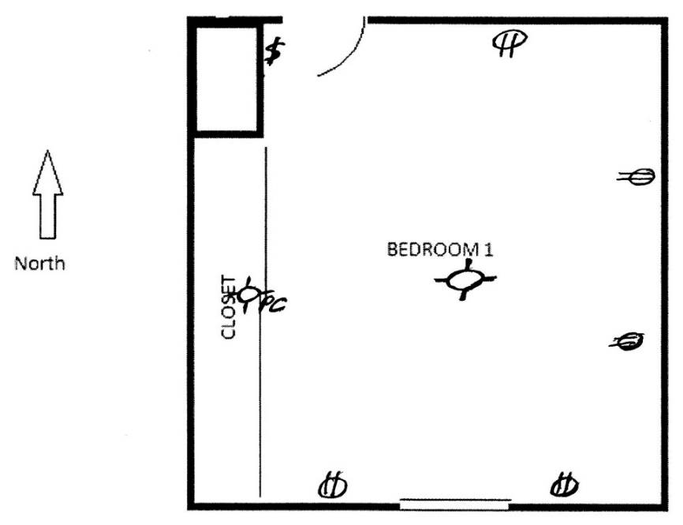

Performance Descriptors
Levels | Performance Descriptors | Needs Work | Completes task with support from practitioner | Completes task independently
A2.3 | Performs complex searches using multiple search criteria
 | Integrates several pieces of information from documents
 | Compares or contrasts information between two or more documents
 | Uses layout to locate information
B3.2a | Uses layout to determine where to make entries
 | Follows instructions on documents
C4.1 | Identifies and compares quantities of items

This task: Was successfully completed Needs to be tried again

Learner Comments:

Instructor (print): Learner (print):
__________________ _________________

