

Task Title: Understand a Cleaning Product MSDS

OALCF Cover Sheet – Practitioner Copy

Learner Name:___________________________________________
Date Started (m/d/yyyy):__________________________________
Date Completed (m/d/yyyy): _______________________________
Successful Completion: Yes No

Goal Path: | Employment | Apprenticeship
Secondary School | Post Secondary | Independence

Task Description: The learner reads a Material Safety Data Sheet (MSDS) to become familiar with a cleaning product.

Main Competency / Task Group / Level Indicator:
- Find and Use Information/Interpret documents/A2.2

Materials Required:
- Pen and paper and/or digital device

Learner Information

Cleaners and workers in jobs where cleaning is important (like Early Childhood Educators) need to use products that have a Material Safety Data Sheet (MSDS).
Scan “The Clorox Company 409” Material Safety Data Sheet.

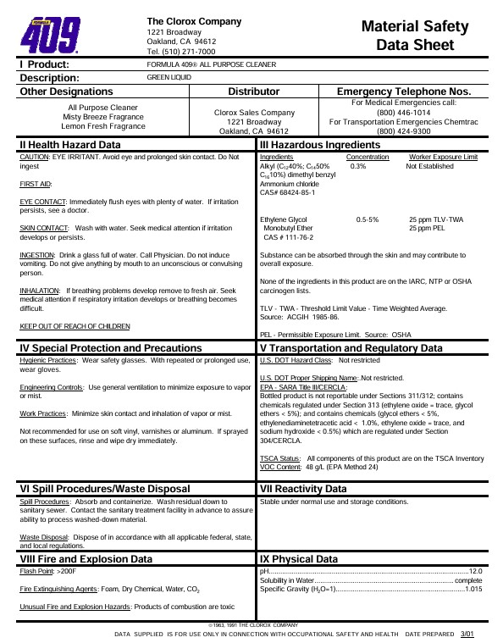

Work Sheet

Task 1: What is the product name?

Answer:

_____________________________________________________________
Task 2: Who is the distributor for this product?

Answer:

_____________________________________________________________
Task 3: What is the purpose of the Health Hazard Data section?

Answer:

_____________________________________________________________
Task 4: What should the cleaner do if the product is accidentally swallowed?

Answer:

_____________________________________________________________
Task 5: What should the cleaner do if they are splashed by the product?

Answer:

_____________________________________________________________
Task 6: List the recommended PPE (Personal Protective Equipment) for this product.

Answer:

_____________________________________________________________
Task 7: What should the cleaner do to minimize exposure to product mist?
Answer:

_____________________________________________________________
Task 8: Why would the cleaner use this product?
Answer:

_____________________________________________________________

Answers

Task 1: What is the product name?
Answer: Formula 409® glass & surface cleaner
Task 2: Who is the distributor for this product?
Answer: The Clorox Sales Company
Task 3: What is the purpose of the Health Hazard Data section?
Answer: It gives directions in case of injury or discomfort from exposure when using the product.
Task 4: What should the cleaner do if the product is accidentally swallowed?
Answer: Drink a glassful of water. Call a doctor or poison control centre (Do not induce vomiting. Do not give anything by mouth to an unconscious or convulsing person.)
Task 5: What should the cleaner do if they are splashed by the product?
Answer: Rinse with plenty of water. If irritation persists, call a doctor.
Task 6: List the recommended PPE (Personal Protective Equipment) for this product.
Answer: Safety glasses; wear gloves with repeated or prolonged use
Task 7: What should the cleaner do to minimize exposure to product mist?
Answer: Use general ventilation to minimize exposure to product mist.
Task 8: Why would the cleaner use this product?
Answer: To clean glass and other surfaces.

Performance Descriptors
Levels | Performance Descriptors | Needs Work | Completes task with support from practitioner | Completes task independently
A2.2 | Performs limited searches using one or two search criteria
 | Extracts information from tables and forms
 | Uses layout to locate information
 | Makes connections between parts of documents
 | Makes low-level inferences
 | Begins to identify sources and evaluate information

This task: Was successfully completed Needs to be tried again

Learner Comments:

Instructor (print): Learner (print):
_________________________ _____________________

