

Task Title: Inventory Price Sheet

OALCF Cover Sheet – Practitioner Copy

Learner Name: __________________________________________
Date Started: ___________________________________________
Date Completed: _________________________________________

Goal Path: | Employment | Apprenticeship
Secondary School | Post Secondary | Independence
Successful Completion: Yes No

Task Description: The learner will use spreadsheet data to calculate unit prices and amounts for food inventories.
Main Competency/Task Group/Level Indicator:
- Find and Use Information/Interpret documents/A2.2
- Understand and Use Numbers/Manage money/C1.2
- Understand and Use Numbers/Use measures/C3.2
Materials Required:
- Pen/pencil and paper and/or digital device
- Calculator or digital device with calculator function

Learner Information
Cooks and other food services workers use spreadsheets with lists of items to calculate costs.
Scan the “Inventory Price per Unit Sheet”.

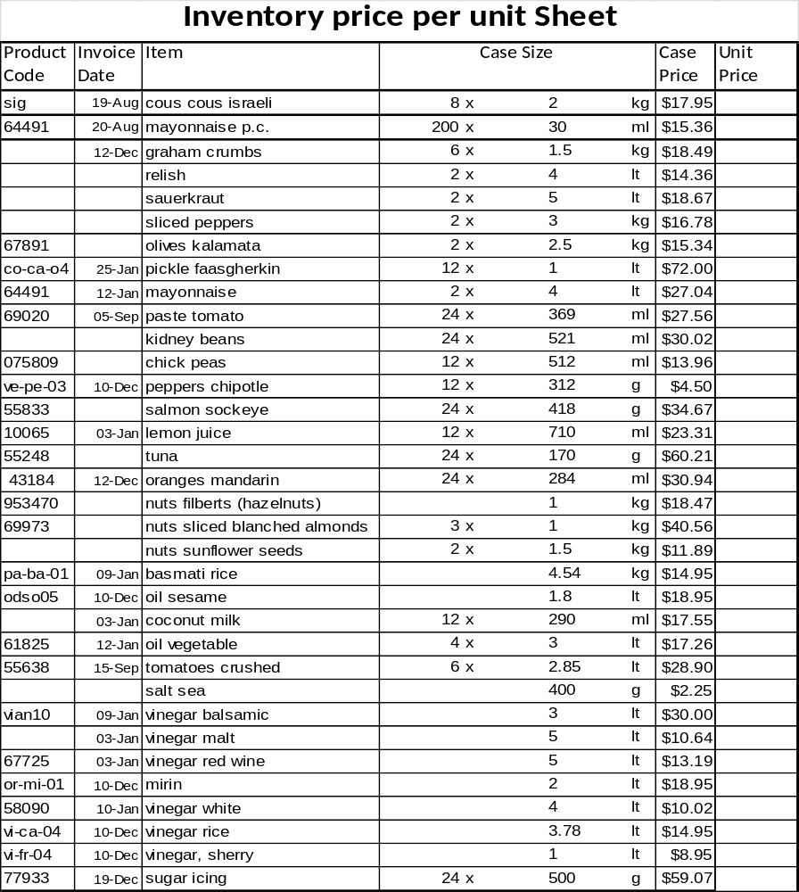

Work Sheet
Task 1: Highlight, circle or underline the case size and case price for sliced peppers. If doing this task online, write the answer below.
Answer:

______________________________________________________
Task 2: Calculate the price of 10 lt of malt vinegar.
Answer:

______________________________________________________
Task 3: One (1) ounce (oz.) is equal to 29.574 millilitres (ml). Calculate the total ounces (oz.) in a case of coconut milk.
Answer:

______________________________________________________
Task 4: A cook is preparing for an upcoming function. The cook needs to have 20 kilograms (kg) of couscous. Calculate the cost of 20 kilograms of couscous.
Answer:

______________________________________________________
Task 5: Calculate the number of kilograms (kg) per case of graham crumbs.
Answer:

______________________________________________________
Task 6: Calculate the cost per gram for salmon sockeye.
Answer:

______________________________________________________
Task 7: Calculate the unit price of kidney beans and the unit price for chick peas. Which is higher?
Answer:

______________________________________________________

Answers
Task 1: Highlight, circle or underline the case size and case price for sliced peppers. If doing this task online, write the answer below.
Answer: sliced peppers 2 x 3 kg $16.78 should be indicated. This is six items from the top of the page.

Task 2: Calculate the price of 10 lt of malt vinegar.
Answer:
One unit of vinegar malt is 5 lt at a cost of $10.64
10lt ÷ 5lt = 2
$10.64 x 2 = $21.28
Cost for 10 lt of vinegar malt is $21.28

Task 3: One (1) ounce (oz.) is equal to 29.574 millilitres (ml). Calculate the total ounces (oz.) in a case of coconut milk.
Answer:
Total number of ml in one case of coconut milk is (12 units x 290 ml/unit) 3480 ml.
3480 ml / 29.574 ml = 117.67
117.67 ounces (oz.)

Task 4: A cook is preparing for an upcoming function. The cook needs to have 20 kilograms (kg) of couscous. Calculate the cost of 20 kilograms of couscous.
Answer:
Calculate the cost per kilogram: $17.95/16kg = $1.12/kg
Calculate cost of $1.12 x 20 kg = $22.40
Cost of 20 kg of couscous is $22.40

Task 5: Calculate the number of kilograms (kg) per case of graham crumbs.
Answer: 1.5 kg x 6 = 9 kg

Task 6: Calculate the cost per gram for salmon sockeye.
Answer:
Calculate number of grams in one case (418 g x 24 units = 10032 g)
Divide case cost by total number of grams ($34.67 / 10032 g = $0.0035/g)
Round to nearest thousandth. $0.004/g

Task 7: Calculate the unit price of kidney beans and the unit price for chick peas. Which is higher?
Answer:
Unit price of kidney beans: $30.02 / 24 = $1.246 unit (round up to $1.25 unit)
Unit price of chick peas: $14.96 / 12 = $1.163 unit (round down to $1.16 unit)
The unit price of kidney beans is higher than the unit price of chick peas.

Performance Descriptors
Levels | Performance Descriptors | Needs Work | Completes task with support from practitioner | Completes task independently
A2.2 | performs limited searches using one or two search criteria
 | extracts information from tables and forms
 | makes connections between parts of documents
 | makes low-level inferences
 | begins to identify sources and evaluate information
C1.2 | calculates using numbers expressed as whole numbers, fractions, decimals, percentages and integers
 | interprets and applies rates (e.g. $/kg, $/1)
 | chooses and performs required operation(s); may make inferences to identify required operation(s)
 | selects appropriate steps to reach solutions
 | represents costs and rates using monetary symbols, decimals and percentages
 | interprets, represents and converts amounts using whole numbers, decimals, percentages, ratios and simple, common fractions (e.g. ½, ¼)
 | uses strategies to check accuracy (e.g. estimating, using a calculator, repeating a calculation, using the reverse operation)
C3.2 | calculates using numbers expressed as whole numbers, fractions, decimals, percentages and integers
 | interprets and applies rates (e.g. km/hr) and ratios (e.g. map scales)
 | converts units of measurement within the same system and between systems
 | chooses and performs required operation(s); may make inferences to identify required operation(s)
 | selects appropriate steps to solutions
 | interprets, represents and converts measures using whole numbers, decimals, percentages, ratios and simple, common fractions (e.g. ½, ¼)
 | uses strategies to check accuracy (e.g. estimating, using a calculator, repeating a calculation, using the reverse operation)

This task: Was successfully completed Needs to be tried again
Learner Comments:

Instructor (print): Learner (print):
__________________ _________________

