

Task Title: Interpret Blueprints

OALCF Cover Sheet – Practitioner Copy

Learner Name:___________________________________________
Date Started:____________________________________________
Date Completed: _________________________________________
Successful Completion: Yes ☐ No ☐
Goal Path: | Employment | Apprenticeship
Secondary School | Post Secondary | Independence
Task Description: The learner will read a blueprint and excerpts from the Ontario Building Code to answer questions and inform a customer about modifications to their home.
Main Competency/Task Group/Level Indicator:
- Find and Use Information/Interpret documents/A2.2
- Communicate Ideas and Information/Write continuous text/B2.2

Materials Required:
- Pen/pencil and paper and/or digital device

Learner Information
Carpenters interpret blueprints and other scale drawings to determine placement of building materials. They also consult the Building Code to determine if modifications are legal.

Scan the A1.01 First Floor Plan and the 2024 Ontario Building Code Compendium 9.7.2.2 and 9.7.2.3 excerpts.

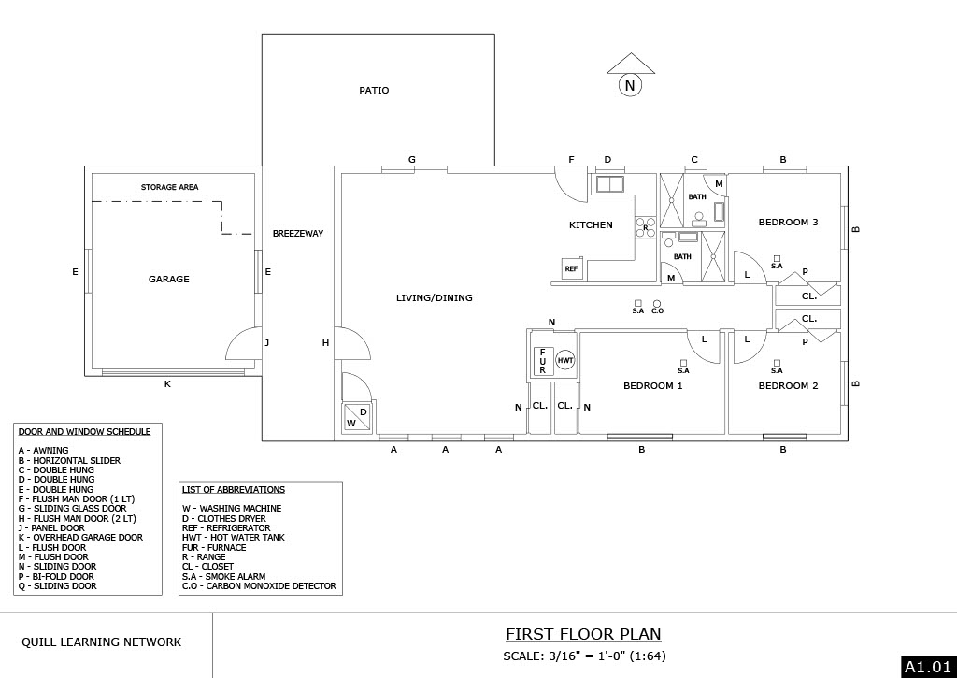

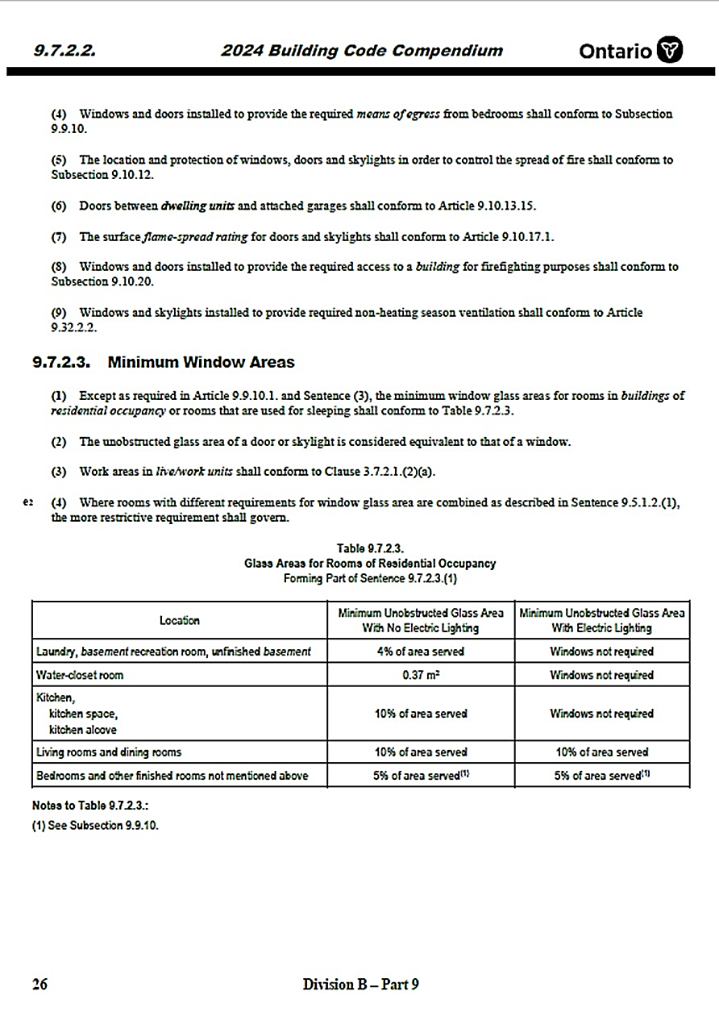 Work Sheet
Task 1: What type of door separates the Living/Dining Room from the Furnace Room?
Answer:
_____________________________________________________________
Task 2: On which side of the Living Room are the awning type of windows found?

Answer:
_____________________________________________________________
Task 3: Which bedrooms have bi-fold doors?
Answer:
_____________________________________________________________
Task 4: What is the minimum unobstructed glass area required for a laundry room with no electric lighting?
Answer:
_____________________________________________________________
Task 5: Bedroom 1 is 7.5’ x 9’. The owner wants to have the closet run the whole length of the south wall. Using the excerpt from the Building Code, write a note to the customer explaining why that is not possible.
Answer:

_____________________________________________________________
Answers
Task 1: What type of door separates the Living/Dining Room from the Furnace Room?
Answers: Sliding Door (N)

Task 2: On which side of the Living Room are the awning type of windows found?
Answer: South

Task 3: Which bedrooms have bi-fold doors?
Answer: Bedrooms 2 and 3

Task 4: What is the minimum unobstructed glass area required for a laundry room with no electric lighting?
Answer: 4% of the area served
Task 5: Bedroom 1 is 7.5’ x 9’. The owner wants to have the closet run the whole length of the south wall. Using the excerpt from the Building Code, write a brief note to the customer explaining why that is not possible. Include a greeting and your name.
Answer: Something similar to:
Hi (Insert fictitious name). According to the 2024 Ontario Building Code 9.7.2.3.(1) and Table 9.7.2.3. a bedroom requires a minimum of 5% natural light to the area served. By constructing a closet along the noted (south) wall, the natural light will become restricted/blocked and therefore would not meet the minimum building code requirements.
(Insert their name or another fictitious name)

Performance Descriptors
Levels | Performance Descriptors | Needs Work | Completes task with support from practitioner | Completes task independently
A2.2 | Performs limited searches using one or two search criteria
 | Extracts information from tables and forms
 | Uses layout to locate information
 | Makes connections between parts of documents
 | Makes low-level inferences
 | Begins to identify sources and evaluate information
B2.2 | Writes texts to explain or describe
 | Conveys intended meaning on familiar topics for a limited range of purposes and audiences
 | Connects ideas using paragraph structure
 | Uses a limited range of vocabulary and punctuation appropriate to the task
 | Begins to select words and tone appropriate to the task
 | Begins to organize writing to communicate effectively
This task: Was successfully completed ☐ Needs to be tried again ☐
Learner Comments:

Instructor (print): Learner (print):
_____________________ ___________________

