

Task Title: Finding Information on a Bill

OALCF Cover Sheet – Practitioner Copy

Learner Name:___________________________________________
Date Started:____________________________________________
Date Completed: _________________________________________
Goal Path: | Employment | Apprenticeship
Secondary School | Post Secondary | Independence
Successful Completion: Yes No

Task Description: The learner will read and locate information on three household bills.
Main Competency/Task Group/Level Indicator
- Find and Use Information/Interpret documents/A2.2
Materials Required:
- Pen, pencil or highlighter

Learner Information
When paying bills, you need to know information such as the name of the billing company, your account number, the date the bill was sent and when payment is due, the amount that is owed, and the tax to be paid.

Scan the bills from “Hydro One”, “Bruce Telecom” and “Epcor Natural Gas”.

Hydro One Bill (2 pages)
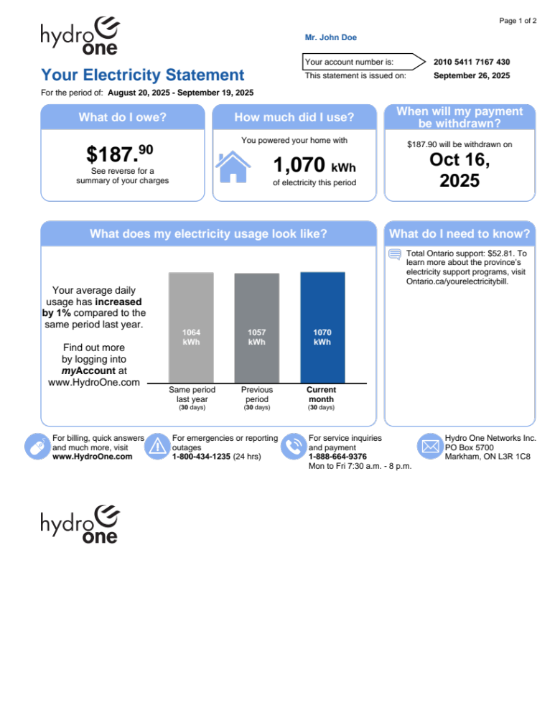

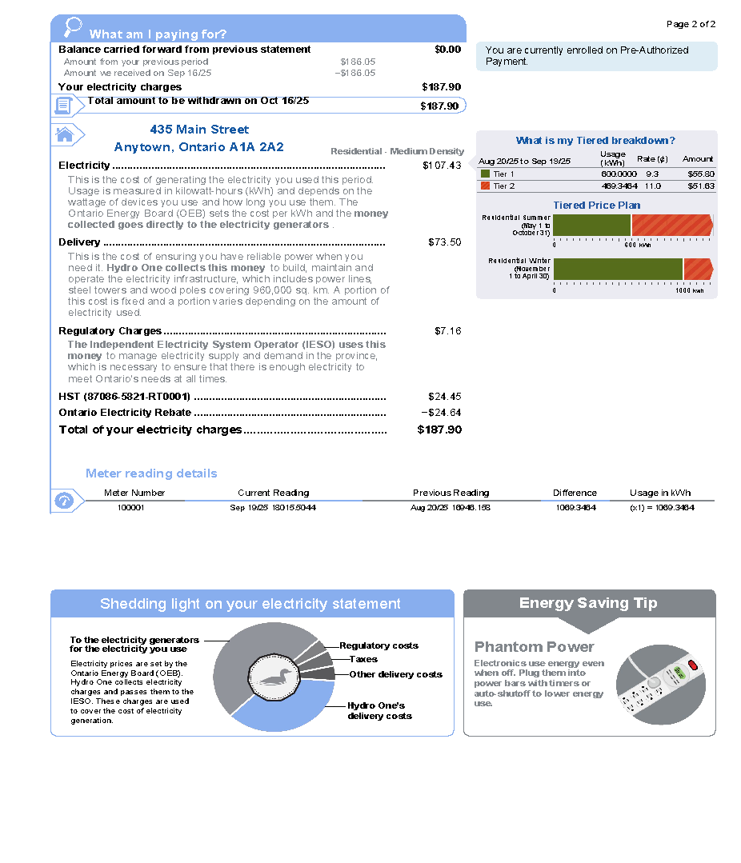

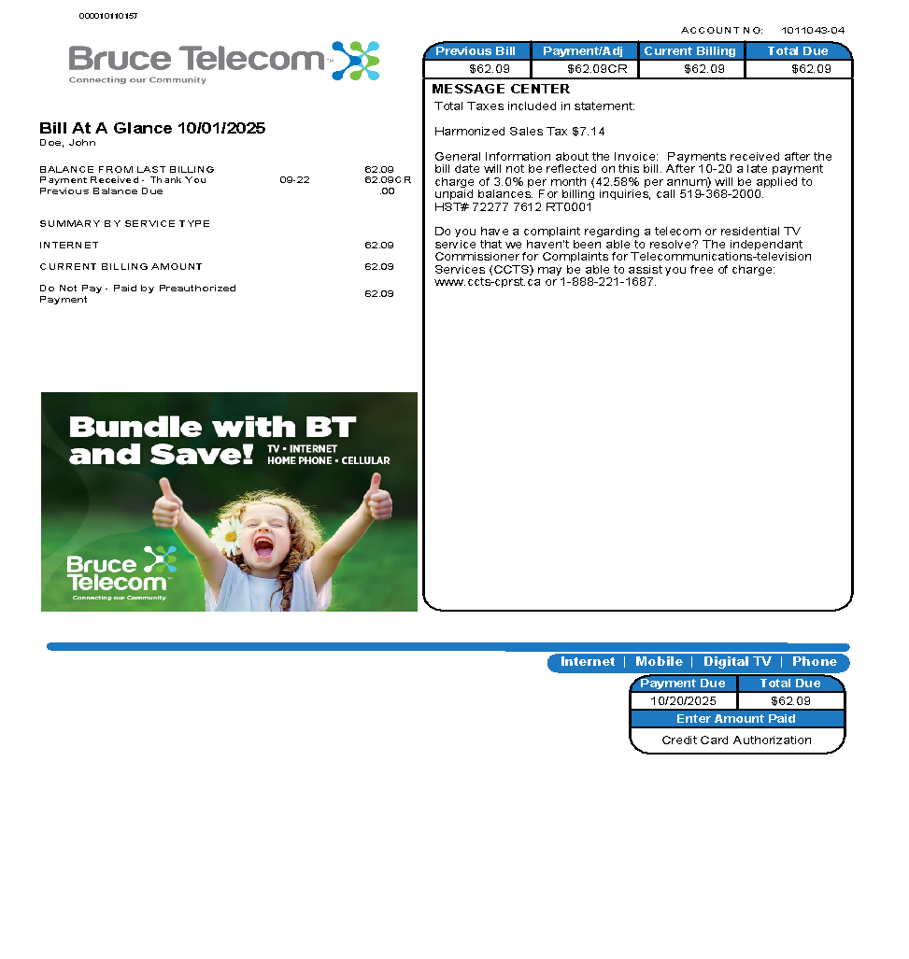
Bruce Telecom Bill

EPCOR Bill
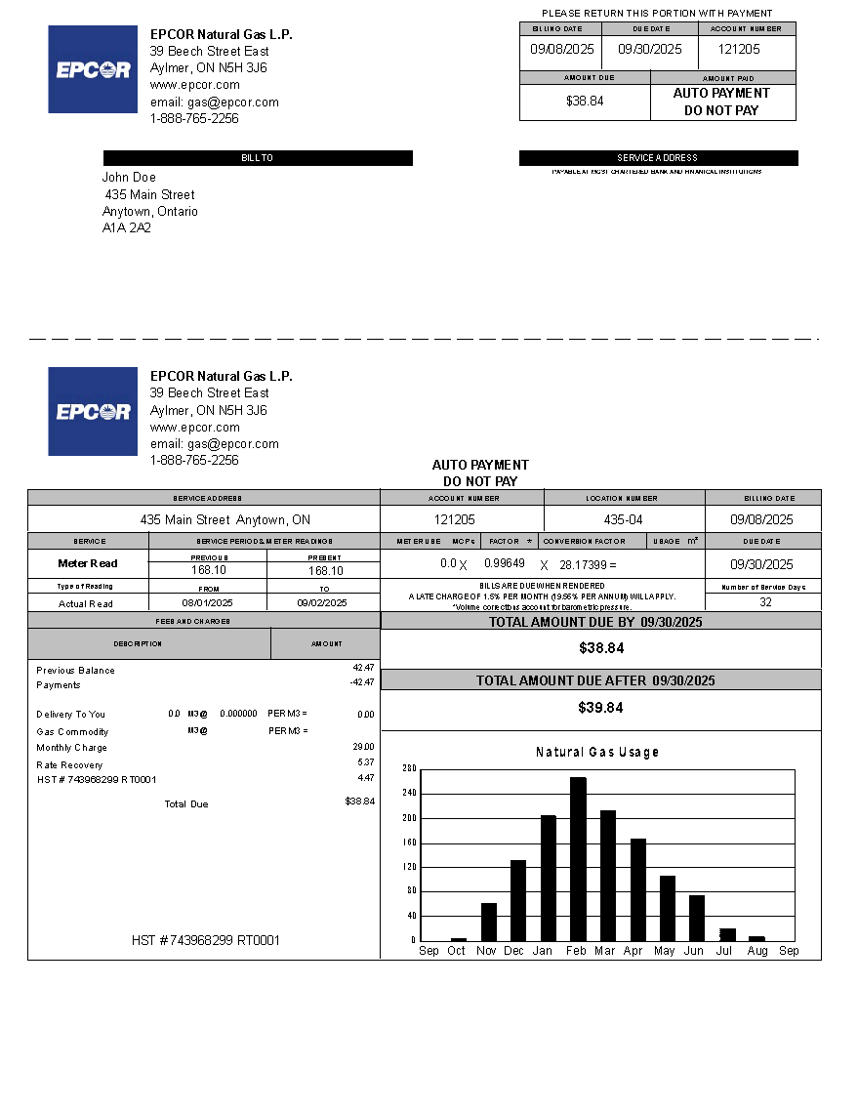

Work Sheet
Task 1: Circle, highlight or underline the name of the billing company on each of the three bills. Write a #1 beside it.
Answer: No written response required here.

Task completed: Yes:
_____________________________________________________________
Task 2: Circle, highlight or underline the account number on each of the three bills. Write a #2 beside it.
Answer: No written response required here.

Task completed: Yes:
_____________________________________________________________
Task 3: Circle, highlight or underline the billing date on each of the three bills. Write a #3 beside it.
Answer: No written response required here.

Task completed: Yes:
_____________________________________________________________
Task 4: Circle, highlight or underline the current amount due on each bill. Write a #4 beside it.
Answer: No written response required here.

Task completed: Yes:
_____________________________________________________________
Task 5: All goods and services require taxes. Circle, highlight or underline the taxes (GST, PST or HST) on each bill. Write a #5 beside it.
Answer: No written response required here.

Task completed: Yes:
_____________________________________________________________
Task 6: Circle, highlight or underline the payment date on each bill. For bills with pre-authorized payments, this may be listed as the date a payment will be withdrawn. Write a #6 beside it.
Answer: No written response required here.

Task completed: Yes:
_____________________________________________________________

Answers
Answers are shown on the bills on the next pages. On some bills, the same information is listed more than once. This has been indicated, but the learner is only expected to highlight the information once for each question.

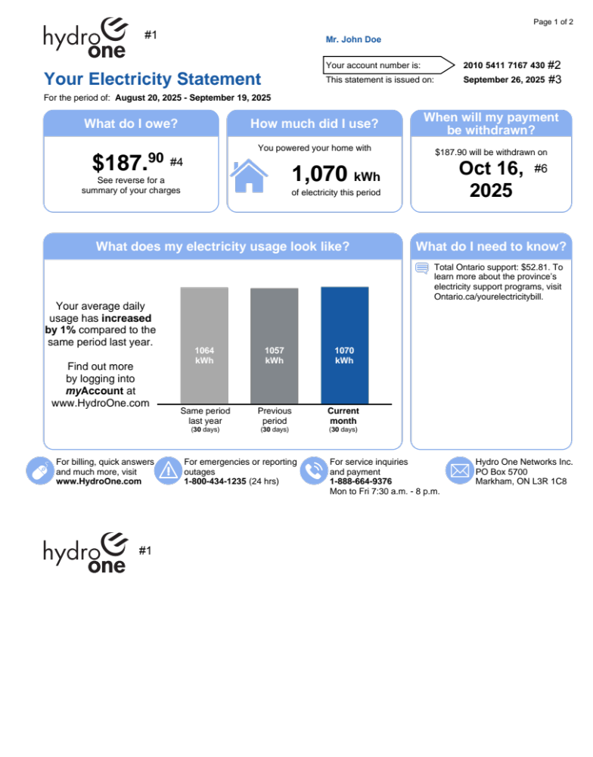

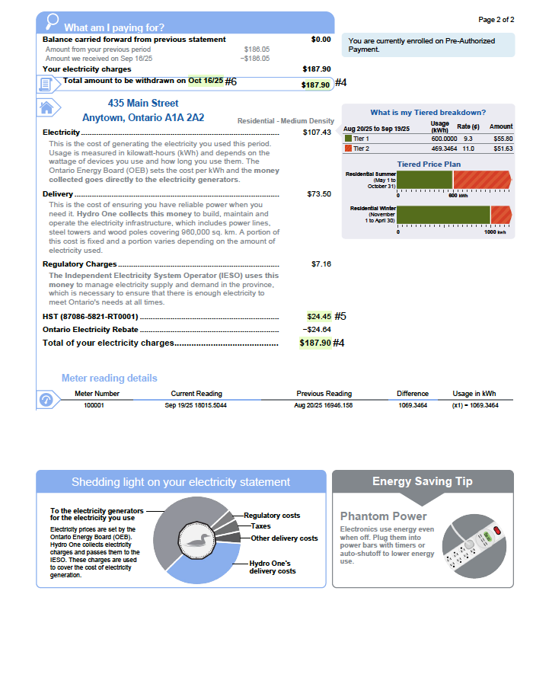

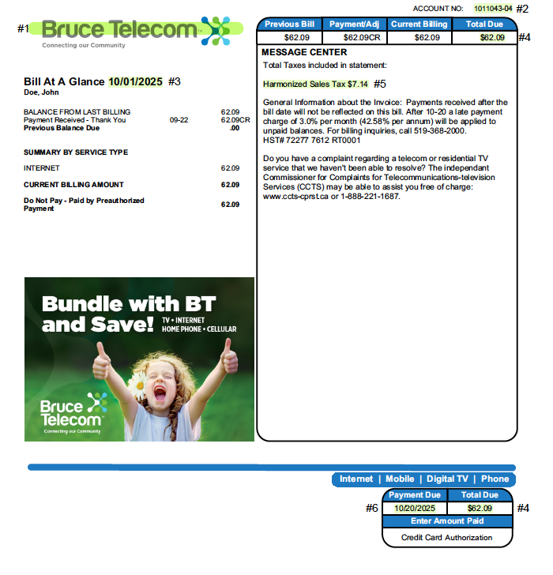

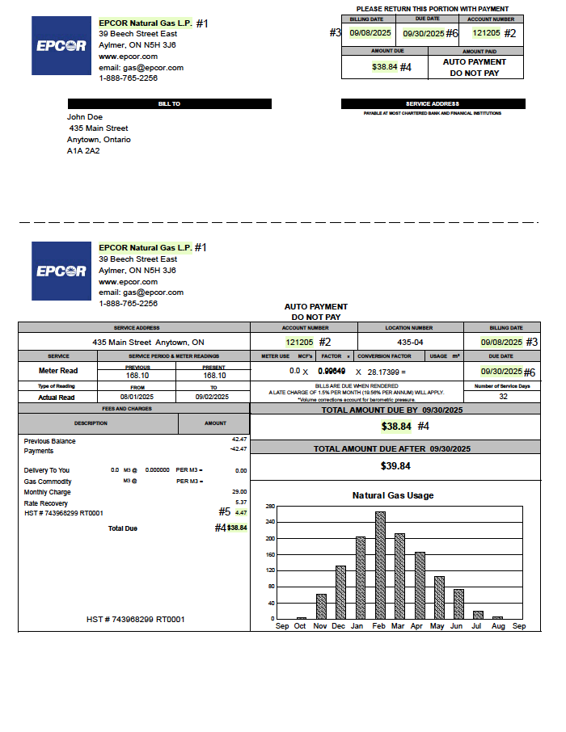

Performance Descriptors
Levels | Performance Descriptors | Needs Work | Completes task with support from practitioner | Completes task independently
A2.2 | Performs limited searches using one or two search criteria
 | Extracts information from tables and forms
 | Locates information in simple graphs and maps
 | Uses layout to locate information
 | Makes connections between parts of documents
 | Begins to identify sources and evaluate information

This task: Was successfully completed Needs to be tried again

Learner Comments:

Instructor (print): Learner (print):
_______________________ _______________________

