

Task Title: Understand Completed Hotel Room Repair Card

OALCF Cover Sheet – Practitioner Copy

Learner Name: __________________________________________
Date Started: ___________________________________________
Date Completed: _________________________________________

Goal Path: | Employment | Apprenticeship
Secondary School | Post Secondary | Independence
Successful Completion: Yes No

Task Description: The learner will read a hotel room repair card to determine repair work that needs to be completed.
Main Competency/Task Group/Level Indicator:
- Find and Use Information/Read continuous text/A1.1
- Find and Use Information/Interpret documents/A2.1

Materials Required:
- Pen/pencil and paper and/or digital device

Learner Information
Employees in maintenance departments often receive memos or repair cards that have been completed. In a hotel, repair work needs are often submitted by guests. Review the “Repair Card”.

Repair Card
Does the Room Need Any Repairs?

Dear Guest: Our highest goal is to provide you with a high standard of service and quality. To help us meet our goal, please give us your comments about anything in the room that might be out of order or need our attention. Please hang this card on the outside of your hotel door. We will look after it.
Thank you for helping us, Hotel Management.

Room Number: 2315 Date: November 2, 2024
Check off any repairs that need to be done:

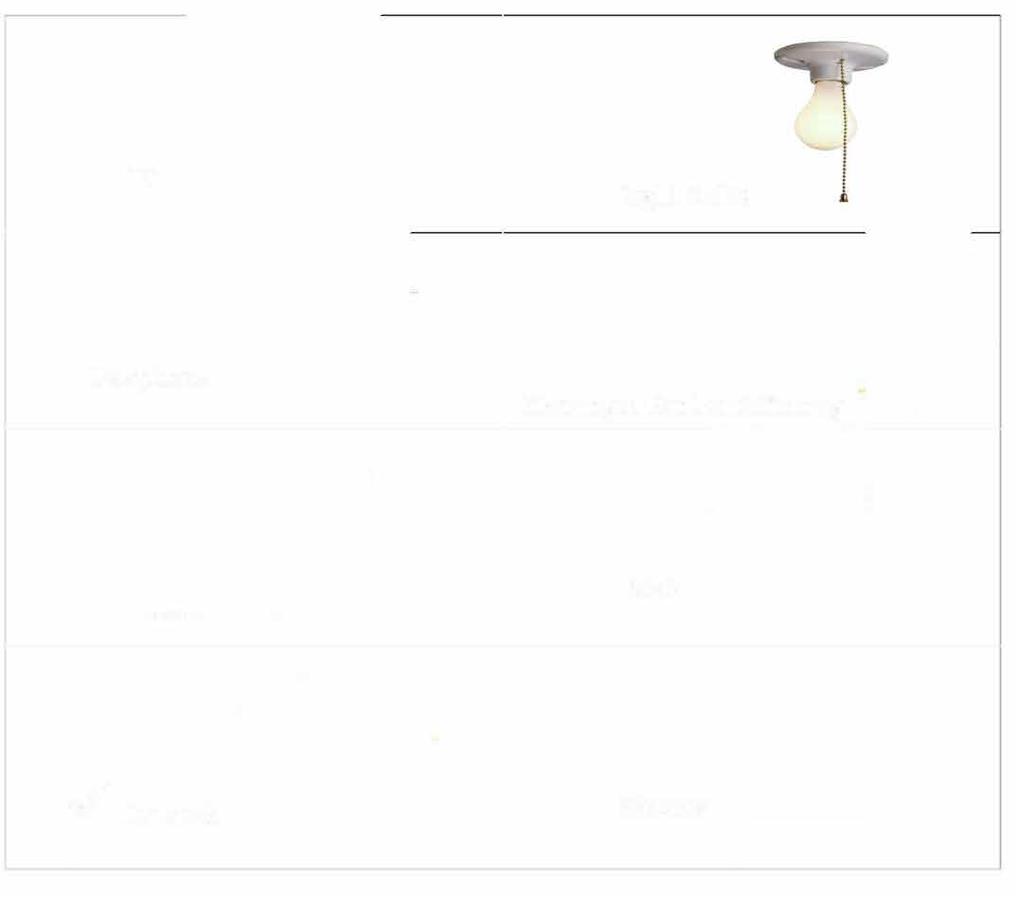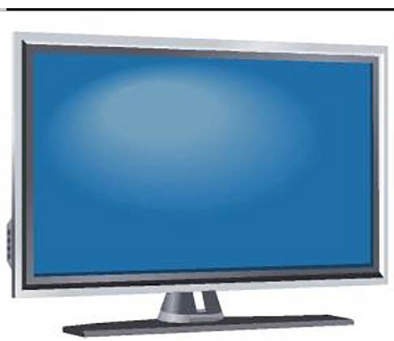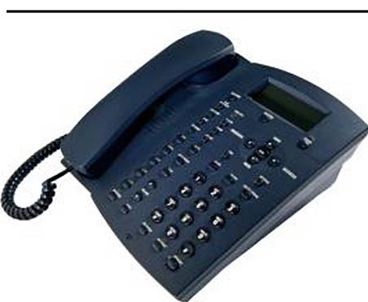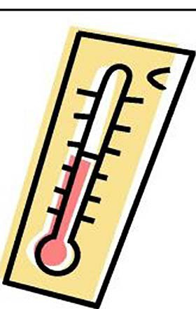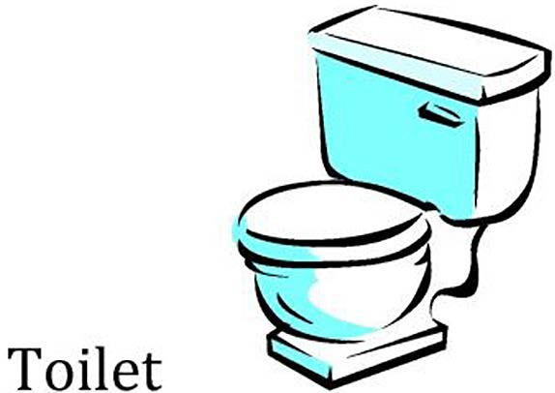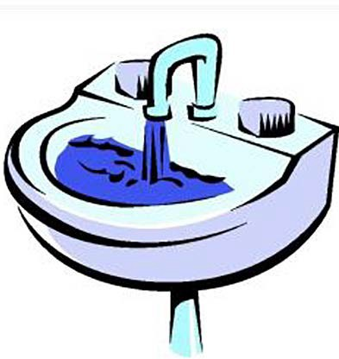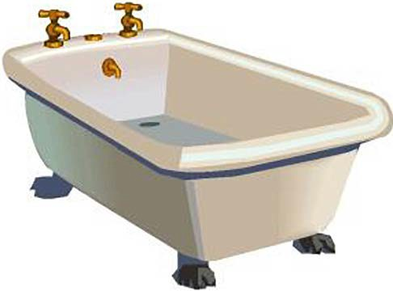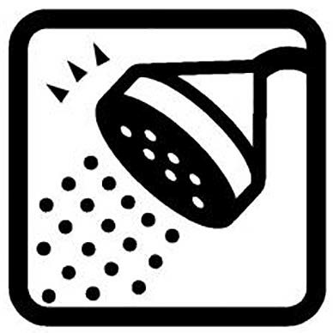

TV

Light Bulbs

Telephone

Heating or Air Conditioning

Shower

Bathtub

Sink
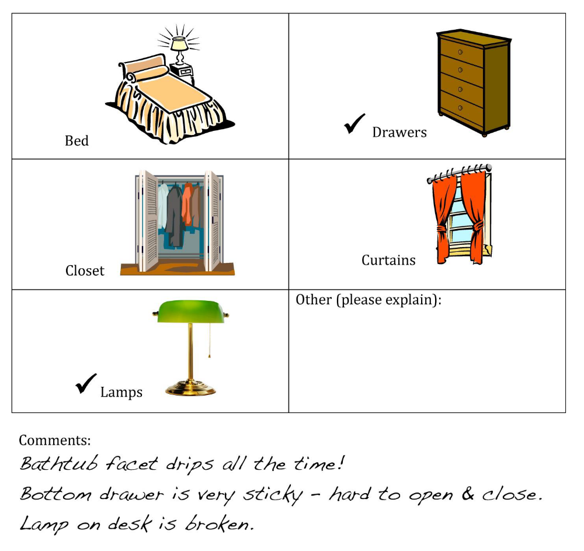

Work Sheet
Task 1: Where is a guest to put the completed Hotel Room Repair Card?
Answer:

______________________________________________________
Task 2: Circle, underline or highlight the hotel room and date.
Answer: No written response required here.

Task completed: Yes: No:

Task 3: Name the three items that need repair.
Answer:

______________________________________________________
Task 4: What is the problem with the bathtub?
Answer:

______________________________________________________
Task 5: What is wrong with the dresser?
Answer:

______________________________________________________

Answers
Task 1: Where is a guest to put the completed Hotel Room Repair Card?
Answer: The guest is asked to hang the card outside their hotel door.

Task 2: Circle, underline or highlight the hotel room and date.
Answer: Learner should circle Room 2315 and November 2, 2024.

Task 3: Name the three items that need repair.
Answer: Bathtub (faucet), drawers, lamp.

Task 4: What is the problem with the bathtub?
Answer: the bathtub faucet drips.

Task 5: What is wrong with the dresser?
Answer: The bottom drawer is very sticky – it is hard to open and close.

Performance Descriptors
Levels | Performance Descriptors | Needs Work | Completes task with support from practitioner | Completes task independently
A1.1 | reads short texts to locate a single piece of information
 | decodes words and makes meaning of sentences in a single text
 | follows the sequence of events in straightforward chronological texts
 | follows simple, straightforward instructional texts
 | identifies the main idea in brief texts
A2.1 | scans to locate specific details
 | interprets brief text and common symbols
 | locates specific details in simple documents, such as labels and signs
 | identifies how lists are organized (e.g. sequential, chronological, alphabetical)
 | requires support to identify sources and to evaluate and integrate information

This task: Was successfully completed Needs to be tried again
Learner Comments:

Instructor (print): Learner (print):

__________________ _________________
Instructor (print) Learner Signature

