

Task Title: Reading a Medicine Dosage Chart

OALCF Cover Sheet – Practitioner Copy

Learner Name: __________________________________________
Date Started: ___________________________________________
Date Completed: _________________________________________

Goal Path: | Employment | Apprenticeship
Secondary School | Post Secondary | Independence
Successful Completion: Yes No

Task Description: The learner will interpret a medicine dosage chart to determine the correct dosage and time it should be given.
Main Competency/Task Group/Level Indicator:
- Find and Use Information/Interpret documents/A2.2
- Understand and Use Numbers/Manage time/C2.2

Materials Required:
- Pen/pencil and paper and/or digital device

Learner Information
Tylenol® is the name brand for a medicine called Acetaminophen. It can be taken to help relieve pain from colds, headaches, and muscle aches. It can also be used to help reduce a fever.
You are looking after your friend’s child for the afternoon. You notice that the child has a mild fever. You call your friend on the phone and she says it’s ok to give the child Tylenol®.

Scan the “Tylenol® Dosage Chart”.

Tylenol Dosage Chart
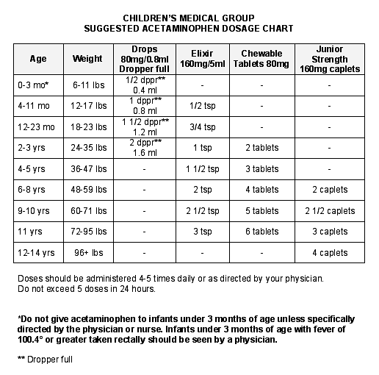

Work Sheet
Task 1: The child is 4 years old and weighs 40 pounds. List the types of Tylenol and the doses of each that you could give this child.
Answer:

______________________________________________________
Task 2: You give the child the first dose of medicine at 4:30pm. What time could you give the next dose?
Answer:

______________________________________________________
Task 3: What is the maximum number of doses you can give the child in a day (24 hours)?
Answer:

______________________________________________________

Answers
Task 1: The child is 4 years old and weighs 40 pounds. List the types of Tylenol and the doses of each that you could give this child.
Answer: 1 ½ tsp of Elixir (160mg/5ml); 3 Chewable Tablets (80mg)

Task 2: You give the child the first dose of medicine at 4:30pm. What time could you give the next dose?
Answer: Between 9:30pm and 10:30pm (4.8 (5) - 6 hours after the first dose)

Task 3: What is the maximum number of doses you can give the child in a day (24 hours)?
Answer: Maximum 5 doses in 24 hours

Performance Descriptors
Levels | Performance Descriptors | Needs Work | Completes task with support from practitioner | Completes task independently
A2.2 | performs limited searches using one or two search criteria
 | extracts information form tables and forms
 | uses layout to locate information
 | makes connections between parts of documents
 | makes low-level inferences
C2.2 | converts between units of time (e.g. hours and days)
 | makes simple estimates
 | interprets, represents and converts time using whole numbers, decimals, percentages, ratios and simple, common fractions
 | chooses and performs required operation(s); may make inferences to identify required operation(s)
 | selects appropriate steps to reach solutions

This task: Was successfully completed Needs to be tried again

Learner Comments:

Instructor (print): Learner (print):
__________________ _________________

