

Task Title: Read a Business Message

OALCF Cover Sheet – Practitioner Copy

Learner Name:___________________________________________
Date Started:____________________________________________
Date Completed: _________________________________________

Goal Path: | Employment | Apprenticeship
Secondary School | Post Secondary | Independence
Successful Completion: Yes No

Task Description: Read aloud a message from a business and then answer written questions about the message.
Main Competency/Task Group/Level Indicator:
- Find and Use Information/Read continuous text/A1.2
- Find and Use Information/Interpret documents/A2.1
- Understand and Use Numbers/Manage time/C2.1
- Manage Learning/E.1

Materials Required:
- Pen/pencil and paper and/or digital device

Notes for Practitioners/Instructors
- Review the learner’s instructions with the learner.
- Go over the checklist with your learner so that your learner is aware of the skills to be demonstrated.

- Ask the learner to read the message aloud.
Help allowed: Dictionary
Adaptation: Any other message from a retail or wholesale outlet

Learner Information
Messages are often taken for colleagues at work. It is important that they are accurately understood, recorded and shared.
Read the business message from Kwik Kopy Printing out loud to your instructor.

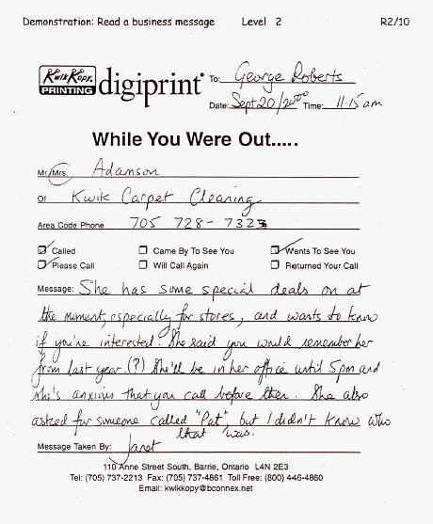

Work Sheet
Task 1: Who took the message?
Answer:

______________________________________________________
Task 2: How did she get this message?
Answer:

______________________________________________________
Task 3: Who is the message for?
Answer:

______________________________________________________
Task 4: Who is the message from?
Answer:

______________________________________________________
Task 5: When was the message left?
Answer:

______________________________________________________
Task 6: What is the main purpose of this message?
Answer:

______________________________________________________

Task 7: What do you think the special deal is about?
Answer:

______________________________________________________
Task 8: When does George have to return the call?
Answer:

______________________________________________________
Task 9: Do you think this message is clear? Why or why not?
Answer:

______________________________________________________
Learner’s Self-Reflection
I recognized that this was a telephone message. Yes ❑ No ❑

I knew who took this message and who this message was for. Yes ❑ No ❑

I knew what had to be done. Yes ❑ No ❑

I could read all the names on this message. Yes ❑ No ❑

I found it easy to read this message. Yes ❑ No ❑

I answered __ out of 9 questions correctly. Yes ❑ No ❑

Learner Comments:

Answers
Task 1: Who took the message?
Answer: Janet
Task 2: How did she get this message?
Answer: By phone
Task 3: Who is the message for?
Answer: George Roberts
Task 4: Who is the message from?
Answer: Mrs. Adamson
Task 5: When was the message left?
Answer: 11:15am
Task 6: What is the main purpose of this message?
Answer: To tell George about special deals and see if he’s interested.
Task 7: What do you think the special deal is about?
Answer: Carpet cleaning
Task 8: When does George have to return the call?
Answer: Before 5pm
Task 9: Do you think this message is clear? Why or why not?
Answer: Answer will vary depending on the learner. We don’t know what the special deal is and we don’t know who Pat is. These things are both unclear based on this message.

Performance Descriptors
Levels | Performance Descriptors | Needs Work | Completes task with support from practitioner | Completes task independently
A1.2 | follows the main events of informational texts
 | scans text to locate information
 | locates multiple pieces of information in simple texts
 | makes low level inferences
A2.1 | interprets brief text
 | locates specific details in simple documents
 | scans to locate specific details
C2.1 | understands and uses common date formats
 | represents dates and times using standard conventions
E.1 | begins to monitor own learning
 | uses feedback to improve performance

This task: Was successfully completed Needs to be tried again
Learner Comments:

Instructor (print): Learner (print):
__________________ _________________

