

Task Title: Compose a Paragraph which Conveys Information

OALCF Cover Sheet – Practitioner Copy

Learner Name: __________________________________________
Date Started: ___________________________________________
Date Completed: _________________________________________

Goal Path: | Employment | Apprenticeship
Secondary School | Post Secondary | Independence
Successful Completion: Yes No

Task Description: The learner will write a paragraph based on a personal interest.
Main Competency/Task Group/Level Indicator:
- Communicate Ideas and Information/Write continuous text/B2.1
- Manage Learning/E.2
Materials Required:
- Pen/pencil and paper and/or digital device with word processing program (e.g., Microsoft Word or Google Docs)
- Printer (optional)
- Dictionary and thesaurus or digital device with dictionary and thesaurus functions

Notes for Instructors/Practitioners
Paragraphs may be typed on the computer or handwritten. To evaluate, look at both the rough copy and the final copy. Most of the skills listed on the evaluation checklist should be completed successfully, although frequent spelling and grammar errors are expected at this level. Emphasis should be on content. There is no time requirement. If needed, this activity may be completed over more than one class session.

Help Allowed: Brainstorming and the rough copy should be completed independently by the learner. The practitioner may help with the process of editing grammar and spelling errors, but the learner should be able to identify some of the errors. A dictionary, thesaurus or spell-check may be used.

Adaptation: Any topic relevant to the learner may be chosen.

Learner Information
Reviewing your writing for errors can help improve skills like spelling and grammar. Writing also gives you a chance to focus on how you express ideas on paper.

Work Sheet
Task 1: Choose one of the following subjects to write about and circle or highlight your choice.
- First day returning to adult classes
- A special day in your life
- A place you have visited
- A job you would like
- Any memorable event
- An important person in your life

Task 2: Write down at least five ideas you have about this topic. Highlight or circle your best ideas.
Answer:

Task 3: Write a paragraph of at least five sentences on this topic.
Answer:

Task 4: Read over your rough copy looking for spelling or grammar mistakes. If you have typed your paragraph, you may use spellcheck on your computer. You may also use a dictionary or thesaurus. Make any changes to correct your draft. Write your revised draft here. Your final copy does not have to be perfect, but it should clearly express your ideas.
Answer:

Task 5: Give your final copy to your instructor. If you used a computer to write your paragraph, you may show it to your instructor or print it off if a printer is available.
Answer: No written response required here.

Task completed: Yes:
Task 6: Complete the Learner’s Self-Reflection below.
Answer:
Learner’s Self-Reflection:

1. I was able to come up with ideas on my topic. Yes No

2. I wrote the rough copy by myself. Yes No

3. I made some changes to make the paragraph better. Yes No

4. I stayed on the same topic throughout the paragraph. Yes No

5. My information was clear so that anyone could understand. Yes No

6. Most of the time, I wrote complete sentences. Yes No

7. I was able to find some of my errors. Yes No

8. I checked the spelling of words that I was unsure of. Yes No

9. If handwritten, my final copy looked neat and legible. Yes No

Answers
Learner answers will vary. Here are three examples with rationales for successful completion of the task.

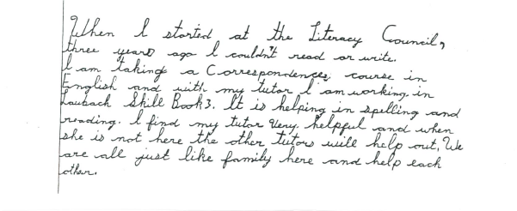

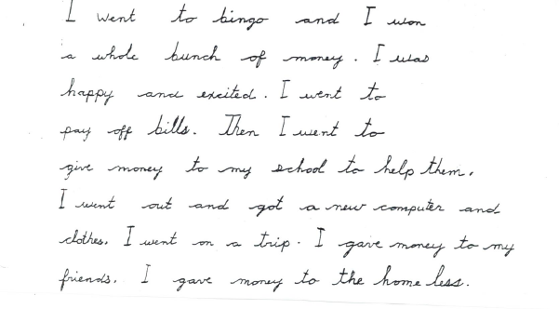

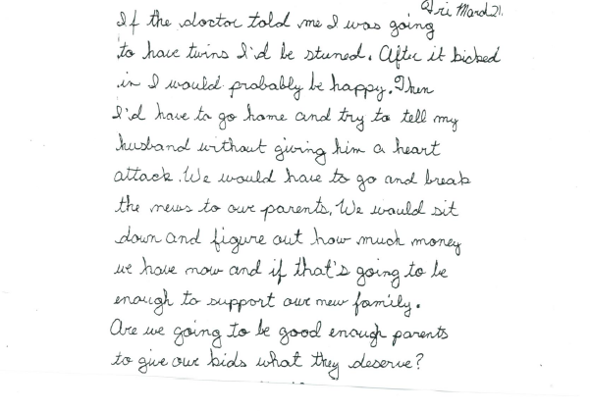

Sample 1: Starting at the Literacy Council

Rationale for successful completion of task:

One paragraph of 5 sentences, talking about personal experience

Stayed on topic throughout

Neat cursive writing

Used appropriate vocabulary

Wrote complete sentences

Capitals generally used correctly (a couple of exceptions)

Spelling is excellent but used help

Sample 2: Bingo

Rationale for successful completion of task:

one paragraph of 8 short sentences

writing about self (an event in his life)

main idea of how he spent his money after winning at Bingo

details are sparse (how much he won, what bills he paid, where he went on his trip, etc.)

some sense of organization introductory sentence and sequencing (then) but there is little evidence of an ending

cursive writing is legible and well-spaced

used appropriate words to convey meaning and feeling, but they are trite (happy, whole bunch of money)

sentence structure is very repetitive (I went... I gave...),

each sentence expresses a complete thought

grammar and spelling is flawless but sentences are very simple with few descriptive words

Sample 3: Having Twins

Rationale for successful completion of task:

one paragraph of 6 sentences

main idea is the writer’s thoughts and feelings if the doctor told her she was going to have twins

she goes through her feelings in chronological order which gives some organization to the writing

uses familiar vocabulary to convey feelings (e.g. stunned and heart attack) and some colloquial expressions such as “After it kicked in”

writes complete sentences, using periods

forms plurals of words

uses capital letters correctly

only spelling mistake is “stuned”; added ending correctly for “giving”

Performance Descriptors
Levels | Performance Descriptors | Needs Work | Completes task with support from practitioner | Completes task independently
B2.1 | writes simple texts to request, remind or inform
 | conveys simple ideas and factual information
 | demonstrates a limited understanding of sequence
 | uses sentence structure, upper and lower case and basic punctuation
 | uses highly familiar vocabulary
E.2 | monitors progress towards achieving goals
 | identifies barriers to achieving goals
 | monitors own learning
 | evaluates own performance using established criteria and tools (e.g. checklist, rubrics)
 | begins to identify ways to improve performance

This task: Was successfully completed Needs to be tried again

Learner Comments:

Instructor (print): Learner (print):
__________________ _________________

