

Task Title: Finding Nutritional Information Online

OALCF Cover Sheet – Practitioner Copy

Learner Name: __________________________________________
Date Started: ___________________________________________
Date Completed: _________________________________________

Goal Path: | Employment | Apprenticeship
Secondary School | Post Secondary | Independence
Successful Completion: Yes No

Task Description: The learner will find and compare nutritional information about coffee items in the Tim Horton’s Nutritional Guide.
Main Competency/Task Group/Level Indicator:
- Find and Use Information/Interpret documents/A2.2
- Understand and Use Numbers/Manage data/C4.1
Materials Required:
- Pen/pencil and paper or computer/digital device

Learner Information
On restaurant websites, nutritional information is posted about the food and drinks that are sold. This is useful for people who have allergies or other dietary restrictions.
Scan “Tim Horton’s Nutritional Information for Coffee Beverages”.

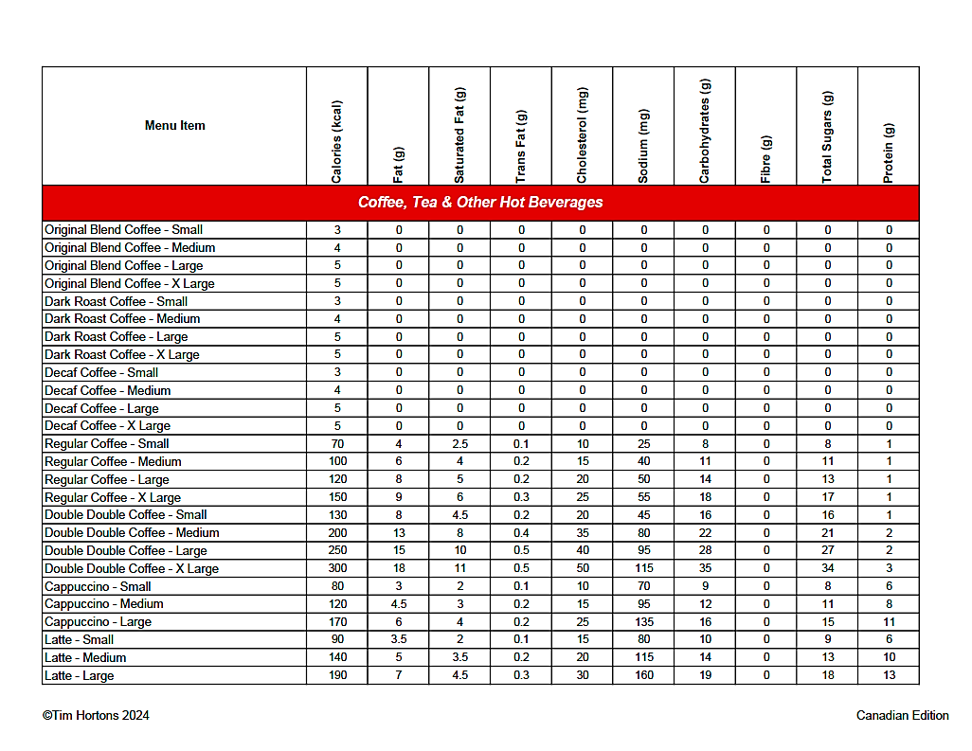
Tim Horton’s Nutritional Information for Coffee Beverages

Work Sheet
Task 1: You are comparing original blend coffee, dark roast coffee, decaf coffee, regular coffee, and double double coffee. Which options have zero grams of sugar?
Answer:

______________________________________________________
Task 2: Which has fewer grams of carbohydrates - a small cappuccino or a small latte?
Answer:

______________________________________________________
Task 3: Which drink has the most protein?
Answer:

______________________________________________________
Task 4: Which large drink option would you purchase if you wanted the fewest calories (kcal)?
Answer:

______________________________________________________

Answers
Task 1: You are comparing original blend coffee, dark roast coffee, decaf coffee, regular coffee, and double double coffee. Which options have zero grams of sugar?
Answer: Original blend coffee, dark roast coffee and decaf coffee

Task 2: Which has fewer grams of carbohydrates - a small cappuccino or a small latte?
Answer: Small cappuccino. Small cappuccino (9 grams of carbohydrates); small lattee (10 grams of carbohydrates).

Task 3: Which drink has the most protein?
Answer: Large latte (13 grams of protein)

Task 4: Which large drink option would you purchase if you wanted the fewest calories (kcal)?
Answer: Large original blend, dark roast or decaf coffee

Performance Descriptors
Levels | Performance Descriptors | Needs Work | Completes task with support from practitioner | Completes task independently
A2.2 | performs limited searches using one or two search criteria
 | extracts information from tables and forms
 | uses layout to locate information
 | makes connections between parts of documents
 | makes low-level inferences
C4.1 | identifies and compares quantities of items

This task: Was successfully completed Needs to be tried again
Learner Comments:

Instructor (print): Learner (print):
__________________ _________________

