

Task Title: Book or Movie Review & Report A

OALCF Cover Sheet – Practitioner Copy
Learner Name:___________________________________________
Date Started (m/d/yyyy):__________________________________
Date Completed (m/d/yyyy): _______________________________
Successful Completion: Yes No
Goal Path: | Employment | Apprenticeship
Secondary School | Post Secondary | Independence

Task Description: Read and answer questions about a short report.
Main Competency / Task Group / Level Indicators:
- Find and Use Information/Read continuous text/A1.2
- Find and Use Information/Interpret documents/A2.1
- Communicate Ideas and Information/Write continuous text/B2.2
Performance Descriptors: See chart on last page
Materials Required:
- Pen and Paper and/or digital device

Learner Information
In this task you will understand how a book or movie is developed.

Read the article: "Movie and Book Components".

Movie and Book Components

Both books and movies create impressions for the reader/viewer through setting, characters, conflict, plot, theme and point of view. Therefore, whether you choose to read a book or watch a movie, and then write a review, the writing process is the same.

The setting tells us where and when the story takes place. It can also give important background information and create atmosphere for the story.
Characterization is the creation of imaginary people who are so believable that we see them as real. We learn the character’s name, his appearance, his actions, his words, his thoughts and his feelings. All of these contribute to creating an impression. What others say and how they feel about a character gives us more information about that character.
Conflict is a struggle between two opposing forces. Conflict in literature (or in movies) can take several forms. A character may struggle against another character, against society, against nature, or against the unknown. Often, more than one conflict is present in a story. The audience wants to know how the characters react to conflict and how the story ends.
- Conflict with others sets one character against another and is the most basic kind of conflict.
- Conflict with society sets one character against accepted ways of thinking and behaving. Since society is made up of people, this is conflict between people on a larger scale.
- Conflict with self involves a struggle that takes place within a character. It occurs when an individual is confronted with a difficult choice or an unpleasant situation.
- Conflict with nature sets a character against the forces of nature.
- Conflict with the unknown sets a character against that which is beyond human comprehension such as: fate, magic, or death.
The plot is a series of events in a novel or movie through which the author reveals what is happening, to whom, and why. The author builds tension through the development of the plot.
The initial conflict is the first problem or twist in the plot. It leads to the complications which heighten the suspense and interest.
Complications are twists and turns in the plot which create tension and further conflict. Every plot is built around conflict in order to create interest and build suspense.
The climax is the point of greatest tension in the story. A novel or movie will often have several points of high tension, each followed by a resolution. Plots follow a basic pattern like the one shown in this chart:
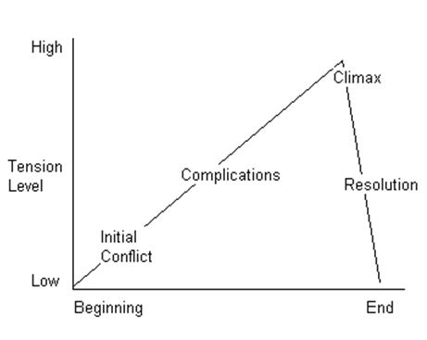
The theme of a novel or movie tells us the author’s message about the people and the world in which we live. One theme may be stated in different ways. One story may have several themes. The theme is expressed through setting, characterization, and conflict and plot. Themes apply to people in general and can also apply to us personally. Our understanding of the author’s message may reinforce, or even change, some of our attitudes and opinions.
The point of view often determines what we think of the characters and the story’s outcome. Telling the story through different character’s eyes or using a third person narrator may change our feelings about what happens. We may be more or less sympathetic toward different characters.

Work Sheet
Task 1: List each impression created for viewers/readers in movies or books.
Answer:

______________________________________________________
Task 2: How many types of conflicts can be created in a movie or book?
Answer:
______________________________________________________
Task 3: List the components that contribute to the characterization of imaginary people in movies and books.
Answer:

______________________________________________________
Task 4: At what point does the greatest tension occur in a movie or book?
Answer:
______________________________________________________
Task 5: Explain what is meant by "complications”.
Answer:

______________________________________________________

Answer Sheet
Task 1: List each impression created for viewers/readers in movies or books.
Answer: Setting, Characters, Conflict, Plot, Theme and Point of View.

Task 2: How many types of conflicts can be created in a movie or book?
Answer: Up to 5

Task 3: List the components that contribute to the characterization of imaginary people in movies and books.
Answer: character’s name, his appearance, his actions, his words, his thoughts and his feelings (can also include what others say and how they feel about a character)

Question 4: At what point does the greatest tension occur in a movie or book?
Answer: The climax

Question 5: Explain what is meant by "complications.
Answer: Complications are twists and turns in the plot which create tension and further conflict. Every plot is built around conflict in order to create interest and build suspense.

Performance Descriptors
Levels | Performance Descriptors | Needs Work | Completes task with support from practitioner | Completes task independently
A1.2 | Scans text to locate information
 | Locates multiple pieces of information in simple texts
 | Makes low-level inferences
 | Makes connections between sentences and between paragraphs in a single text
 | Begins to identify sources and evaluate information
A2.1 | Scans to locate specific details
 | Interprets brief text and common symbols
 | Locates specific details in simple documents, such as labels and signs
B2.2 | Writes texts to explain and describe
 | Conveys intended meaning on familiar topics for a limited range of purposes and audiences
 | Uses limited range of vocabulary and punctuation appropriate to the task

This task: Was successfully completed Needs to be tried again

Learner Comments:

Instructor (print): Learner Signature:

____________________ ____________________

