

Task Title: Applying for a Canadian Passport

OALCF Cover Sheet – Practitioner Copy

Learner Name: __________________________________________
Date Started: ___________________________________________
Date Completed: _________________________________________

Goal Path: | Employment | Apprenticeship
Secondary School | Post Secondary | Independence
Successful Completion: Yes No

Task Description: Learner will read through instructions to learn how to apply for a Canadian passport.
Main Competency/Task Group/Level Indicator:
- Find and Use Information/Read continuous text/A1.2
- Communicate Ideas and Information/Write continuous text/B2.1
Materials Required:
- Pen/pencil and paper and/or digital device

Learner Information
Canadian citizens who travel outside of Canada need a Canadian passport. People need to apply for Canadian passports using a passport application. There are several items needed to complete a passport application form.
Scan the requirements page for the “Adult General Passport Application”.

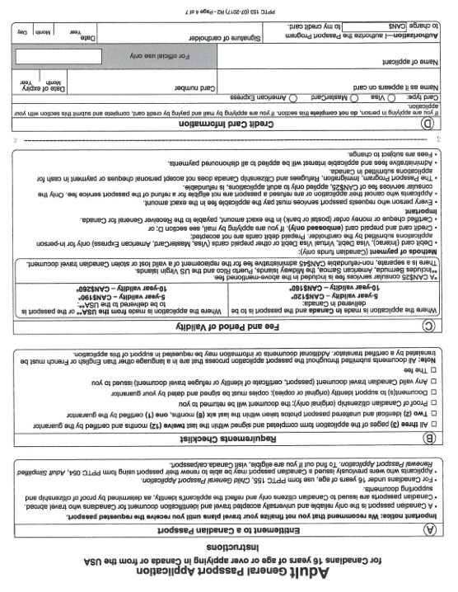

Work Sheet
Task 1: Why is it important for a Canadian citizen who is travelling to have a passport (according to the Canadian passport application form instruction sheet)?
Answer:

______________________________________________________
Task 2: List 3 items you will need to take (or mail) to the passport office so you can get your passport.
Answer:

______________________________________________________
Task 3: How much does it cost to get a Canadian passport valid for 10 years if you are applying from Canada?
Answer:

______________________________________________________
Task 4: If you are applying by mail, what are the accepted methods of payment for a passport?
Answer:

______________________________________________________

Answers
Why is it important for a Canadian citizen who is travelling to have a passport (according to the Canadian passport application form instruction sheet)?
Answer: A Canadian passport is the only reliable and universally accepted travel and identification document for Canadians who travel abroad.

Task 2: List 3 items you will need to take (or mail) to the passport office so you can get your passport.
Answer: Any three of
- All three pages of the application form completed and signed within the last twelve months, with page one certified by the guarantor
- Two identical and unaltered passport photos taken within the last six months, one certified by the guarantor
- Proof of Canadian citizenship (original only)
- Document(s) to support identity (original or copies)
- Any valid Canadian travel document (passport, certificate of identity or refugee travel document) issued to you
- The fee

Task 3: How much does it cost to get a Canadian passport valid for 10 years if you are applying from Canada?
Answer: $160

Task 4: If you are applying by mail, what are the accepted methods of payment for a passport?
Answer: Credit card (Visa, Mastercard, American Express)

Performance Descriptors
Levels | Performance Descriptors | Needs Work | Completes task with support from practitioner | Completes task independently
A1.2 | scans text to locate information
 | locates multiple pieces of information in simple texts
 | makes low-level inferences
 | reads more complex texts to locate a single piece of information
 | obtains information from detailed reading
 | begins to identify sources and evaluate information
B2.1 | writes simple texts to request, remind or inform
 | conveys simple ideas and factual information
 | demonstrates a limited understanding of sequence
 | uses sentence structure, upper and lower case and basic punctuation
This task: Was successfully completed Needs to be tried again

Learner Comments:

Instructor (print): Learner (print):
__________________ _________________

