

Task Title: Write a Work Order/Invoice

OALCF Cover Sheet – Practitioner Copy

Learner Name:___________________________________________
Date Started (m/d/yyyy):__________________________________
Date Completed (m/d/yyyy):_______________________________
Successful Completion: Yes No

Goal Path: | Employment | Apprenticeship
Secondary School | Post Secondary | Independence

Task Description: The learner will use information provided during role play to complete a work order/invoice.

Main Competency / Task Group / Level Indicator:
- Find and Use Information/Read continuous text/A1.2
- Communicate Ideas and Information/Interact with others/B1.1
- Communicate Ideas and Information/Complete and create documents/B3.2a
- Understand and Use Numbers/Manage money/C1.2
- Manage Learning/E.1

Materials Required:
- Pencil or Pen
- Calculator
Notes for Instructor/Practitioner:
- Make sure the learner understands the information/instructions for this task.
- Go over the performance descriptors section with your learner to ensure they understand what is being assessed by this task.
- Discuss with the learner and decide what would be a reasonable length of time for the completion of this task. Record this on the assessment form.
- When the learner has completed the task, provide a way for them to self-reflect on the experience. Complete the assessment form with the learner, enter the date completed, and note whether it was successful or needs to be tried again.
- Make any adjustments to size of font or amount of text on a page that you feel is appropriate for this level and this learner.

Role-Play Scenario:
You, the practitioner, are a customer who comes into the learner’s place of business to ask for a repair to be done. This is the information you will need.
• You have a mirror that is broken, and the glass needs to be replaced.
• You need this as quickly as possible.
• You want to know how much it will cost.

Give the following information when and if prompted:
• Your name is Philippa Madison
• Your address is 56 Willowdale Road, Tottenham, Ontario, L0G 1W0
• Your phone number is 936-3355 (area code 905). You have an
answering machine at home.
• The size of the mirror frame is 20 inches by 28 inches.
• You plan to pay with Visa

Help Allowed:
The student may ask questions to clarify information, ask for the spelling of proper names, and/or take notes while you are talking and use them to calculate costs and write up the invoice.

Adaptation: Conduct the initial contact with the student over the telephone. Make up a different scenario, with different materials/ products, and an appropriate invoice /bill form.

Learner Information
Working with bills and invoices is one of the tasks you will face when you reach your goal of getting a job in the sales and service industry. This task will give you an opportunity to use several skills together and to see how they are used for preparing a bill for a customer.
Scan the “Work Order/Invoice” and the “Price List”.

Learner Instructions
In this activity, you will play the part of a clerk in the customer service department of the Bradford Glass Company. Your instructor will be a customer coming to Bradford Glass to get some help. Your job is to prepare a work order / invoice for the job. Here is a list of things that will help you as you work through this demonstration.
1. Ask questions of the customer to get the information you need.
2. You may ask your customer for the spelling of any proper names that you
are not sure of.
3. You may take rough notes during or after the conversation with your
customer.
4. You will need to be familiar with the company price list in order to answer
questions the customer will ask.
5. Use the form provided to write up the work order/invoice.
6. When you have completed writing up the invoice, go over the invoice with
your customer so that they understand the charges.

BRADFORD GLASS LTD.  Box 1233  Bradford, Ontario, L9Z 2B7  (905) 775- 0000 |  |  |  |  |  |  | WORK ORDER / INVOICE  Number: 0217
Customer Order # |  |  |  | Telephone |  |  |  | Fax |  |  |  | Date
Name:
Address:
Postal Code
Sold By | Cash |  | Charge  Card |  | Cheque | Debit |  |  | C.O.D. |  | On Acct |  |  | Mdse ret | Paid out
Quantity Description Price Amount
Special instructions  All claims and returned goods must be accompanied by a paid bill |  |  |  |  |  |  |  |  |  | Subtotal
 |  |  |  |  |  |  |  |  |  | HST
 |  |  |  |  |  |  |  |  |  | TOTAL
Received by: Thank You

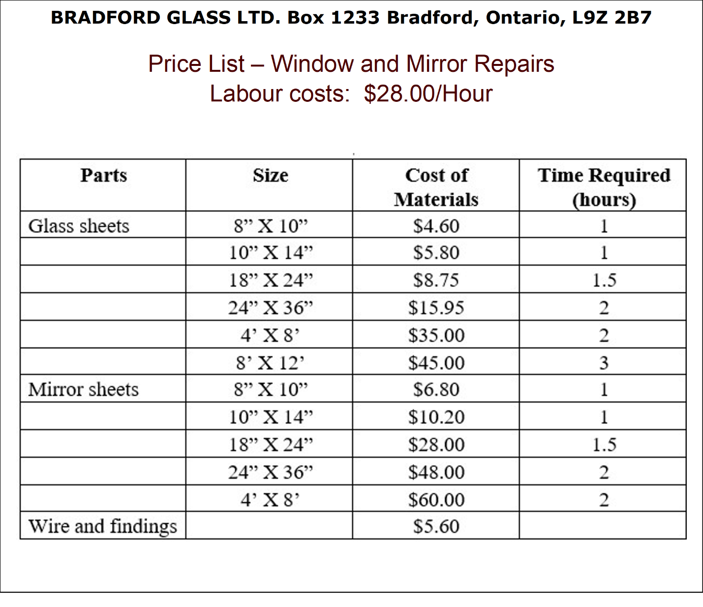

Learner’s self reflection:

I listened carefully to what my customer wanted. Yes  No 

I took notes during the conversation. Yes  No 

I asked for all the details I needed. Yes  No 

I was able to answer any questions the customer asked. Yes  No 

I could re-read my notes after the conversation. Yes  No 

I was able to make up an invoice with all the relevant Yes  No 
details.
The invoice was clear and neatly written. Yes  No 

Other comments:

Answer Key
*There may be some variation, depending on the questions that the learner asked
BRADFORD GLASS LTD.  Box 1233  Bradford, Ontario, L9Z 2B7  (905) 775- 0000 |  |  |  |  | WORK ORDER / INVOICE  Number: 0217
Customer Order # |  | Telephone  905-936-3355 |  |  |  | Fax |  | Date  (today’s date)
Name: Philippa Madison
Address: 56 Willowdale Road, Tottenham, ON
Postal Code L0G 1W0
Sold By | Cash | Charge  Card (Visa) | Cheque | Debit |  | C.O.D. | On Acct | Mdse ret |  | Paid out
Quantity Description Price Amount
1 | Mirror Sheet – 24”x 36” |  |  |  |  |  | 48.00 |  | 48.00
2 | Labour – cut to 20”x28” and install |  |  |  |  |  | 28.00 |  | 56.00
Special instructions  Needs done ASAP  Messages can be left on answering machine  All claims and returned goods must be accompanied by a paid bill |  |  |  |  |  |  | Subtotal |  | 104.00
 |  |  |  |  |  |  | HST |  | 13.52
 |  |  |  |  |  |  | TOTAL |  | 117.52
Received by: Thank You

Performance Descriptors
Levels | Performance Descriptors | Needs Work | Completes task with support from practitioner | Completes task independently
A1.2 | Scans text to locate information
 | Locates multiple pieces of information in simple texts
 | Obtains information from detailed reading
 | Makes low-level inferences
B1.1 | Chooses appropriate language in exchanges with clearly defined purposes
 | Participates in short, simple exchanges
 | Gives short, straightforward instructions or directions
B3.2a | Uses layout to determine where to make entries
 | Begins to make some inferences to decide what information is needed, where and how to enter the information
 | Makes entries using a limited range of vocabulary
 | Follows instructions on documents
C1.2 | Calculates using numbers expressed as whole numbers, fractions, decimals, percentages and integers
C1.2 | Calculates percentages
 | Interprets and applies rates
 | Chooses and performs required operation(s); may make inferences to identify required operation(s)
 | Selects appropriate steps to reach solutions
 | Represents costs and rates using monetary symbols, decimals and percentages
 | Interprets, represents and converts amounts using whole numbers, decimals, percentages, ratios and simple, common fractions (e.g. ½, ¼ )
 | Uses strategies to check accuracy (e.g. estimating, using a calculator, repeating a calculation, using the reverse operation)
E.1 | Begins to monitor own learning

This task:
Was successfully completed Needs to be tried again

Learner Comments:

Instructor (print): Learner (print):
________________________ ________________________

