

Task Title: Understand Temperature in Celsius and Fahrenheit

OALCF Cover Sheet – Practitioner Copy

Learner Name: __________________________________________
Date Started: ___________________________________________
Date Completed: _________________________________________

Goal Path: | Employment | Apprenticeship
Secondary School | Post Secondary | Independence
Successful Completion: Yes No

Task Description: The learner will identify and mark different temperatures on a thermometer showing Celsius and Fahrenheit.
Main Competency/Task Group/Level Indicator:
- Understand and Use Numbers/Use measures/C3.1
Materials Required:
- Pen/pencil and paper

Learner Information
Understanding how different temperatures are marked on thermometers can help you plan your day. Depending on the temperature, you may choose different clothing or decide to do activities outdoors. While Canada most commonly uses Celsius to measure temperature, many thermometers show both. Some news reports will also give the temperature in both Celsius and Fahrenheit so it can be helpful to learn basic equivalencies.

Scan the Thermometer.

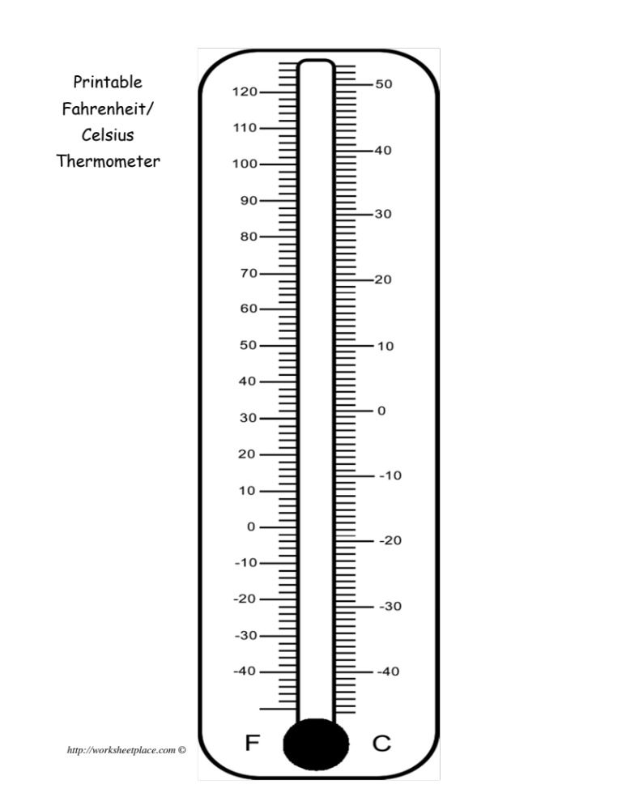

Work Sheet
Task 1: Water freezes at 0 degrees Celsius or 32 degrees Fahrenheit. Draw a line on the thermometer showing the freezing point of water.
Answer: No written response required here.

Task completed: Yes:

Task 2: Room temperature is often 20 degrees Celsius or 68 degrees Fahrenheit. Draw a line on the thermometer showing room temperature.
Answer: No written response required here.

Task completed: Yes:

Task 3: Body temperature is 37 degrees Celsius or 99 degrees Fahrenheit. Draw a line on the thermometer showing body temperature.
Answer: No written response required here.

Task completed: Yes:

Answers

Task 2
Task 3
Task 1

Performance Descriptors
Levels | Performance Descriptors | Needs Work | Completes task with support from practitioner | Completes task independently
C3.1 | measures distance, length, width, height, weight, liquid volume, angles and temperature
 | uses common measuring tools, such as rulers, scales and thermometers
 | understands numerical order
 | begins to interpret integers (e.g. temperature, elevation)

This task: Was successfully completed Needs to be tried again
Learner Comments:

Instructor (print): Learner (print):
__________________ _________________

