

Task Title: Take-Out Food Purchase

OALCF Cover Sheet – Practitioner Copy

Learner Name: __________________________________________
Date Started: ___________________________________________
Date Completed: _________________________________________

Goal Path: | Employment | Apprenticeship
Secondary School | Post Secondary | Independence
Successful Completion: Yes No

Task Description: The learner will calculate the costs and amount of money left over after purchasing a take-out meal with friends.
Main Competency/Task Group/Level Indicator:
- Find and Use Information/Interpret documents/A2.1
- Understand and Use Numbers/Manage money/C1.1
Materials Required:
- Pen/pencil and paper and/or digital device
- Calculator or digital device with calculator function (optional)

Learner Information
Many people get together with friends or family members and order take-out. When placing one order together, it is important to calculate how much each person or family has spent.
Read the Scenario and Vito’s Take-Out Menu”.

Scenario
Three families get together once a month for a take-out and movie night. This month, the Closs family is hosting and it is their turn to pick up meals.
The Closs Family wants 2 orders of Pasta and Garlic Bread for Two.
The Devlin Family wants the Pizza and Wing Combo.
The Emerson Family wants the Pizza and Chicken Family Meal.

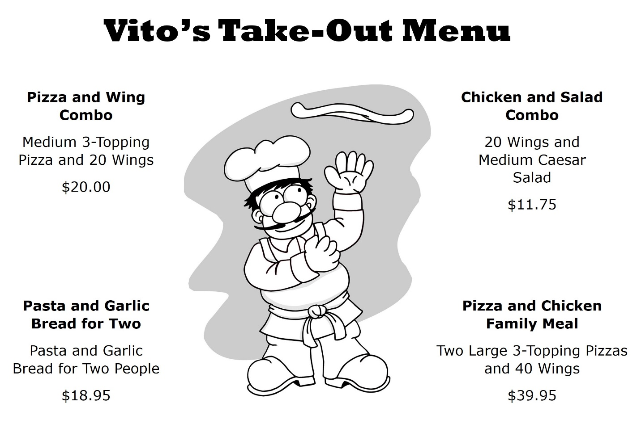

Work Sheet
Task 1: Calculate the total cost for each family’s meal. It is January 2025 and there is no tax on take-out meals in Canada this month. Each family will also contribute $5 for a tip.
Answer:

______________________________________________________
Task 2: Including the tip, what will be the total cost for dinner for all three families?
Answer:

______________________________________________________
Task 3: Rob Closs is stopping to pick up videos which cost $7.00. There is no tax on video rentals. He is then going to pick up the food. If he takes $140.00, how much will he have left after picking up the videos and food?
Answer:

______________________________________________________
Answers
Task 1: Calculate the total cost for each family’s meal. It is January 2025 and there is no tax on take-out meals in Canada this month. Each family will also contribute $5 for a tip.
Answer:
Closs Family: Two orders of Pasta and Garlic Bread for Two.
$18.95 x 2 = $37.90
$37.90 + $5.00 tip = $42.90
Devlin Family: Pizza and Wing Combo.
$20.00 + $5.00 tip = $25.00
Emerson Family: Pizza and Chicken Family Meal.
$39.95 + $5.00 tip = $44.95

Task 2: Including the tip, what will be the total cost for dinner for all three families?
Answer: $42.90 + $25.00 + $44.95 = $112.85

Task 3: Rob Closs is stopping to pick up videos which cost $7.00. There is no tax on video rentals. He is then going to pick up the food. If he takes $140.00, how much will he have left after picking up the videos and food?
Answer: $140.00 - $112.85 = $27.15 - $7.00 = $20.15 left

Performance Descriptors
Levels | Performance Descriptors | Needs Work | Completes task with support from practitioner | Completes task independently
A2.1 | scans to locate specific details
 | interprets brief text and common symbols
 | locates specific details in simple documents, such as labels and signs
C1.1 | adds, subtracts, multiplies and divides whole numbers and decimals
 | recognizes values in number and word format
 | identifies and performs required operation
 | follows apparent steps to reach solutions
 | interprets and represents costs using monetary symbols and decimals
 | uses strategies to check accuracy (e.g. estimating, using a calculator, repeating a calculation, using the reverse operation)

This task: Was successfully completed Needs to be tried again

Learner Comments:

Instructor (print): Learner (print):
__________________ _________________

