

Task Title: Paying Household Bills

OALCF Cover Sheet – Practitioner Copy

Learner Name: __________________________________________
Date Started: ___________________________________________
Date Completed: _________________________________________

Goal Path: | Employment | Apprenticeship
Secondary School | Post Secondary | Independence
Successful Completion: Yes No

Task Description: The learner will write cheques for household bills and track monthly expenses.
Main Competency/Task Group/Level Indicator:
- Find and Use Information/Interpret documents/A2.2
- Communicate Ideas and Information/Complete and create documents/B3.1a
- Understand and Use Numbers/Manage money/C1.2
Materials Required:
- Pen/pencil and paper and/or digital device
- Calculator or digital device with calculator function (optional)

Notes for Instructors/Practitioners

This task requires the learner to fill in cheques by hand. Print out the cheques beforehand and give them to your learner. You can also print the Record of Cheques and Monthly Budget, or your learner can complete this question electronically. A calculator is optional.

Learner Information
Most people track their monthly expenses and the amount of money they have in their account after paying each bill.

Look at Veena Hamilton’s monthly bills for
- phone
- water
- electricity
- cable

Scan the “Cheques” and “Record of Cheques and Monthly Budget”.

Global Phone  Veena Hamilton |  | 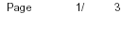
 |  | Account Number 416-225-8448
 |  | Bill date: May 4, 2024

64.34
63.34cr
.00
.00

49.64
.00
5.10
3.84
4.08
62.66
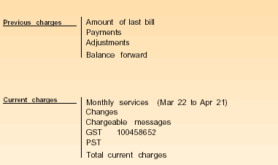

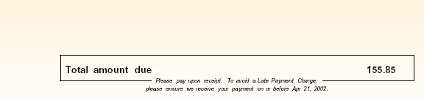 | 62.66

 | WATER Bill |  |  | Account # |  |  | Meter #
 |  |  |  | 000037788 8988 |  |  | 12577008
Make cheque payable to:  Treasurer, City of Tonto  Mail to: Treasurer,  Box 600  Tonto, Ontario  M5L 5L6 |  |  |  |  |  |  | Amount Paid
 |  |  |  | Client
 |  |  |  | Veena Hamilton |  |  | Amount due
 |  |  |  |  |  |  | $46.06
 |  |  |  |  |  |  | Due Date
For enquiries pertaining to your account call 444-2323 |  |  |  |  |  |  | 27/Sep/2024
 |  |  |  | Please return this portion with your payment
WATER Bill |  |  |  |  | Account # |  |  |  | Meter #
 |  |  |  |  | 000037788 8988 |  |  |  | 12577008
Current Reading Date |  |  | Reading
02/Aug/2024 |  |  | 868890.00
Previous Reading Date |  |  | Reading |  |  |  |  | Previous Payment
29/Mar/2024 |  |  | 861056.00 |  |  |  |  | $37.78
Total Consumption |  |  |  |  |  |  |  | Due Date
7834 gallons |  |  |  |  |  |  |  | 27/Sep/2024
 |  |  |  |  |  |  |  | Amount Due
 |  |  |  | Last billing | $37.78 |  |  | $46.06
Payment (thank you) |  |  |  |  | -$37.78
 |  |  |  | Balance | $0.00
 |  |  |  | Current Billing
Total 7834 gallons @ .00588 |  |  |  |  | $46.06
Total Current Billing (incl. previous balance) |  |  |  |  | $46.06

Electricity Bill

Customer: Veena Hamilton

Meter Number | Bill for: | Days | Current meter reading | Previous meter reading |  | Kilowatt Hours Used
0126923 | Oct 2/24 – Nov 2/24 | 31 | 88472 | 87691 |  | 781
 | Customer Charge 14.97
 | *Delivery charge @ $.03 /KWH 23.43
 | Debt retirement charge @$.007/KWH 5.47
 | Electricity Charge @ $.043/KWH 33.58
 | Water Heater Rental 7.00

Total 84.45
GST 5.91

 | Total $90.36
 | Due Date: Dec 4 2024
*includes distribution, transmission and wholesale operations charges

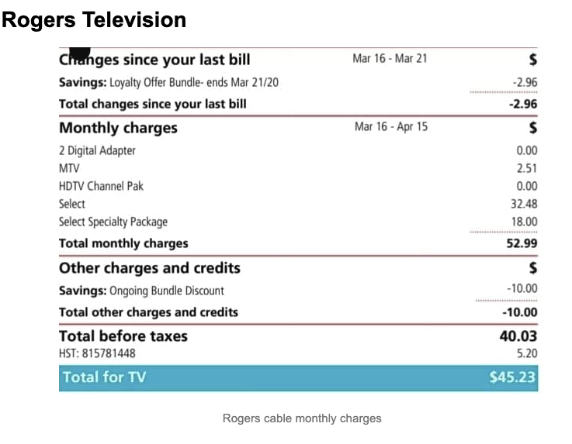

Cheques

 | Veena hamilton  777 Any Street  Toronto, Ontario |  |  |  |  |  |  |  |  | 598
 |  |  |  |  | Date
 | Pay to the  Order of |  |  |  |  |  | $
 |  |  |  |  |  |  | 100 Dollars
 | Memo

 | Veena hamilton  777 Any Street  Toronto, Ontario |  |  |  |  |  |  |  |  | 599
 |  |  |  |  | Date
 | Pay to the  Order of |  |  |  |  |  | $
 |  |  |  |  |  |  | 100 Dollars
 | Memo

 | Veena hamilton  777 Any Street  Toronto, Ontario |  |  |  |  |  |  |  |  | 600
 |  |  |  |  | Date
 | Pay to the  Order of |  |  |  |  |  | $
 |  |  |  |  |  |  | 100 Dollars
 | Memo
 | Veena hamilton  777 Any Street  Toronto, Ontario |  |  |  |  |  |  |  |  | 601
 |  |  |  |  | Date
 | Pay to the  Order of |  |  |  |  |  | $
 |  |  |  |  |  |  | 100 Dollars
 | Memo

 | Veena hamilton  777 Any Street  Toronto, Ontario |  |  |  |  |  |  |  |  | 602
 |  |  |  |  | Date
 | Pay to the  Order of |  |  |  |  |  | $
 |  |  |  |  |  |  | 100 Dollars
 | Memo

 | Veena hamilton  777 Any Street  Toronto, Ontario |  |  |  |  |  |  |  |  | 603
 |  |  |  |  | Date
 | Pay to the  Order of |  |  |  |  |  | $
 |  |  |  |  |  |  | 100 Dollars
 | Memo

Record of Cheques and Monthly Budget
Check No. | Date | Payment/Deposit | Check amount  - |  | Amount of deposit  + |  | Balance
 |  |  |  |  |  |  | $3,465 | 00

Work Sheet
Task 1: Using the cheques provided, write a cheque for each of Veena’s monthly bills. Use today’s date and sign Veena Hamilton’s name. Write an additional cheque, dated for the first day of next month, for $978 to Reynolds Corporation for Veena’s rent.
Answer: No written response required here.

Task completed: Yes:
______________________________________________________
Task 2: Record the amount of each cheque you wrote in Task 1 in the Record of Cheques and Monthly Budget. The beginning balance is $3,465.00. For each entry remember to calculate the new balance.
Answer: No written response required here.

Task completed: Yes:
______________________________________________________

Answers
Task 1: Using the cheques provided, write a cheque for each of Veena’s monthly bills. Use today’s date and sign Veena Hamilton’s name. Write an additional cheque, dated for the first day of next month, for $978 to Reynolds Corporation for Veena’s rent.
Answer: Completed cheques should have all information accurately written in the appropriate place with today’s date for all bills and the first of next month for the rent cheque. Writing should be clear and legible. Veena Hamilton’s name should be signed.

Task 2: Record the amount of each cheque you wrote in Task 1 in the Record of Cheques and Monthly Budget. The beginning balance is $3,465.00. For each entry remember to calculate the new balance.

Record of Cheques and Monthly Budget Record
Check No. | Date | Payment/Deposit | Check amount  - |  | Amount of deposit  + |  | Balance
 |  |  |  |  |  |  | $3,465 | 00
598 | (today’s date) | Phone (Global Phone) | 62 | 66 |  |  | $3,402 | 34
599 | (today’s date) | Electricity | 90 | 36 |  |  | $3,311 | 98
560 | (today’s date) | Water (City of Tonto) | 46 | 06 |  |  | $3,265 | 92
561 | (today’s date) | Cable (Rogers) | 45 | 23 |  |  | $3,220 | 69
562 | (First of next month) | Rent (Reynolds Corporation) | 978 | 00 |  |  | $2,242 | 69

Performance Descriptors
Levels | Performance Descriptors | Needs Work | Completes task with support from practitioner | Completes task independently
A2.2 | performs limited searches using one or two search criteria
 | extracts information from tables and forms
 | uses layout to locate information
 | makes connections between parts of documents
 | makes low-level inferences
B3.1a | makes a direct match between what is requested and what is entered
C1.2 | calculates using numbers expressed as whole numbers, fractions, decimals, percentages and integers
 | chooses and performs required operation(s); may make inferences to identify required operation(s)
C1.2 cont’d | selects appropriate steps to reach solutions
 | represents costs and rates using monetary symbols, decimals and percentages
 | uses strategies to check accuracy (e.g. estimating, using a calculator, repeating a calculation, using the reverse operation)

This task: Was successfully completed Needs to be tried again
Learner Comments:

Instructor (print): Learner (print):
__________________ _________________

