

Task Title: Paying Bills by Cheque

OALCF Cover Sheet – Practitioner Copy

Learner Name: __________________________________________
Date Started: ___________________________________________
Date Completed: _________________________________________

Goal Path: | Employment | Apprenticeship
Secondary School | Post Secondary | Independence
Successful Completion: Yes No

Task Description: The learner will practise writing cheques and addressing envelopes to pay bills.
Main Competency/Task Group/Level Indicator:
- Find and Use Information/Interpret documents/A2.1
- Communicate Ideas and Information/Complete and create documents/B3.1a
Materials Required:
- Pen
- 3 cheques and 3 envelopes (if learner is doing taskset using their own bills)

Notes for Practitioners/Instructors
For this taskset, three sample bills are provided as well as templates for an envelope to be addressed and cheques to be filled out. Alternatively, the learner may wish to bring in their own bills, cheques and envelopes to complete this assignment.
The sample bills can be modified beforehand with current dates and learner name/address for authenticity.

Learner Information
Many people mail cheques to pay their bills. This requires you to properly interpret the bill, then fill out a cheque and address an envelope.
Scan
- Sample Bill #1
- Sample Bill #2
- Sample Bill #3
- Sample Envelope
- Sample Cheque

Sample Bill #1
B & J PLUMBING | 44 Bolton Road  Anytown, ON  K1P 2O3  715-854-8201 | Date December 11, 2024
B & J PLUMBING | 44 Bolton Road  Anytown, ON  K1P 2O3  715-854-8201 | Invoice # 68411
Sold To:

1 | Replacement hose for Washing machine  Labour  Total parts and labour  HST | $ 12.03  $ 30.00 |  | $ 42.03  $ 5.46
Net: 30 days TOTAL  Please write invoice number on front of cheque. |  |  |  | $47.49
Payment Stub (cut along dotted line and include with your payment)

B & J Plumbing
44 Bolton Road
Anytown, ON
K1P 2O3
715-854-8201
Sold To: |  |  | Invoice # 68411
Payment Amount: |  |  | Date:

Sample Bill #2
Hydro Ontario Your account number
08975-11231
Electricity bill for: Date: January 1 2024

(Learner’s name & address)

Here’s what you owe
Amount of your last bill $200.12
Amount we received - $200.12
Balance forward $ 0.00
Your new charges $132.33

Total amount now due $132.33

A penalty will apply for accounts overdue.

Please tear off bottom portion and include with payment.
Account number: 08975-11231 Name:

Send payment to: Amount enclosed:
Hydro Ontario, Box 93,
Toronto ON R6M 9E2

Sample Bill #3
THE CITY OF OVERLEA Water Billing
P.O. Box 378
Overlea, ON K4X 3H7
Account Number. Z00068 B

Water charges $45.00
Sewer charges 0.00
Miscellaneous 0.00
TOTAL BILL $45.00

Due date: January 1 2025 Payment after due date: $47.25

Please write account number on front of cheque

THE CITY OF OVERLEA Payment Portion
Water Billing Dept.
P.O. Box 378
Overlea, ON K4X 3H7

Account Number
Z00068 B
Amount Paid:

Date:

Sample Envelope
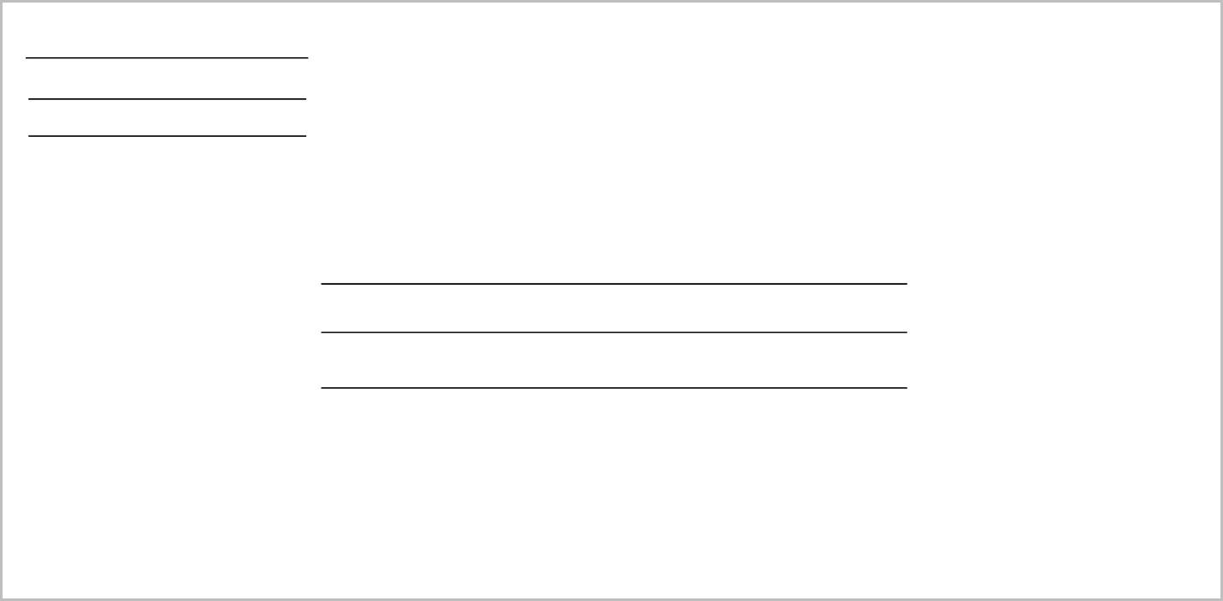

Sample Cheque
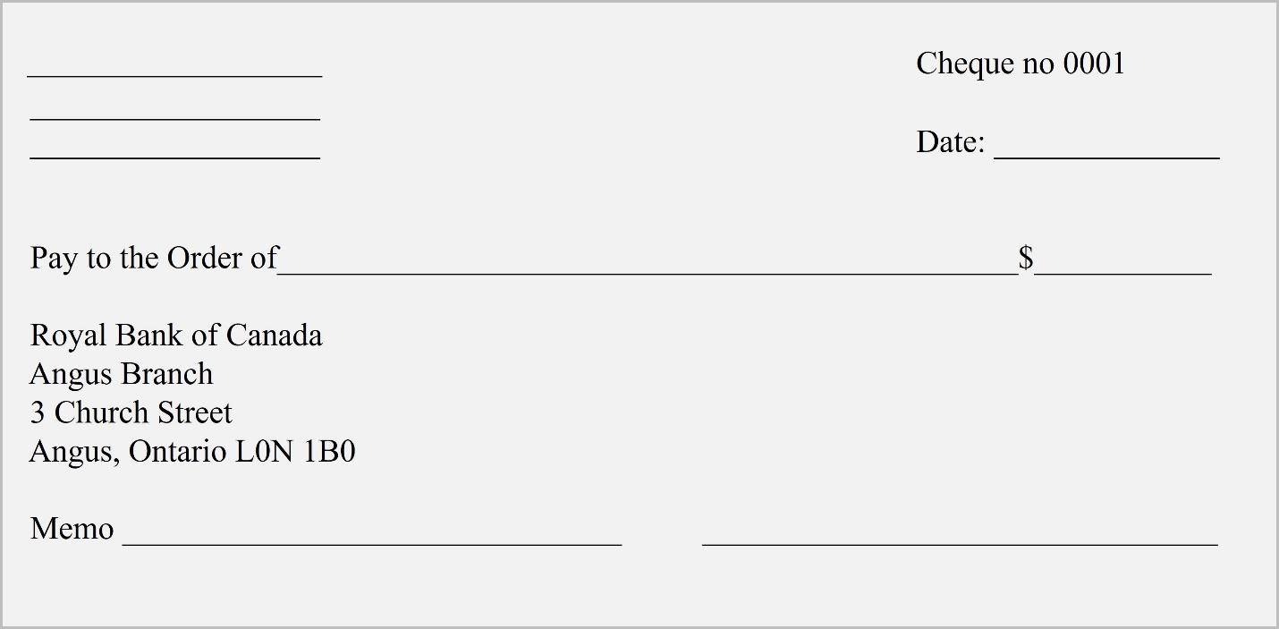

Work Sheet
Task 1: Write down the following information for each bill:
- Who the bill is from
- When the bill is due
- How much money is owed
- Any special instructions given.
Answer:

_____________________________________________________________
Task 2: Using today’s date and information from the bills, fill out 3 cheques, one for each bill to be paid.
Answer:
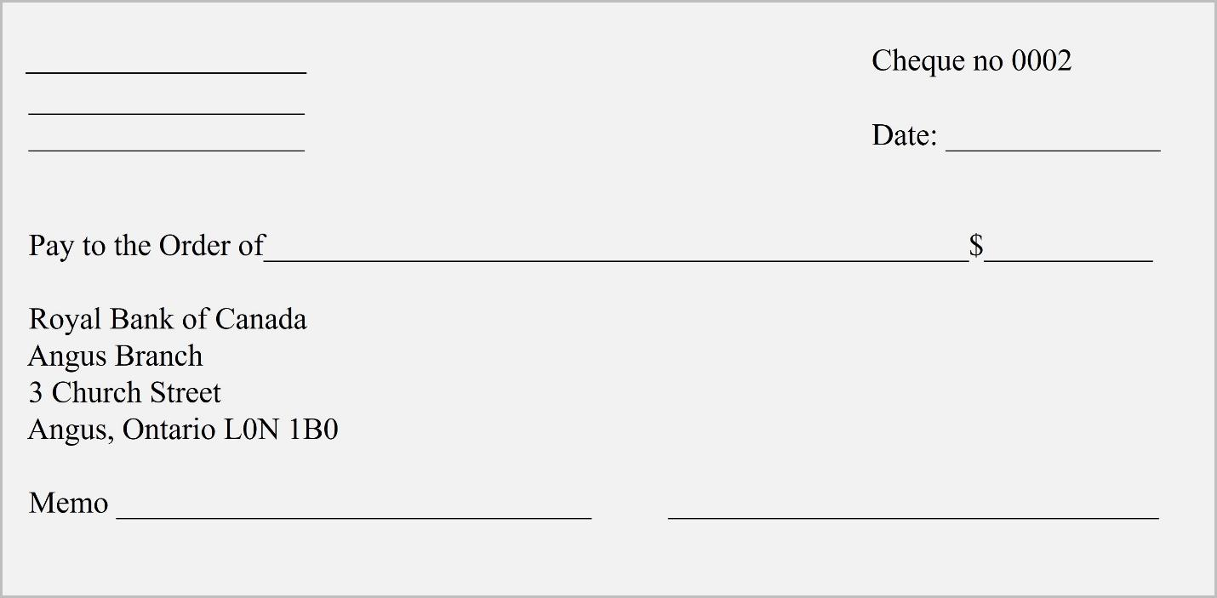

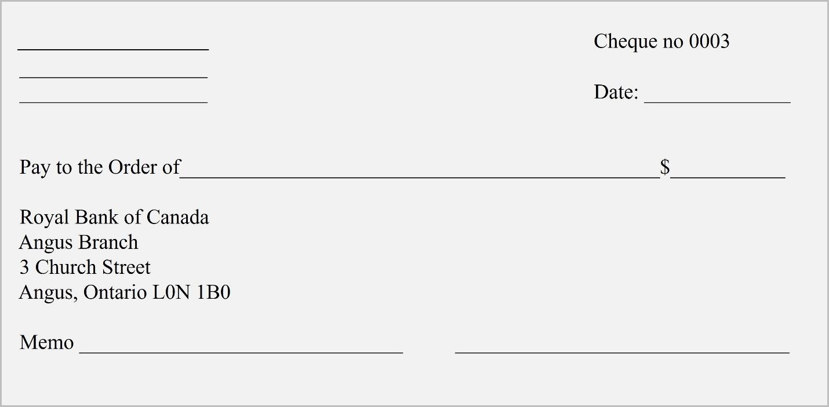

Task 3: Using the sample envelope provided, prepare an envelope to mail each cheque.
Answer: See next page

Answers
Task 1: Write down the following information for each bill:
- Who the bill is from
- When the bill is due
- How much money is owed
- Any special instructions given.

Answer:
BILL #1 - B&J Plumbing; due 30 days after invoice (January 31, 2024, as invoice is January 1, 2024); $47.49; invoice number must be written on front of cheque and payment stub must be included with payment
BILL#2 – Hydro Ontario; due now; $132.33; include bottom portion with payment
BILL #3 – The City of Overlea (Water billing); January 1, 2025; $45 if paid by due date; write account number on front of cheque

Tasks 2 and 3:
Answers will vary as the learner’s name and address will be included on all cheques and envelopes. Ensure that all information on cheques and envelopes matches what is on either the sample bills or the actual bills the learner has used for this task. Writing should be clear and legible, and all information should be written in the correct location.

Performance Descriptors
Levels | Performance Descriptors | Needs Work | Completes task with support from practitioner | Completes task independently
A2.1 | scans to locate specific details
 | interprets brief text and common symbols
 | locates specific details in simple documents, such as labels and signs
B3.1a | makes a direct match between what is requested and what is entered
 | makes entries using familiar vocabulary

This task: Was successfully completed Needs to be tried again
Learner Comments:

Instructor (print): Learner (print):
__________________ _________________

