

Task Title: City Bus Schedule

OALCF Cover Sheet – Practitioner Copy

Learner Name:___________________________________________
Date Started (m/d/yyyy):__________________________________
Date Completed (m/d/yyyy): _______________________________
Successful Completion: Yes No
Goal Path: | Employment | Apprenticeship
Secondary School | Post Secondary | Independence

Task Description: The learner will answer their friend’s questions about the city bus schedule and costs.

Main Competency / Task Group / Level Indicator:
- Find and Use Information/Interpret documents/A2.1
- Communicate Ideas and Information/Interact with other/B1.1

Materials Required:
- Orillia Bus schedule (attached) or a bus schedule from your city

Notes for Instructor/Practitioner

Provide the learner with a copy of the City Bus Schedule provided (or a copy of a bus schedule from the city where they reside), then ask them the task questions using the script provided below. Do not show them the written version of the questions. The learner is expected to answer the questions orally, using the information found in the bus schedule.
Record whether the learner answered the question correctly.

NOTE - If the bus schedule the learner is using is in a table format the level of document use increases to a Level 2.

Script:
Hi ________.
I need some information about Orillia Transit, and since you use their services regularly I thought you could answer some questions I have.
1) I am going to school full-time now. How much would it cost for me to get a monthly bus pass?
2) My class is going to the art exhibit next month. If we decide to go by bus, what time of day would we have to go in order to get the special group pass?
3) If my friend comes by bus from Toronto to Orillia, where do I go to meet him?
4) He may bring his three kids with him. Would they be able to get a special group pass?
5) How could I get more information about cOnnect Pass Cards?

Learner Information
Your friend has called you because she has some questions about using public transportation. You have a city bus schedule with all the information your friend needs to know about Orillia Transit. Read the bus schedule carefully and be prepared to answer your friend’s questions. Your instructor will take the role of the friend who is asking for help.

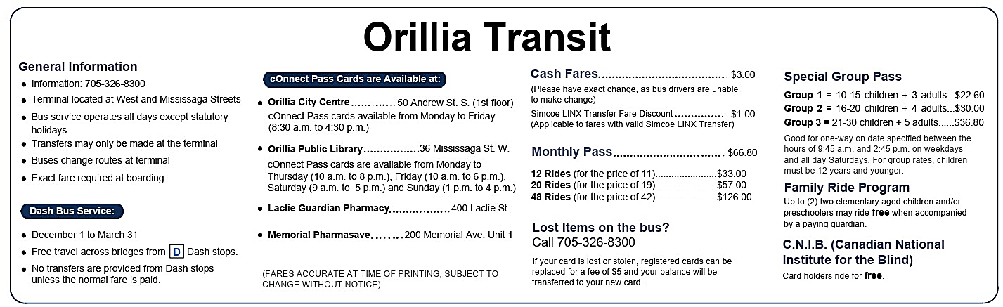

Answers
Task 1: I am going to school full-time now. How much would it cost for me to get a monthly bus pass?
Answer: $66.80

Task 2: My class is going to the art exhibit next month. If we decide to go by bus, what time of day would we have to go in order to get the special group pass?
Answer: Between 9:45 am and 2:45 pm on weekdays and all day on Saturdays.

Task 3: If my friend comes by bus from Toronto to Orillia, where do I go to meet him?
Answer: the terminal located at West and Mississaga Streets

Task 4: He may bring his three kids with him. Would they be able to get a special group pass?
Answer: No, the minimum requirement is 10-15 children + 3 adults.

Task 5: How could I get more information about cOnnect Pass Cards?
Answer: Call 705-326-8300

Performance Descriptors
Levels | Performance Descriptors | Needs Work | Completes task with support from practitioner | Completes task independently
A2.1 | Scans to locate specific details
 | Interprets brief text and common symbols
 | Locates specific details in simple documents, such as labels and signs
B1.1 | Participates in short, simple exchanges
 | Gives short, straightforward instructions or directions

This task: Was successfully completed Needs to be tried again

Learner Comments:

Instructor (print): Learner (print):

