

Task Title: Complete a Money Order Form

OALCF Cover Sheet – Practitioner Copy

Learner Name:___________________________________________
Date Started (m/d/yyyy):__________________________________
Date Completed (m/d/yyyy): _______________________________
Successful Completion: Yes No

Goal Path: | Employment | Apprenticeship
Secondary School | Post Secondary | Independence

Task Description: Read to complete a money order.
Main Competency/Task Group/Level Indicator:
- Find and Use Information/Read continuous text/A1.2
- Find and Use Information/Interpret documents/A2.2
- Understand and Use Numbers/Manage money/C1.2
Performance Descriptors: See chart on last page
Materials Required:
- Paper and pen and/or digital device

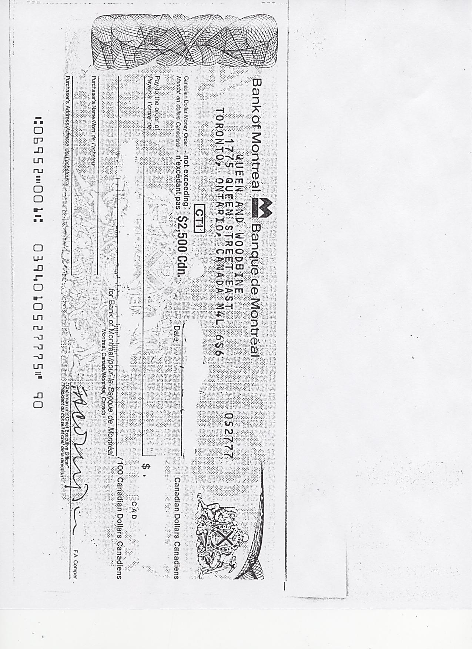
Learner Information
There are times when purchases cannot be paid for by cheque or credit card. An option is to get a money order from places like a bank or a post office. A money order is guaranteed by the bank, like a certified cheque.
Scan the blank money order.

Work Sheet
Task 1: What is the name of the bank listed on the money order?
Answer:
______________________________________________________
Task 2: Where is the bank located in Toronto?
Answer:
_____________________________________________________
Task 3: What is the maximum amount of money you can send using
the money order?
Answer:
______________________________________________________
Task 4: What type of dollars are paid by the money order?
Answer:
______________________________________________________
You have ordered birthday cards and wrapping paper from a mail order company catalogue. The company is Regent Gifts. This company does not accept cash or personal cheques. They only accept a credit card or money order as payment.
You do not have a credit card, so you must pay using a money order. The bank charges $7.50 to issue a money order.

Task 5: If the birthday cards cost $12.99 (tax included) and the wrapping paper cost $15.99 (tax included), what is the total amount you must pay the bank?
Answer:

______________________________________________________
Task 6: Complete the money order by filling in all the blanks. Write in the total amount to be paid as well.
(Note: When you actually purchase a money order, the bank or post office fills in the amount to be paid.)
Answer:

Answers

Task 1: What is the name of the bank listed on the money order?
Answer: Bank of Montreal
Task 2: Where is the bank located in Toronto?
Answer: 1775 Queen Street East (Queen & Woodbine)
Task 3: What is the maximum amount of money you can send using the money order?
Answer: $ 2500.00 Canadian
Task 4: What type of dollars are paid by the money order?
Answer: Canadian Funds
Task 5: If the birthday cards cost $12.99 (tax included) and the wrapping paper cost $15.99 (tax included), what is the total amount you must pay the bank?
Answer: 12.99 + 15.95 + 7.50 = $ 36.44

Task 6: Complete the money order by filling in all the blanks. Write in the total amount to be paid as well.
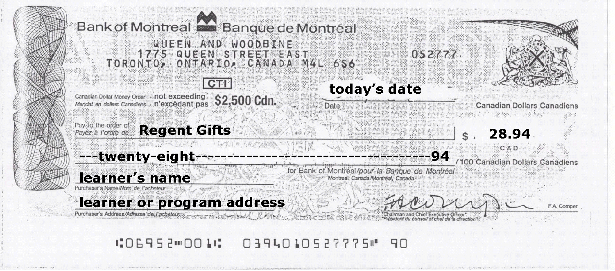

Performance Descriptors

Levels | Performance Descriptors | Needs Work | Completes task with support from practitioner | Completes task independently
A1.2: | Scans text
 | Makes low-level inferences
A2.1: | Scans to locate specific details
 | Interprets brief text and common symbols
 | Makes low-level inferences
C1.1: | Adds, subtracts, multiplies and divides whole numbers and decimals
 | Interprets and represents costs using monetary symbols and decimals
 | Represents costs and rates using monetary symbols, decimals and percentages.
 | Uses strategies to check accuracy (e.g. estimating, using a calculator, repeating a calculation, using the reverse operation)

This task: Was successfully completed Needs to be tried again

Learner Comments:

Instructor (print): Learner (print):

________________________ _______________________

