

Task Title: Calculating a Restaurant Bill

OALCF Cover Sheet – Practitioner Copy

Learner Name:___________________________________________
Date Started:____________________________________________
Date Completed:_________________________________________

Goal Path: | Employment | Apprenticeship
Secondary School | Post Secondary | Independence
Successful Completion: Yes No

Task Description: Take an order, calculate the cost of a bill and make change.
Main Competency/Task Group/Level Indicator:
- Find and Use Information/Interpret documents/A2.2
- Communicate Ideas and Information/Complete and create documents/B3.2a
- Understand and Use Numbers/Manage money/C1.2
Materials Required:
- Pen/pencil and paper and/or digital device

Learner Information
Servers in a restaurant must calculate their own bills when the cash register is down.
Use the menu for Mary’s Café to review the menu items and prices.

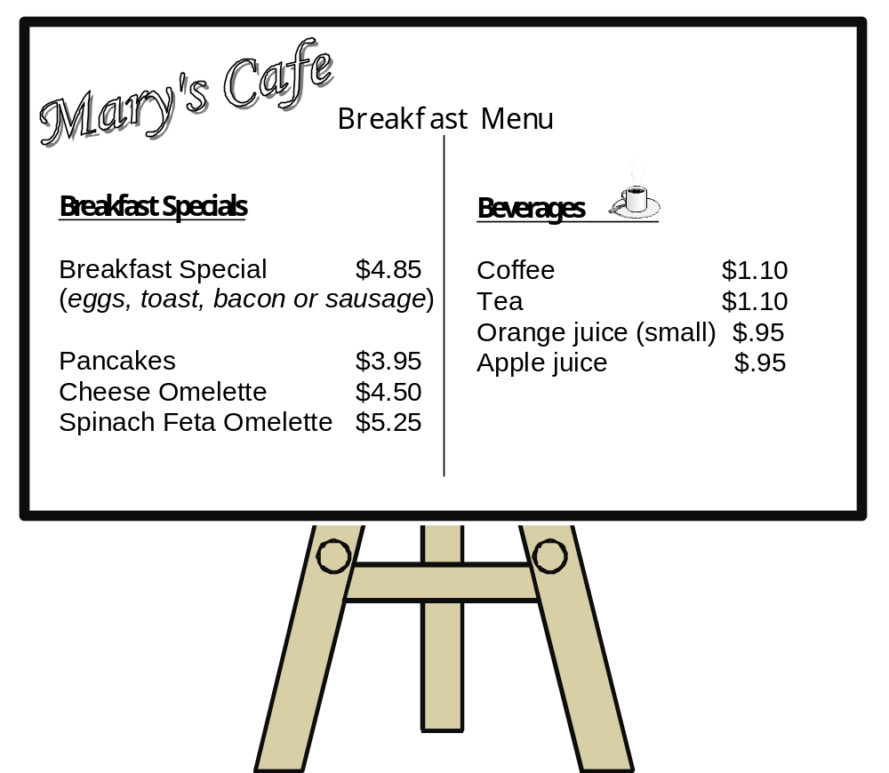

Work Sheet
Task 1a: Write the correct amount beside each item on the bill. Calculate the tax. Show your work.
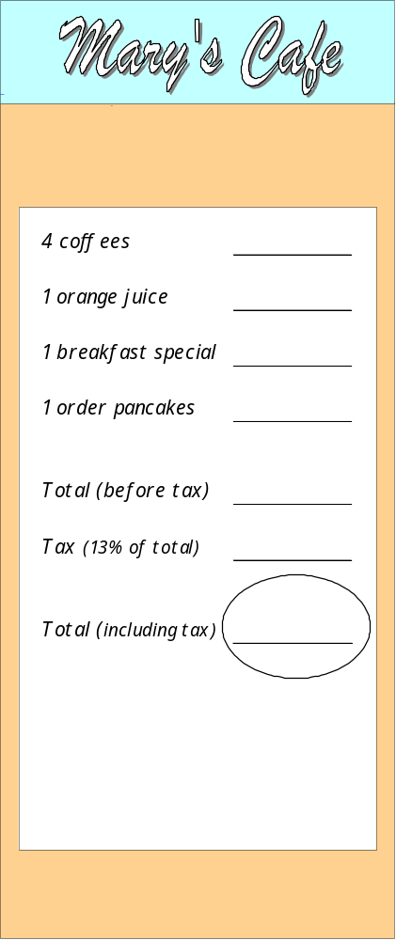

Task 1b: The customer gives you a $20 bill to pay the bill. How much change will you give?
Answer:

______________________________________________________
Task 2a: The server at Mary’s Café is taking a breakfast order. Read the customers’ order.
Bill wants the breakfast special. He hates his eggs sunny side up. He wants his eggs scrambled. He wants bacon with his eggs and brown toast with butter. He wants coffee and a glass of water.

Jill wants the breakfast special too. She’d like her eggs sunny side up, with sausages. She’s on a low-carb diet. She doesn’t want toast at all. She’ll have a glass of water and coffee to drink.

Their son Nowaz wants pancakes with butter instead of syrup. He’d like orange juice.

Task 2b: Write the order on the bill. Write neatly so the cook can understand your writing.
Enter the costs of the items and calculate the total for the bill, including tax.
Answer:
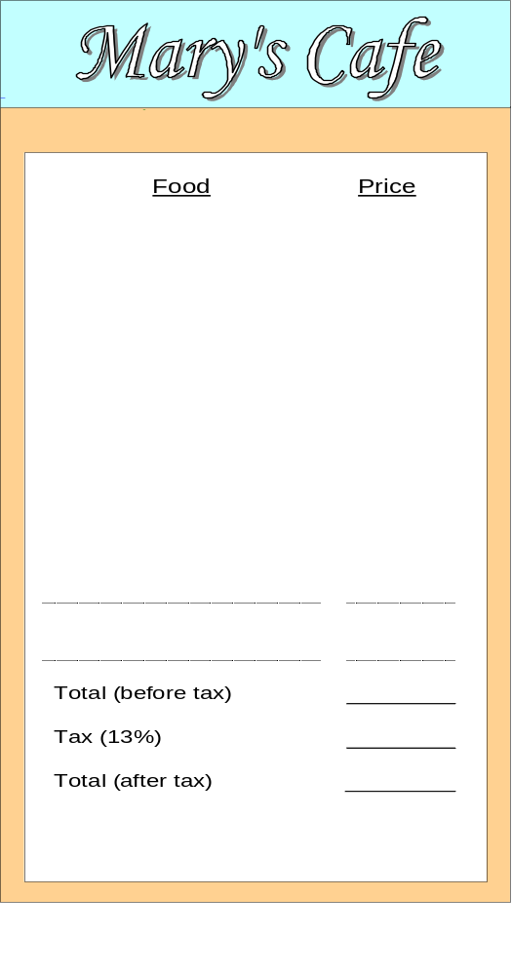

Answers
Task 1a: Write the correct amount beside each item on the bill. Calculate the tax. Show your work.
Task 1b: The customer gives you a $20 bill to pay the bill. How much change will you give?
The customer gives you a $20 bill to pay the bill.
How much change will you give?
$4.01
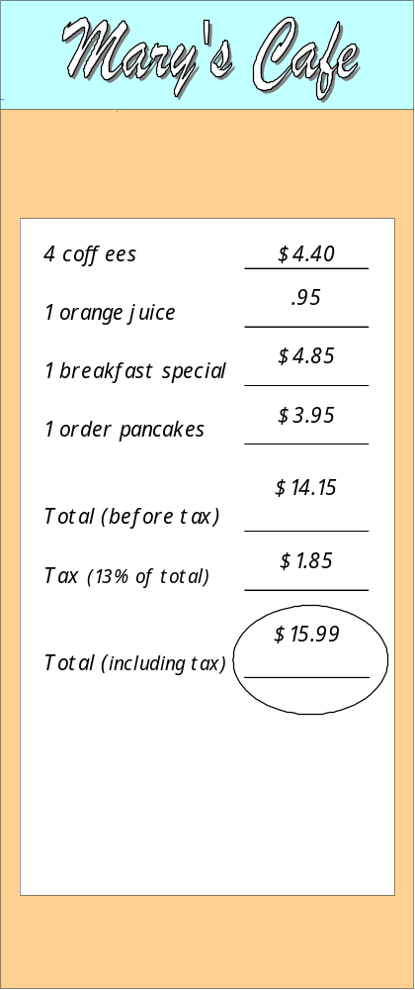
Task 2b: Write the order on the bill. Write neatly so the cook can understand your writing.
Enter the costs of the item and calculate the total for the bill, including tax.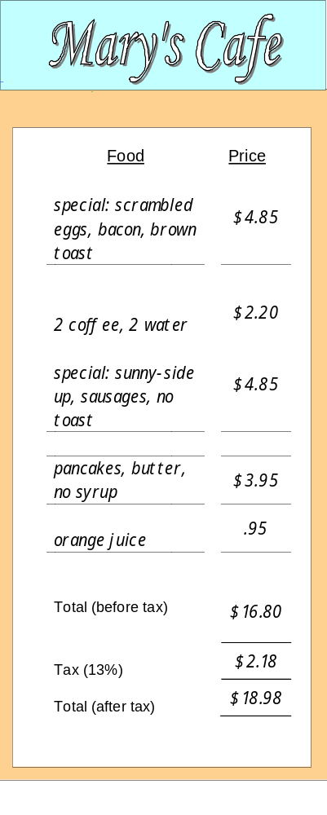

Performance Descriptors
Levels | Performance Descriptors | Needs Work | Completes task with support from practitioner | Completes task independently
A2.2 | performs limited searches using one or two search criteria
 | uses layout to locate information
 | makes low-level inferences
B3.2a | uses layout to determine where to make entries
 | begins to make some inferences to decide what information is needed, where and how to enter the information
 | follows instructions on documents
C1.2 | calculates using numbers expressed as whole numbers, fractions, decimals, percentages and integers
 | calculates percentages
 | chooses and performs required operation(s); may make inferences to identify required operation(s)
 | selects appropriate steps to reach solutions
 | represents costs and rates using monetary symbols, decimals and percentages
 | interprets, represents and converts amounts using whole numbers, decimals, percentages, ratios and simple, common fractions (e.g. ½, ¼)
 | uses strategies to check accuracy (e.g. estimating, using a calculator, repeating a calculation, using the reverse operation)

This task: Was successfully completed Needs to be tried again

Learner Comments:

Instructor (print): Learner (print):
_________________ _________________

